MULTI-PLATINUM AUSTRALIAN SINGER/SONGWRITER VANCE JOY
PARTNERS WITH KALA AND MYMUSICRX TO LAUNCH “UKULELES FOR KIDS,” DELIVERING UKULELES & HOW-TO VIDEO LESSONS TO
CHILDREN’S HOSPITALS ACROSS AMERICA

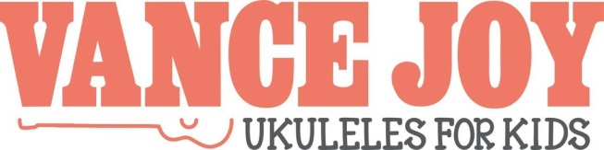
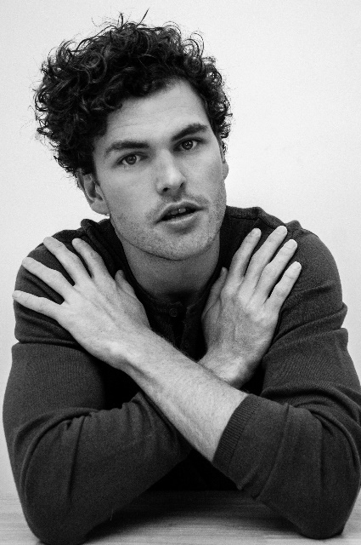

Today, multi-platinum, Australian singer/songwriter Vance Joy announces a new initiative called “Vance Joy - Ukuleles for Kids” in partnership with Kala and MyMusicRx. Exclusively announced via Billboard, the newly founded program will provide the opportunity for children’s hospitals across the United States to opt into donation throughout the month of August. In September, National Childhood Cancer Awareness Month, ukuleles and how-to video lessons will be delivered to hospitals that have opted in to the program. More details can be found at http://www.vancejoy.com/ukulelesforkids.

“I remember hearing a beautiful story about George Harrison driving around in his car, handing out instruments to people,” said Vance Joy. “I’ve always wanted to emulate that idea and what better way than giving the gift of instruments and music lessons to young children who are fighting terminal diseases. My heart goes out to these kids and their families.”

Vance Joy himself will provide the video lessons, teaching children how to play simple songs on ukulele, including his break-out single “Riptide” and latest single “Saturday Sun.” Kala, a long-time partner of Vance Joy, will donate plastic, hospital sanitary ukuleles, encouraging young patients to watch the videos and learn to play. MyMusicRx will host the lessons on MyMusicRx.org, and manage hospital opt-ins through their national network of children’s hospitals.

Vance Joy is currently home in Australia after a whirlwind year traveling the globe in support of his newest album, Nation of Two. The Nation of Two World Tour – North America just concluded with a sold-out show at Greek Theatre in Los Angeles earlier this month, followed by an unforgettable outdoor concert on Jimmy Kimmel Live! (watch here). The tour sold an astounding 140,000 tickets in the United States and 46,000 tickets in Canada. Nation of Two has not only proven a sales and streaming success, but the sophomore album has earned widespread critical applause around the world. “It all adds up to an appealing album from an artist with a promising future,” wrote Associated Press. “This is (Vance Joy’s) time to really shine – and he seizes it.”

About Vance Joy
Vance Joy is a multi-Platinum Australian singer/songwriter with global success. He first broke onto the worldwide music scene in 2014, with ukulele-based hit “Riptide.” His debut album ‘dream your life away’ has gone on to sell nearly half a million copies worldwide. In 2018, Vance Joy released his sophomore album Nation of Two. Debuting #5 on the Billboard 200, the critically-acclaimed album spawned follow-up singles “Lay It On Me” and summer anthem “Saturday Sun,” also performed on ukulele.

About Kala
Founded in 2005, Kala Brand Music Co. is the world's most popular ukulele brand. Known for high-quality instruments at affordable pricing, Kala offers over 200 models in over 40 countries. Endorsing artists include Vance Joy, Mandy Harvey, John Driskell Hopkins (Zac Brown Band), Tarron Crayton (Demi Lovato) and Tyler Joseph (Twenty One Pilots). To learn more about Kala, visit kalabrand.com.

About MyMusicRx
MyMusicRx is the flagship program of the Children’s Cancer Association who believes #JoyMatters and #MusicHeals. Two decades ago they began delivering the healing power of music to children and teens facing cancer and other serious illnesses. Today, their bedside and digital “music medicine” programs engage hospitalized children of all ages and diagnoses, relieving stress, anxiety, and perception of pain. Since 1995, MyMusicRx has served more than 180,000 children along with their families, caregivers, and medical professionals. MyMusicRx digital programs are available daily to 7,500 children in 25 pediatric hospitals across the country and growing. See MyMusicRx in action here, or visit us anytime at MyMusicRx.org

