FOR IMMEDIATE RELEASE

JULY 26, 2019

**WHY DON’T WE RELEASES 7TH NEW SONG OF 2019, “I STILL DO”**

**BLOCKBUSTER ‘8 LETTERS TOUR’ CONTINUES GLOBAL DOMINATION,**

**RESUMING IN NORTH AMERICA, EUROPE, ASIA & AUSTRALIA THROUGH END OF YEAR**

**BREAKOUT POP GROUP SET TO RETURN FOR *TODAY SHOW***

**CITI CONCERT SERIES IN ROCKEFELLER PLAZA ON LABOR DAY**

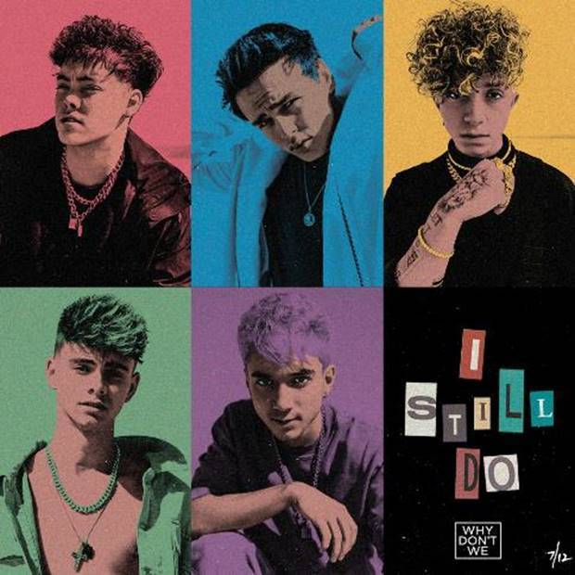

[DOWNLOAD HIGH-RES IMAGES](http://press.atlanticrecords.com/why-dont-we/)

**STREAM “I STILL DO”:** <https://wdw.lnk.to/IStillDoPR>

*“One of pop music’s biggest breakout stories”* – **NBC’s TODAY**

*“Artist To Watch”* – **ROLLING STONE**

*“the next generation’s all-American boy band”* – **PAPER**

*“The Next Boy Band Taking Over The World”* – **NYLON**

Atlantic recording artists **Why Don’t We** have released their seventh new track of 2019, “**I Still Do**” – available now via all DSPs.

Known for their prolific and creative output, “**I Still Do**” continues a steady flow of new releases from **Why Don’t We** – also including collaborative single “**I Don’t Belong In This Club**” with **Macklemore**, “**Come To Brazil**,” “**Unbelievable**,” “**Big Plans**,” “**Cold In LA**,” and their soundtrack contribution to STXFilm’s ***UglyDolls***, “**Don’t Change**.”

“**I Still Do**” arrives amidst an exciting few months for **Why Don’t We**, highlighted by the RIAA-Gold certification of last year’s explosive Top 20 single “**8 Letters**” – which alone accounts for 185 million of the band’s over 1 billion global audio and video streams – and the second leg of their biggest headline run to date, the ***8 Letters Tour***. The group was also recently announced as part of the **2019** **TODAY Show** **Citi Concert Series** line-up, returning once again to Rockefeller Plaza on Labor Day (Sept. 2nd) following last year’s performance which garnered one of the largest crowds of the summer. For ticketing details, tour updates, and more, please visit [www.whydontwemusic.com](http://www.whydontwemusic.com).

***

Amassing more than 1 billion global audio streams, 4 million Instagram followers, and total You Tube views exceeding 460 million with over 2.8 million subscribers in under 3 years, Why Don’t We has become one of pop music’s biggest breakout stories. Taking an innovative and unconventional approach towards releasing new music and actively engaging their rapidly growing fanbase, the prolific young group – the quintet ranges in age from 18-21 years old – put out their first five EPs in under 12 months. The group closed 2017 on a high note, performing on the entire iHeartRadio Jingle Ball Tour, including the New York City stop at Madison Square Garden where they shared the stage with Taylor Swift, Ed Sheeran and more. Their 2018 inaugural full length album, *8 Letters*, debuted in the top 10 on the Billboard 200 at #9 and immediately shot to #1 on US iTunes’ Overall Albums chart (along with topping charts in over 20 more territories around the globe) – while the title track is RIAA-certified Gold, hit Top 20 at Pop radio and boasts over 185 million global audio and video streams to date. The band has sold out back-to-back North American headlining tours, and is currently on the road for their most extensive *8 Letters Tour* (which included a stop at New York City’s Radio City Music Hall which sold out in under two hours). High profile national television appearances include performances on NBC’s TODAY Show (including back-to-back summer concerts in Rockefeller Plaza), ABC’s Good Morning America, nationally syndicated Live with Kelly and Ryan, CBS’s The Late Late Show with James Corden, ABC's Jimmy Kimmel Live! and more.  Press highlights include features in Rolling Stone, Entertainment Weekly, Billboard, PAPER and TIME among others.  WHY DON’T WE is:  Daniel Seavey, Zach Herron, Corbyn Besson, Jonah Marais, and Jack Avery

***

**WHY DON’T WE**

***8 LETTERS* NORTH AMERICAN TOUR**

July 26 – Rogers, AR – Walmart AMP

July 27 – St. Louis, MO – Fabulous Fox Theatre

July 28 – Nashville, TN – Ascend Amphitheater

July 30 – Louisville, KY – The Louisville Palace

August 1 – Boca Raton, FL – Mizner Park Amphitheatre

August 2 – Jacksonville, FL – Daily’s Place Amphitheater

August 3 – Raleigh, NC – The Red Hat Amphitheater

August 5 – Baltimore, MD – Pavilion

August 6 – Albany, NY – Palace Theatre

August 8 – Gilford, NH – Bank of New Hampshire Pavilion

August 9 – Uncasville, CT – Mohegan Sun Arena

August 10 – Philadelphia, PA – The Met

August 11 – Moon Township, PA – UPMC Events Center

August 13 – Springfield, IL – Illinois State Fair

August 14 – Lincoln, NE – Pinnacle Bank Arena

August 18 – Park City, KS – Hartman Arena

August 20 – Charleston, SC – Volvo Car Stadium

August 21 – Pelham, AL – Oak Mountain Amphitheatre

August 25 – Cincinnati, OH – PNC Pavilion at Riverbend

August 26 – Grand Rapids, MI – Devos Performance Hall

August 28 – Cleveland, OH – Jacobs Pavilion

August 29 – Syracuse, NY – New York State Fair

August 31 – Allentown, PA – The Great Allentown Fair

**CONNECT**:

[WHYDONTWEMUSIC.COM](http://whydontwemusic.com/) | [TWITTER](http://twitter.com/whydontwemusic) | [INSTAGRAM](https://www.instagram.com/whydontwemusic/) | [FACEBOOK](https://facebook.com/whydontwemusic) | [YOUTUBE](https://www.youtube.com/channel/UCgJMQU7JOIoP-YnrhH_P-bA) | [ASSETS](http://press.atlanticrecords.com/why-dont-we/)

**CONTACT:**

Glenn Fukushima | [glenn.fukushima@atlanticrecords.com](mailto:glenn.fukushima@atlanticrecords.com)

Ted Sullivan | [ted.sullivan@atlanticrecords.com](mailto:ted.sullivan@atlanticrecords.com)