FOR IMMEDIATE RELEASE

SEPTEMBER 12, 2019

**WHY DON’T WE ANNOUNCE “WHAT AM I” POP-UP SHOP SERIES**

**BREAKOUT POP GROUP UNVEILS PLANS FOR ONE-DAY ONLY EVENTS**

**CELEBRATING THEIR NEW SINGLE IN SIX CITIES ACROSS THE COUNTRY**

**FEATURING AN EXCLUSIVE MERCHANDISE LINE, SPECIAL ACOUSTIC PERFORMANCES,**

**AND MORE**

**EXACT LOCATIONS IN WASHINGTON DC, NEW YORK, CHICAGO, ATLANTA,**

**SAN FRANCISCO AND LOS ANGELES TO BE REVEALED THE DAY BEFORE EACH EVENT**

**“WHAT AM I” ENTERS THE TOP 40 RADIO CHART THIS WEEK**

**FOLLOWING LABOR DAY PERFORMANCE IN ROCKEFELLER PLAZA ON NBC’S TODAY**

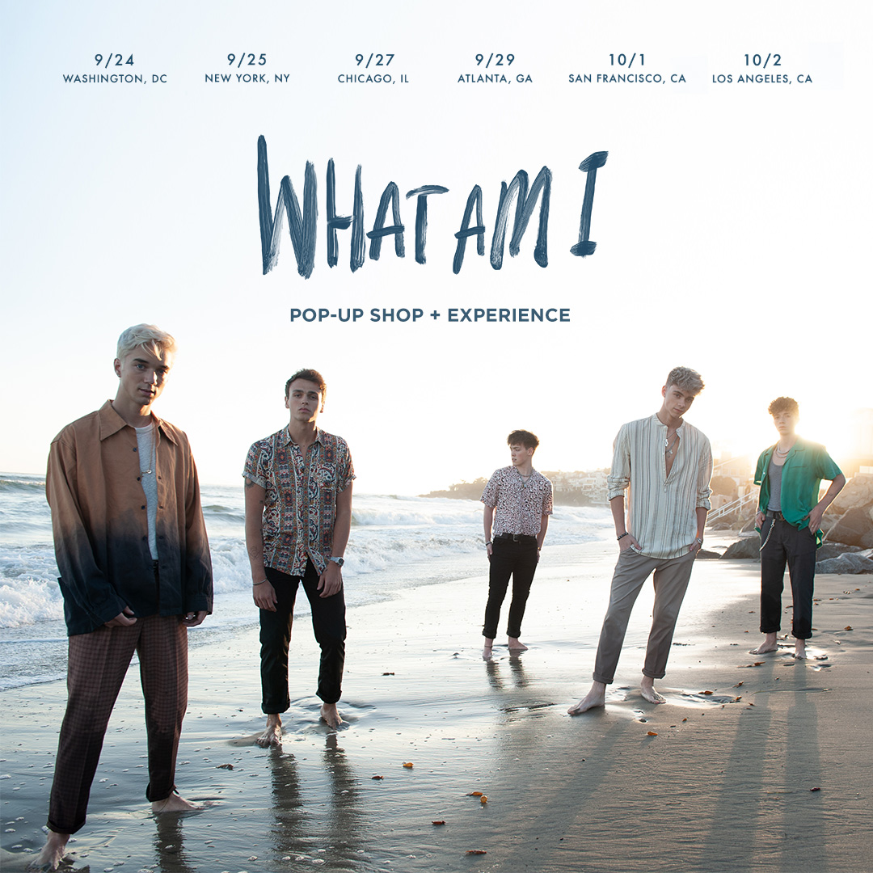

Breakout pop group **Why Don’t We** has announced a series of pop-up shops to celebrate the recent release of their new single **“What Am I.”** Each one-day only event - taking place in six different cities across the country in the coming weeks - will feature an exclusive merchandise line including city-specific items, one-of-a-kind fan experiences, and a special acoustic performance by the band for a limited number of fans. Cities include Washington DC (Sept 24), New York City (Sept 25), Chicago (Sept 27), Atlanta (Sept 29), San Francisco (Oct 1), and Los Angeles (Oct 2). The stores will be open from 12noon-10pm local time. Exact locations will be announced the day before each pop-up via the band’s social platforms (links below) along with details on how to attend the band’s performance.

Why Don’t We’s new single “**What Am I**” has officially debuted on the Top 40 radio chart this week. Penned by **Ed Sheeran** and produced by **Steve Mac**, the track – available now via Atlantic Records – marks the triumphant follow up to “8 Letters,” their RIAA-Gold certified, Top 20 single which alone accounts for 213 million of the band’s over 1.2 billion global streams. The single’s companion music video – directed by Andy Hines (Lizzo, Big Sean, Anderson Paak, Logic) – has logged over 6 million views in under 3 weeks and is streaming now on Why Don’t We’s official YouTube channel ([WATCH HERE](https://nam04.safelinks.protection.outlook.com/?url=https%3A%2F%2Fwww.youtube.com%2Fwatch%3Fv%3DZxgbQz4n8-s&data=02%7C01%7CSydneyWorden%40elektra.com%7C4b574cb0fc224608e6a308d727cf3b80%7C8367939002ec4ba1ad3d69da3fdd637e%7C0%7C0%7C637021643334667404&sdata=rH4EA%2B5Nfhc%2BiGKD9hiBiA7nZyALys2FR7rks3i%2Fg7I%3D&reserved=0)).

The band’s wildly popular 8 Letters Tour has already sold out dates all over the globe, including a stop at New York City’s famed Radio City Music Hall that sold out in less than 2 hours. Next month, the worldwide trek resumes in Europe before continuing on to Southeast Asia, Australia, and New Zealand. For ticketing details, tour updates, and more, please visit [www.whydontwemusic.com](https://nam04.safelinks.protection.outlook.com/?url=http%3A%2F%2Fwww.whydontwemusic.com&data=02%7C01%7CSydneyWorden%40elektra.com%7C4b574cb0fc224608e6a308d727cf3b80%7C8367939002ec4ba1ad3d69da3fdd637e%7C0%7C0%7C637021643334677398&sdata=hIKOkqtbXR3xT4eh1G0Hk9IxHcFy%2BBT4DP1OFuWkkdo%3D&reserved=0).

*“One of pop music’s biggest breakout stories”* – **NBC’s TODAY**

*“Artist To Watch”* – **ROLLING STONE**

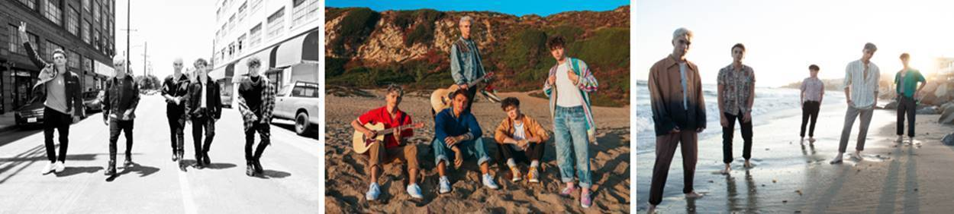

[DOWNLOAD HIGH-RES IMAGES](https://nam04.safelinks.protection.outlook.com/?url=http%3A%2F%2Fpress.atlanticrecords.com%2Fwhy-dont-we%2F&data=02%7C01%7CSydneyWorden%40elektra.com%7C4b574cb0fc224608e6a308d727cf3b80%7C8367939002ec4ba1ad3d69da3fdd637e%7C0%7C0%7C637021643334677398&sdata=X%2Bq8tKVanHN6AvLJuWNHqy5u54qb8aLPwPu%2BqXXpu68%3D&reserved=0)

***

Amassing more than 1.2 billion global audio streams, 4.1 million Instagram followers, and total You Tube views exceeding 501 million with over 3 million subscribers in under 3 years, Why Don’t We has become one of pop music’s biggest breakout stories. Taking an innovative and unconventional approach towards releasing new music and actively engaging their rapidly growing fanbase, the prolific young group – the quintet ranges in age from 18-21 years old – put out their first five EPs in under 12 months. After only a year together, the group earned a highly coveted spot on the entire iHeartRadio Jingle Ball Tour, including the New York City stop at Madison Square Garden where they shared the stage with Taylor Swift, Ed Sheeran and more. Their 2018 inaugural full length album, *8 Letters*, debuted in the top 10 on the Billboard 200 at #9 and immediately shot to #1 on US iTunes’ Overall Albums chart (along with topping charts in over 20 more territories around the globe) – while the title track is RIAA-certified Gold, hit Top 20 at Pop radio and boasts over 204 million global streams to date. The band has sold out back-to-back North American headlining tours, and is currently on the road for their most extensive *8 Letters Tour* (which included a stop at New York City’s Radio City Music Hall which sold out in under two hours). High profile national television appearances include performances on NBC’s TODAY Show (including back-to-back summer concerts in Rockefeller Plaza), ABC’s Good Morning America, nationally syndicated Live with Kelly and Ryan, CBS’s The Late Late Show with James Corden, ABC's Jimmy Kimmel Live! and more.  Press highlights include features in Rolling Stone, Entertainment Weekly, Billboard, PAPER and TIME among others.  WHY DON’T WE is:  Daniel Seavey, Zach Herron, Corbyn Besson, Jonah Marais, and Jack Avery

**CONNECT**:

[WHYDONTWEMUSIC.COM](https://nam04.safelinks.protection.outlook.com/?url=http%3A%2F%2Fwhydontwemusic.com%2F&data=02%7C01%7CSydneyWorden%40elektra.com%7C4b574cb0fc224608e6a308d727cf3b80%7C8367939002ec4ba1ad3d69da3fdd637e%7C0%7C0%7C637021643334677398&sdata=%2B0oW9XQX8ZaXuZQfoBzoK9G7VgzjVpItiDHIQhRglKk%3D&reserved=0) | [TWITTER](https://nam04.safelinks.protection.outlook.com/?url=http%3A%2F%2Ftwitter.com%2Fwhydontwemusic&data=02%7C01%7CSydneyWorden%40elektra.com%7C4b574cb0fc224608e6a308d727cf3b80%7C8367939002ec4ba1ad3d69da3fdd637e%7C0%7C0%7C637021643334687391&sdata=Q2yYlNojkShN0QHKduq6eN3CPXDcduvRG5M%2FNWrBfrM%3D&reserved=0) | [INSTAGRAM](https://nam04.safelinks.protection.outlook.com/?url=https%3A%2F%2Fwww.instagram.com%2Fwhydontwemusic%2F&data=02%7C01%7CSydneyWorden%40elektra.com%7C4b574cb0fc224608e6a308d727cf3b80%7C8367939002ec4ba1ad3d69da3fdd637e%7C0%7C0%7C637021643334687391&sdata=%2BWxyVUwXjoqYIkPv%2FDGrKWH6LHI2krCHNWyS7%2Fq3e9Q%3D&reserved=0) | [FACEBOOK](https://nam04.safelinks.protection.outlook.com/?url=https%3A%2F%2Ffacebook.com%2Fwhydontwemusic&data=02%7C01%7CSydneyWorden%40elektra.com%7C4b574cb0fc224608e6a308d727cf3b80%7C8367939002ec4ba1ad3d69da3fdd637e%7C0%7C0%7C637021643334697386&sdata=ytuj46Pst6FsEWnf5DHt5VtqSPlWCDiKAtO9Usg6d0A%3D&reserved=0) | [YOUTUBE](https://nam04.safelinks.protection.outlook.com/?url=https%3A%2F%2Fwww.youtube.com%2Fchannel%2FUCgJMQU7JOIoP-YnrhH_P-bA&data=02%7C01%7CSydneyWorden%40elektra.com%7C4b574cb0fc224608e6a308d727cf3b80%7C8367939002ec4ba1ad3d69da3fdd637e%7C0%7C0%7C637021643334697386&sdata=hQd12FY2MqMc827DqH%2BE%2FKU2IurqxM2Cthu4e0H%2B5iI%3D&reserved=0) | [ASSETS](https://nam04.safelinks.protection.outlook.com/?url=http%3A%2F%2Fpress.atlanticrecords.com%2Fwhy-dont-we%2F&data=02%7C01%7CSydneyWorden%40elektra.com%7C4b574cb0fc224608e6a308d727cf3b80%7C8367939002ec4ba1ad3d69da3fdd637e%7C0%7C0%7C637021643334697386&sdata=DYe699%2FsETZxQew0N0KVmLqgLrG%2BZqoC9bYAn%2FjXPsg%3D&reserved=0)

**CONTACT:**

Glenn Fukushima | [glenn.fukushima@atlanticrecords.com](mailto:glenn.fukushima@atlanticrecords.com)

Ted Sullivan | [ted.sullivan@atlanticrecords.com](mailto:ted.sullivan@atlanticrecords.com)