FOR IMMEDIATE RELEASE
MARCH 20, 2019

WHY DON’T WE JOIN FORCES WITH MACKLEMORE ON
“I DON’T BELONG IN THIS CLUB”

BRAND NEW TRACK ARRIVES OVERNIGHT WITH COMPANION MUSIC VIDEO
STREAMING NOW

BREAKOUT POP GROUP’S BIGGEST HEADLINE TOUR TO DATE KICKS OFF TONIGHT;
NYC SHOW AT THE LEGENDARY RADIO CITY MUSIC HALL SOLD OUT IN 2 HOURS;
OTHER SELL OUTS INCLUDE LOS ANGELES, CHICAGO, BOSTON AND MORE

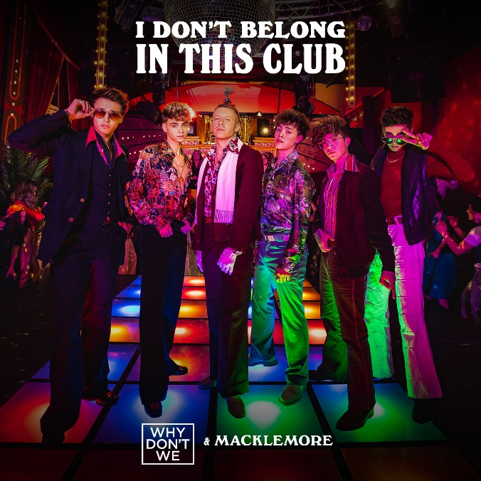

WATCH THE OFFICIAL MUSIC VIDEO “I DON’T BELONG IN THIS CLUB” HERE

“One of pop music’s biggest breakout stories” – NBC’s TODAY

“Artist To Watch” – ROLLING STONE

Atlantic recording artists Why Don’t We have teamed up with Macklemore on the brand new track, "I Don't Belong In This Club,” available now at all digital retailers and streaming services HERE. The surprise collaboration arrived overnight and the companion music video – directed by Jason Koenig (Ed Sheeran, Macklemore) – can now be viewed HERE. “I Don’t Belong In This Club” arrives on opening night of the band's 8 Letters Tour, kicking off tonight in Phoenix, AZ.

The 8 Letters Tour – the group’s biggest headlining tour to date - already includes sold out shows in Los Angeles, Boston, Chicago, and New York City, where they sold out the legendary Radio City Music Hall in just 2 hours. Why Don’t We recently announced a second leg of dates, running from July through August. For ticketing details, tour updates, and more, please visit www.whydontwemusic.com.

Known for their prolific, creative output, "I Don't Belong In This Club" marks the third song and video release from Why Don't We in 2019. The band kicked off the year with “Big Plans,” which also shot to #1 on the iTunes all genres chart and boasts over 6 million views on YouTube, followed by last month’s of “Cold in LA.”

“I Don’t Belong In This Club” follows Why Don’t We’s latest single “8 Letters” which hit the Top 20 at Pop radio and boasts over 130 million global audio and video streams to date. The group recently performed “8 Letters,” “Big Plans,” and more on the outdoor stage at Jimmy Kimmel Live! in front of one of the loudest audiences the show has seen. Marking the event, Rolling Stone noted “…the crowd’s screams and shrieks of glee nearly overpowered the musicians’ voices” while Billboard simply described the performance as “epic.” The pandemonium mirrored the band’s outdoor concert in Rockefeller Plaza as part of TODAY’s Citi Concert Series, where they garnered one of the largest crowds of the summer.

***

About Why Don’t We:
Amassing more than 750 million global audio streams, 3.7 million Instagram followers, and total You Tube views exceeding 378 million with over 2 million subscribers in under 2 years, Why Don’t We has become one of pop music’s biggest breakout stories. Taking an innovative and unconventional approach towards releasing new music and actively engaging their rapidly growing fanbase, the prolific young group – the quintet ranges in age from 17-20 years old – put out four EPs in under 12 months. The group closed 2017 on a high note, performing on the entire iHeartRadio Jingle Ball Tour, including the NYC stop at Madison Square Garden where they shared the stage with Taylor Swift, Ed Sheeran, Camilla Cabello and more. Their debut full length album, 8 Letters, debuted in the top 10 on the Billboard 200 at #9 and immediately shot to #1 on US iTunes’ Overall Albums chart (along with topping charts in over 20 more territories around the globe). The band has sold out back-to-back North American headlining tours, including their biggest trek to date earlier this year that was highlighted by multiple nights in NYC, LA, Chicago, and Toronto. High profile national television appearances include performances on NBC’s, ABC’s Good Morning America, nationally syndicated Live with Kelly and Ryan, CBS’s The Late Late Show with James Corden, ABC's Jimmy Kimmel Live! and more. Press highlights include features in Rolling Stone, Entertainment Weekly, Billboard, and TIME among others. WHY DON’T WE is: Daniel Seavey, Zach Herron, Corbyn Besson, Jonah Marais, and Jack Avery

About Macklemore:
Collectively Macklemore’s music videos have been viewed over 3 billion times and he is one of only two rappers to have a DIAMOND-certified single. ‘GEMINI,’ Macklemore’s first solo effort in 12 years, was released in September of 2017 and is RIAA certified GOLD. It debuted at #2 on the Billboard Top 200 chart and #1 on the charts for Rap, R&B/Hip-Hop, and Independent Albums. The album follows two releases with producer Ryan Lewis: the multiple-GRAMMY award winning album ‘The Heist’ and 2016 release ‘This Unruly Mess I’ve Made' (featuring Platinum-certified single "Downtown").

WHY DON’T WE
8 LETTERS NORTH AMERICAN TOUR

MARCH
20 Phoenix, AZ Comerica Theatre
22 Los Angeles, CA Microsoft Theater *SOLD OUT*
23 Las Vegas, NV The Pearl @ The Palms Casino Resort *SOLD OUT*
24 San Jose, CA Event Center at San Jose University *SOLD OUT*
26 Orem, UT UCCU Center
27 Broomfield, CO 1STBANK Center
29 Sugar Land, TX Smart Financial Centre at Sugar Land
30 Grand Prairie, TX Verizon Theatre

APRIL
1 Orlando, FL CFE Arena
2 Atlanta, GA Fox Theatre
4 Fairfax, VA EagleBank Arena
5 New York, NY Radio City Music Hall *SOLD OUT*
6 Boston, MA Agganis Arena *SOLD OUT*
8 Laval, QC Place Bell
9 Toronto, ON Coca-Cola Coliseum
11 Detroit, MI Fox Theatre
12 Rosemont, IL Rosemont Theatre *SOLD OUT*
14 St. Paul, MN Roy Wilkins Auditorium
17 Portland, OR Arlene Schnitzer Concert Hall
18 Seattle, WA WaMu Theater

MAY
18 Honolulu, HI Neal S. Blaisdell Arena

JULY
18 Costa Mesa, CA OC Fair
19 San Diego, CA Cal Coast Credit Union Open Air Theatre
20 Las Vegas, NV PARK Theater
22 Paso Robles, CA California Mid-State Fair
25 Kansas City, MO Starlight Amphitheatre
26 Rogers, AR Walmart AMP
27 St. Louis, MO Fabulous Fox Theatre
28 Nashville, TN Ascend Amphitheater
30 Louisville, KY The Louisville Palace

AUGUST
1 Boca Raton, FL Mizner Park Amphitheatre
2 Jacksonville, FL Daily’s Place Amphitheater
3 Raleigh, NC The Red Hat Amphitheater
5 Baltimore, MD MECU Pavilion
6 Albany, NY Palace Theatre
8 Gilford, NH Bank of New Hampshire Pavilion
9 Uncasville, CT Mohegan Sun Arena
10 Philadelphia, PA The Met
11 Moon Township, PA UPMC Events Center
13 Springfield, IL Illinois State Fair
14 Lincoln, NE Pinnacle Bank Arena
18 Park City, KS Hartman Arena
20 Charleston, SC Volvo Car Stadium
21 Pelham, AL Oak Mountain Amphitheatre
25 Cincinnati, OH PNC Pavilion at Riverbend
26 Grand Rapids, MI Devos Performance Hall
28 Cleveland, OH Jacobs Pavilion
29 Syracuse, NY New York State Fair
31 Allentown, PA The Great Allentown Fair

CONNECT:
WHYDONTWEMUSIC.COM | TWITTER | INSTAGRAM | FACEBOOK | YOUTUBE | ATLANTICRECORDS.COM

CONTACT:
Glenn Fukushima | glenn.fukushima@atlanticrecords.com
Ted Sullivan | ted.sullivan@atlanticrecords.com

