FOR IMMEDIATE RELEASE
SEPTEMBER 27, 2019

WHY DON’T WE RELEASE LIVE & UNPLUGGED SESSION OF “WHAT AM I”

Breakout pop group’s monumental new SINGLE penned by Ed Sheeran
& produced by Steve Mac continues to ascend at Top 40 radio

“What Am I” pop-up shop + experience series continues through next week
in chicago, atlanta, San Francisco & Los Angeles

Blockbuster ‘8 Letters Tour’ continues global domination,
resuming in Europe, Asia & Australia through end of year

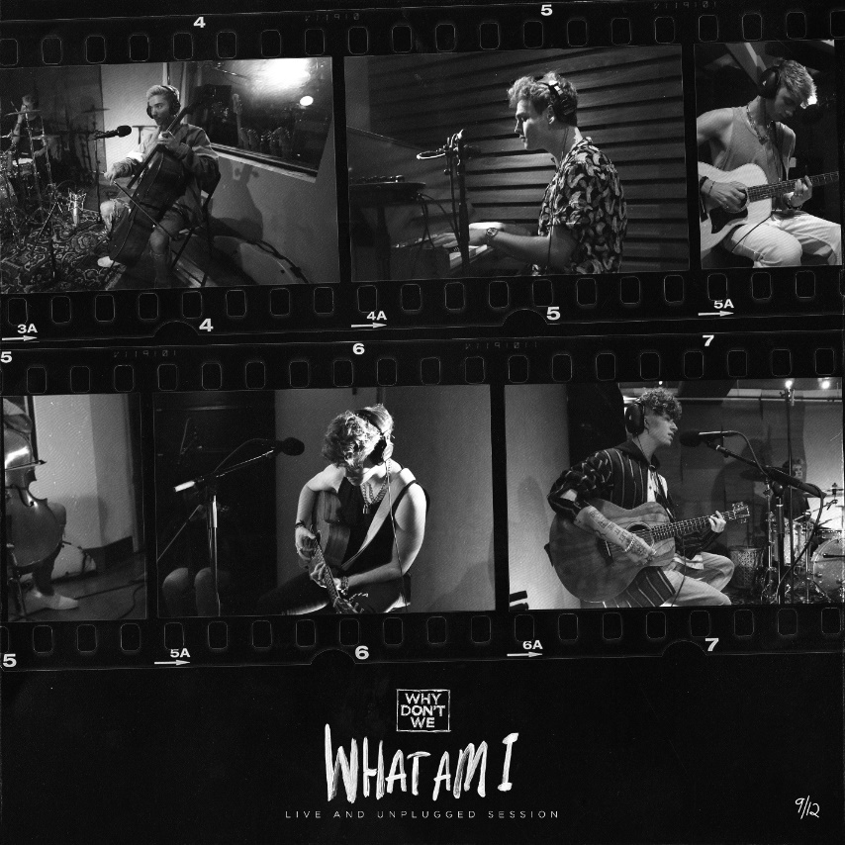
DOWNLOAD HIGH-RES IMAGES

WATCH “WHAT AM I” (LIVE AND UNPLUGGED SESSION): LINK
WATCH “WHAT AM I” music video: LINK

Breakout pop group Why Don’t We have released a live and unplugged session of their new single “What Am I” – available now as their ninth new release of 2019 via Atlantic Records. The single quickly debuted on the Top 40 radio chart, continuing it’s ascent this week to #36 while boasting over 19 million streams and 8.5 million video views. Since release, the band has performed the single on NBC’s TODAY Show Citi Concert Series, MTV’s TRL and this past week on ABC’s Live with Kelly & Ryan.

Penned by Ed Sheeran and produced by Steve Mac, “What Am I” arrived last month as the triumphant follow up to “8 Letters” – their RIAA-Gold certified Top 20 single which alone accounts for 219 million of the band’s over 1.2 billion global streams. The single marks a continuation of an exciting year for Why Don’t We, highlighted by their biggest headline run to date, the widely popular and sold out 8 Letters Tour, which resumes its global domination through end of year in Europe before visiting Southeast Asia, Australia, and New Zealand. Last month, the band also took home the award for Choice Music Group at the 2019 Teen Choice Awards, in addition to receiving a nomination for Best Group at the 2019 MTV Video Music Awards.

To celebrate the release of “What Am I,” Why Don’t We announced a series of exclusive pop-up shops in six different cities across the country – including previous stops in Washington, DC and New York City, and forthcoming stops in Chicago (Sept 27), Atlanta (Sept 29), San Francisco (10/1) and Los Angeles (Oct 2). The stores (open from 12p-10p local time) feature exclusive merchandise lines including city-specific items, one-of-a-kind fan experiences, and a special acoustic performance by the band for a limited number of fans. Exact locations and attendance details will be announced the day before each pop-up via the band’s social platforms.

Known for their prolific and creative output, “What Am I” (Live and Unplugged Session) marks the ninth new release from Why Don’t We in 2019 – preceded by a steady flow of monthly new releases that included “I Don’t Belong In This Club” with Macklemore, ”Come To Brazil,” “Unbelievable,” “Big Plans” & more.

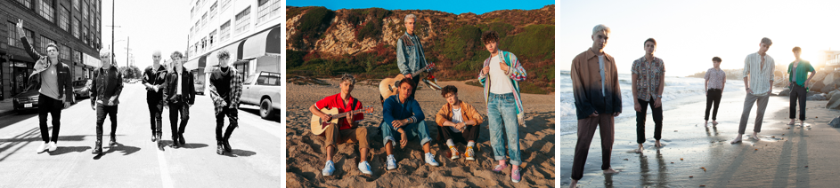
DOWNLOAD HIGH-RES IMAGES

***

“One of pop music’s biggest breakout stories” – NBC’s TODAY
“Artist To Watch” – ROLLING STONE

Amassing more than 1.2 billion global audio streams, 4.1 million Instagram followers, and total You Tube views exceeding 511 million with over 3 million subscribers in under 3 years, Why Don’t We has become one of pop music’s biggest breakout stories. Taking an innovative and unconventional approach towards releasing new music and actively engaging their rapidly growing fanbase, the prolific young group – the quintet ranges in age from 18-21 years old – put out their first five EPs in under 12 months. After only a year together, the group earned a highly coveted spot on the entire iHeartRadio Jingle Ball Tour, including the New York City stop at Madison Square Garden where they shared the stage with Taylor Swift, Ed Sheeran and more. Their 2018 inaugural full length album, 8 Letters, debuted in the top 10 on the Billboard 200 at #9 and immediately shot to #1 on US iTunes’ Overall Albums chart (along with topping charts in over 20 more territories around the globe) – while the title track is RIAA-certified Gold, hit Top 20 at Pop radio and boasts over 219 million global streams to date. The band has sold out back-to-back North American headlining tours, and is currently on the road for their most extensive 8 Letters Tour (which included a stop at New York City’s Radio City Music Hall which sold out in under two hours). High profile national television appearances include performances on NBC’s TODAY Show (including back-to-back summer concerts in Rockefeller Plaza), ABC’s Good Morning America, nationally syndicated Live with Kelly and Ryan, CBS’s The Late Late Show with James Corden, ABC's Jimmy Kimmel Live! and more. Press highlights include features in Rolling Stone, Entertainment Weekly, Billboard, PAPER and TIME among others. WHY DON’T WE is: Daniel Seavey, Zach Herron, Corbyn Besson, Jonah Marais, and Jack Avery

CONNECT:
WHYDONTWEMUSIC.COM | TWITTER | INSTAGRAM | FACEBOOK | YOUTUBE | ASSETS

CONTACT:
Glenn Fukushima | glenn.fukushima@atlanticrecords.com
Ted Sullivan | ted.sullivan@atlanticrecords.com

