FOR IMMEDIATE RELEASE

AUGUST 23, 2019

**WHY DON’T WE RELEASE OFFICIAL NEW SINGLE “WHAT AM I”**

**Breakout pop group’s monumental new TRACK**

**penned by Ed Sheeran & produced by Steve Mac available now**

**Watch Andy Hines-directed music video** [**here**](https://www.youtube.com/watch?v=ZxgbQz4n8-s)

**Why Don’t We wins Teen Choice Award for Choice Music Group,**

**Nominated for best group at mtv video music awards,**

**Returning for *Today Show* Citi Concert series in Rockefeller Plaza on Labor Day**

**Blockbuster ‘8 Letters Tour’ continues global domination,**

**Continuing in North America, Europe, Asia & Australia through end of year**

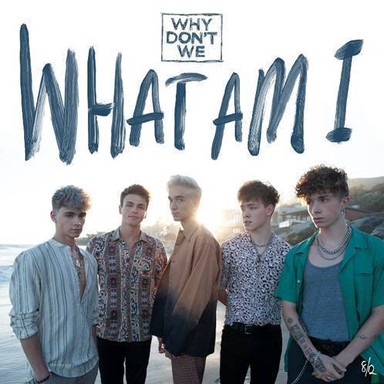

[DOWNLOAD HIGH-RES IMAGES](http://press.atlanticrecords.com/why-dont-we/)

**watch “what am i” video:** [LINK](https://www.youtube.com/watch?v=ZxgbQz4n8-s)

**STREAM “WHAT AM I”:** [LINK](https://wdw.lnk.to/WhatAmIPR)

*“One of pop music’s biggest breakout stories”* – **NBC’s TODAY**

*“Artist To Watch”* – **ROLLING STONE**

*“the next generation’s all-American boy band”* – **PAPER**

*“The Next Boy Band Taking Over The World”* – **NYLON**

Breakout pop group **Why Don’t We** have released their brand new single “**What Am I**,” available now with **Andy Hines**-directed music video via **Atlantic Records** ([WATCH HERE](https://www.youtube.com/watch?v=ZxgbQz4n8-s)). Penned by **Ed Sheeran** and produced by **Steve Mac**, the single marks the triumphant follow up to “**8 Letters**,” their RIAA-Gold certified Top 20 single which alone accounts for 204 million of the band’s over 1.2 billion global streams.

“**What Am I**” arrives amidst an exciting summer for **Why Don’t We**, highlighted by their biggest headline run to date, the ***8 Letters Tour****,* which continues its global domination through end of year with sold out shows in North America, Europe, Asia and Australia. Earlier this month, **Why Don’t We** also took home the award for **Choice Music Group** at the **2019 Teen Choice Awards,** in addition to receiving a nomination for **Best Group** at the **2019 MTV Video Music Awards**. The group is set to perform as part of the **2019** **TODAY Show** **Citi Concert Series** line-up, returning once again to Rockefeller Plaza on Labor Day (Sept. 2nd) following last year’s performance which garnered one of the largest crowds of the summer. For ticketing details, tour updates, and more, please visit [www.whydontwemusic.com](http://www.whydontwemusic.com).

Known for their prolific and creative output, “**What Am I**” marks the eighth new release from **Why Don’t We** in 2019 – preceded by a steady flow of monthly new releases that included “**I Don’t Belong In This Club**” with **Macklemore**, ”**Come To Brazil**,” “**Unbelievable**,” “**Big Plans**” & more.

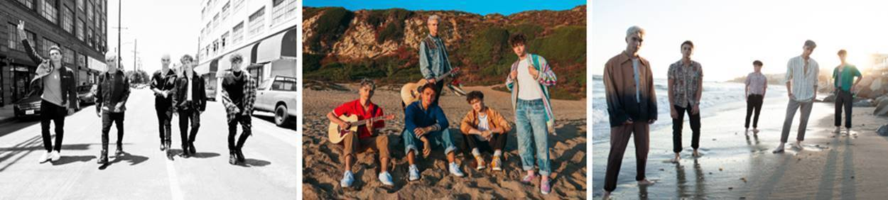

[DOWNLOAD HIGH-RES IMAGES](http://press.atlanticrecords.com/why-dont-we/)

***

Amassing more than 1.2 billion global audio streams, 4.1 million Instagram followers, and total You Tube views exceeding 480 million with over 2.9 million subscribers in under 3 years, Why Don’t We has become one of pop music’s biggest breakout stories. Taking an innovative and unconventional approach towards releasing new music and actively engaging their rapidly growing fanbase, the prolific young group – the quintet ranges in age from 18-21 years old – put out their first five EPs in under 12 months. After only a year together, the group earned a highly coveted spot on the entire iHeartRadio Jingle Ball Tour, including the New York City stop at Madison Square Garden where they shared the stage with Taylor Swift, Ed Sheeran and more. Their 2018 inaugural full length album, *8 Letters*, debuted in the top 10 on the Billboard 200 at #9 and immediately shot to #1 on US iTunes’ Overall Albums chart (along with topping charts in over 20 more territories around the globe) – while the title track is RIAA-certified Gold, hit Top 20 at Pop radio and boasts over 204 million global streams to date. The band has sold out back-to-back North American headlining tours, and is currently on the road for their most extensive *8 Letters Tour* (which included a stop at New York City’s Radio City Music Hall which sold out in under two hours). High profile national television appearances include performances on NBC’s TODAY Show (including back-to-back summer concerts in Rockefeller Plaza), ABC’s Good Morning America, nationally syndicated Live with Kelly and Ryan, CBS’s The Late Late Show with James Corden, ABC's Jimmy Kimmel Live! and more.  Press highlights include features in Rolling Stone, Entertainment Weekly, Billboard, PAPER and TIME among others.  WHY DON’T WE is:  Daniel Seavey, Zach Herron, Corbyn Besson, Jonah Marais, and Jack Avery

**CONNECT**:

[WHYDONTWEMUSIC.COM](http://whydontwemusic.com/) | [TWITTER](http://twitter.com/whydontwemusic) | [INSTAGRAM](https://www.instagram.com/whydontwemusic/) | [FACEBOOK](https://facebook.com/whydontwemusic) | [YOUTUBE](https://www.youtube.com/channel/UCgJMQU7JOIoP-YnrhH_P-bA) | [ASSETS](http://press.atlanticrecords.com/why-dont-we/)

**CONTACT:**

Glenn Fukushima | [glenn.fukushima@atlanticrecords.com](mailto:glenn.fukushima@atlanticrecords.com)

Ted Sullivan | [ted.sullivan@atlanticrecords.com](mailto:ted.sullivan@atlanticrecords.com)