FOR IMMEDIATE RELEASE

DECEMBER 6, 2018

**WIZ KHALIFA’S “SEE YOU AGAIN” (FEAT. CHARLIE PUTH) OFFICIALLY**

**EARNS DIAMOND CERTIFICATION**

**BECOMES ONE OF ONLY 25 SONGS EVER TO EARN THE HIGHEST U.S. CERTIFICATION**

**AFTER SELLING OVER 10 MILLION UNITS**

**GLOBAL SMASH FEATURED ON THE *FURIOUS 7: ORIGINAL MOTION PICTURE SOUNDTRACK***

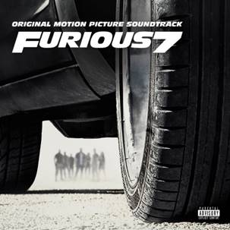 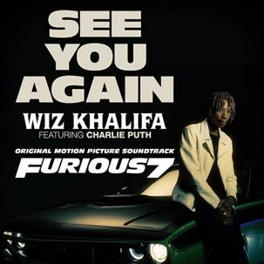

Just over three years since the track’s official release, Atlantic Records is proud to announce that “See You Again” by Wiz Khalifa (feat. Charlie Puth) is now certified diamond by the RIAA. The track, which was featured on the *FURIOUS 7: ORIGINAL MOTION PICTURE SOUNDTRACK,* has earned both Wiz Khalifa and Charlie Puth their first diamond single after selling over a whopping 10.3 million units. “See You Again” has become only one of 25 songs ever to earn this significant accolade.

Originally featured in *FURIOUS 7’*s touching closing tribute to the late Paul Walker, “See You Again" quickly rose to the top of the charts across 95 countries and spent a stunning 12 weeks at #1 on Billboard’s Hot 100 ultimately tying with Eminem’s “Lose Yourself” as the fourth-longest-running track to do so. It also went on to top Billboard’s “Hot Rap Songs” and “Hot R&B/Hip-Hop Songs” for 14 weeks each. The [companion music video](https://www.youtube.com/watch?v=RgKAFK5djSk) became the fastest video on YouTube to reach 1 billion views and currently holds nearly 4 billion views.

“See You Again” went on to make history and shattered Spotify records as the most streamed track ever in a single day with 4.2 million streams while also ranking, at one point, as the platform’s most streamed track in a single week with a stunning 21.9 million worldwide streams.  It also quickly became a worldwide phenomenon after rising to #1 on the iTunes Store’s “Top Songs” chart in the US along with 93 other countries.

The global smash, written by Charlie Puth, Andrew Cedar, Justin Franks and Wiz Khalifa, and produced by Frank E (Justin Franks), Charlie Puth, and Cedar,  went on to collect numerous honors including “Best Song” at the 2015 Critic’s Choice Awards. It also earned several esteemed nominations including “Song of the Year,” “Best Pop/Duo Group Performance” and “Best Song Written for Visual Media” at the 58th Annual GRAMMY Awards, “Best Original Song – Motion Picture” at the 73rd Golden Globe Awards, “Song of the Year” and “Collaboration of the Year” at the 44th Annual American Music Awards, and more.  “See You Again” was written and recorded at Atlantic Studios and mixed by Manny Marroquin at Larrabbee North. A&R on the song was provided by Ben Maddahi and Miles Beard.

# # #

**FURIOUS 7: ORIGINAL MOTION PICTURE SOUNDTRACK**

*FURIOUS 7: ORIGINAL MOTION PICTURE SOUNDTRACK* itself went on to sell over 7.3 million albums worldwide andtop charts as it hit #1 on the iTunes Top Album’s chart in 77 countries including the UK, Canada, Australia, France, Germany and many more. *FURIOUS 7* went on to become the 7th highest-grossing film of all time worldwide along with the highest-grossing film of the *Fast & Furious* franchise. Across its eight installments the franchise has grossed more than $5 billion at the worldwide box office.

*FURIOUS 7: ORIGINAL MOTION PICTURE SOUNDTRACK* was produced by GRAMMY® Award-winning (and 5x nominee) Atlantic Records President, West Coast Kevin Weaver (Suicide Squad, The Greatest Showman, The Fault in Our Stars) and Warner Music Group Creative Officer & APG CEO, Mike Caren (Kevin Gates, Charlie Puth, Kehlani) supervised by GRAMMY® nominated Universal Pictures Film Music President, Global Film Music & Publishing Mike Knobloch (Fifty Shades of Grey, Pitch Perfect, Despicable Me) and Universal Pictures Film Music Executive Vice President Rachel Levy (Fifty Shades of Grey, Sing, Despicable Me).

**PRESS CONTACTS**

SYDNEY MARGETSON // [SYDNEY.MARGETSON@ATLANTICRECORDS.COM](mailto:SYDNEY.MARGETSON@ATLANTICRECORDS.COM)