FOR IMMEDIATE RELEASE
SEPTEMBER 19, 2018

WALLOWS PREMIERE “1980s HORROR FILM” MUSIC VIDEO

DIRECTED BY NINA LJETI + FEATURING NEW MUSICAL ARRANGEMENT AND RECORDING

SOUTHERN CALIFORNIA-BASED TRIO SET FOR FESTIVALS INCLUDING
LIFE IS BEAUTIFUL, AUSTIN CITY LIMITS MUSIC FESTIVAL,
VOODOO MUSIC & ARTS EXPERIENCE, AND CAMP FLOG GNAW

DEBUT EP, SPRING, AVAILABLE NOW

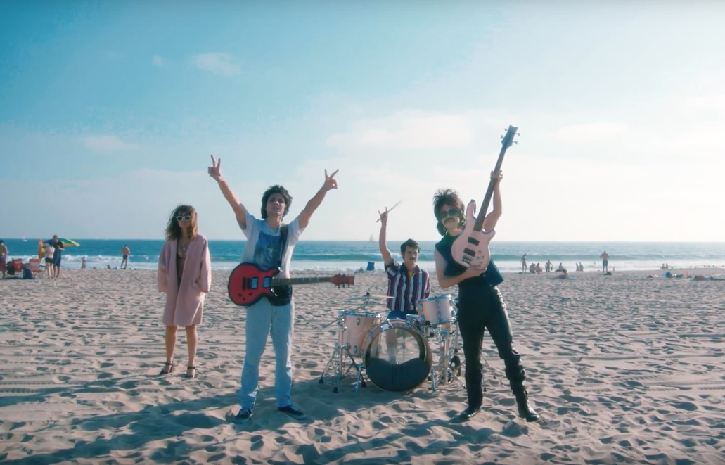

Atlantic recording group Wallows have unveiled a brand-new music video for their Spring EP song “1980s Horror Film.” Directed by Nina Ljeti, the video harkens back to the vibrant 80s and was shot in the famed Los Angeles neighborhoods of Laurel Canyon and Venice Beach. To further embrace the 80s, the video is soundtracked by a new arrangement and recording of the nostalgic Spring EP track. Watch the video on YouTube HERE.

Wallows acclaimed debut EP, Spring, featuring “1980s Horror Film” is available for streaming and download HERE. Produced by GRAMMY® Award-winner John Congleton (St. Vincent, Alvvays, Future Islands), the EP also includes such critically applauded tracks as “These Days” and “Pictures of Girls,” both of which are joined by remarkable companion visuals.

Spring has drawn praise from Idolator, lauding “(the band’s) breezy, Cali approach and hazy, ’90s-influences” while hailing Spring as “a collection of wispy, guitar-led anthems that make unexpected turns into post-punk and mellow surf-rock.” Idolator also named “These Days” as their 4th best video of 2018 so far, coming in behind Childish Gambino, Celine Dion, and The Carters. Stereogum commended “Pictures of Girls” as “dancey post-punk” and “These Days” as “a warm, synth-laden reverie,” while also applauding “1980s Horror Film” as “something simpler and sparer, an openly melodic acoustic guitar ballad that gradually unfolds into a thing of beauty with some help from indie-world superproducer John Congleton.” Summing it all up, PAPER said: “Wallows is here to restore alt-rock to its former glory…(The band’s) West Coast-infused sound is the sonic equivalent of driving down the Pacific Coast highway in a drop top at sunset. Mutually melancholy and enthusiastic, Wallows has the versatility to satiate soppy souls and raise heart rates — all in all, a welcome anecdote to the times.”

Having spent much of the past year selling out shows from Los Angeles to London, Wallows –Braeden Lemasters, Cole Preston, and Dylan Minnette – will continue to celebrate Spring with performances at some of America’s marquee festivals, including Las Vegas, NV’s Life is Beautiful (September 21st), Austin, TX’s Austin City Limits Music Festival (October 13th), New Orleans, LA’s Voodoo Music & Arts Experience (October 27th), and Los Angeles, CA’s Camp Flog Gnaw (November 10th and 11th). For updates, ticket information, and additional announcements, please visit wallowsmusic.com.

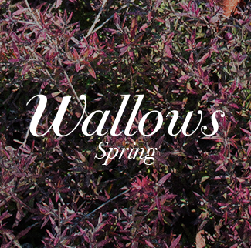

FOR MORE ON WALLOWS, PLEASE VISIT:
WALLOWSMUSIC.COM I FACEBOOK I TWITTER I YOUTUBE I ATLANTICRECORDS.COM
# # #
Press inquiries: Corey Brewer, corey.brewer@atlanticrecords.com

