WALLOWS RELEASE NEW SONG “DRUNK ON HALLOWEEN” & COMPANION LYRIC VIDEO

“1980s HORROR FILM II” ALSO AVAILABLE DIGITALLY TODAY

VANS SIDESTRIPE SESSION STREAMING NOW HERE

PERFORMING AT AUSTIN CITY LIMITS MUSIC FESTIVAL THIS SATURDAY, OCTOBER 13TH

DEBUT EP, SPRING, AVAILABLE NOW

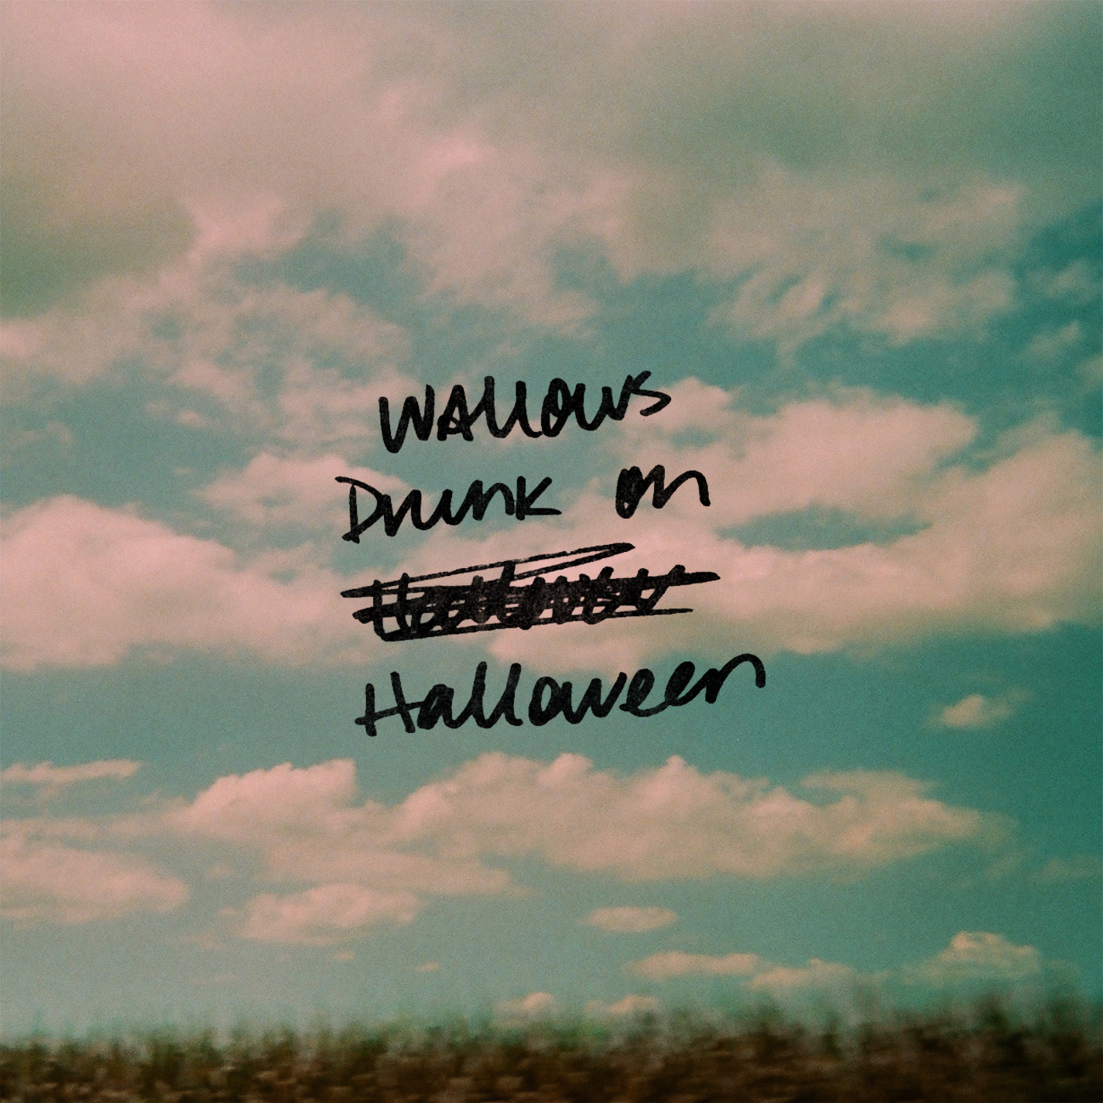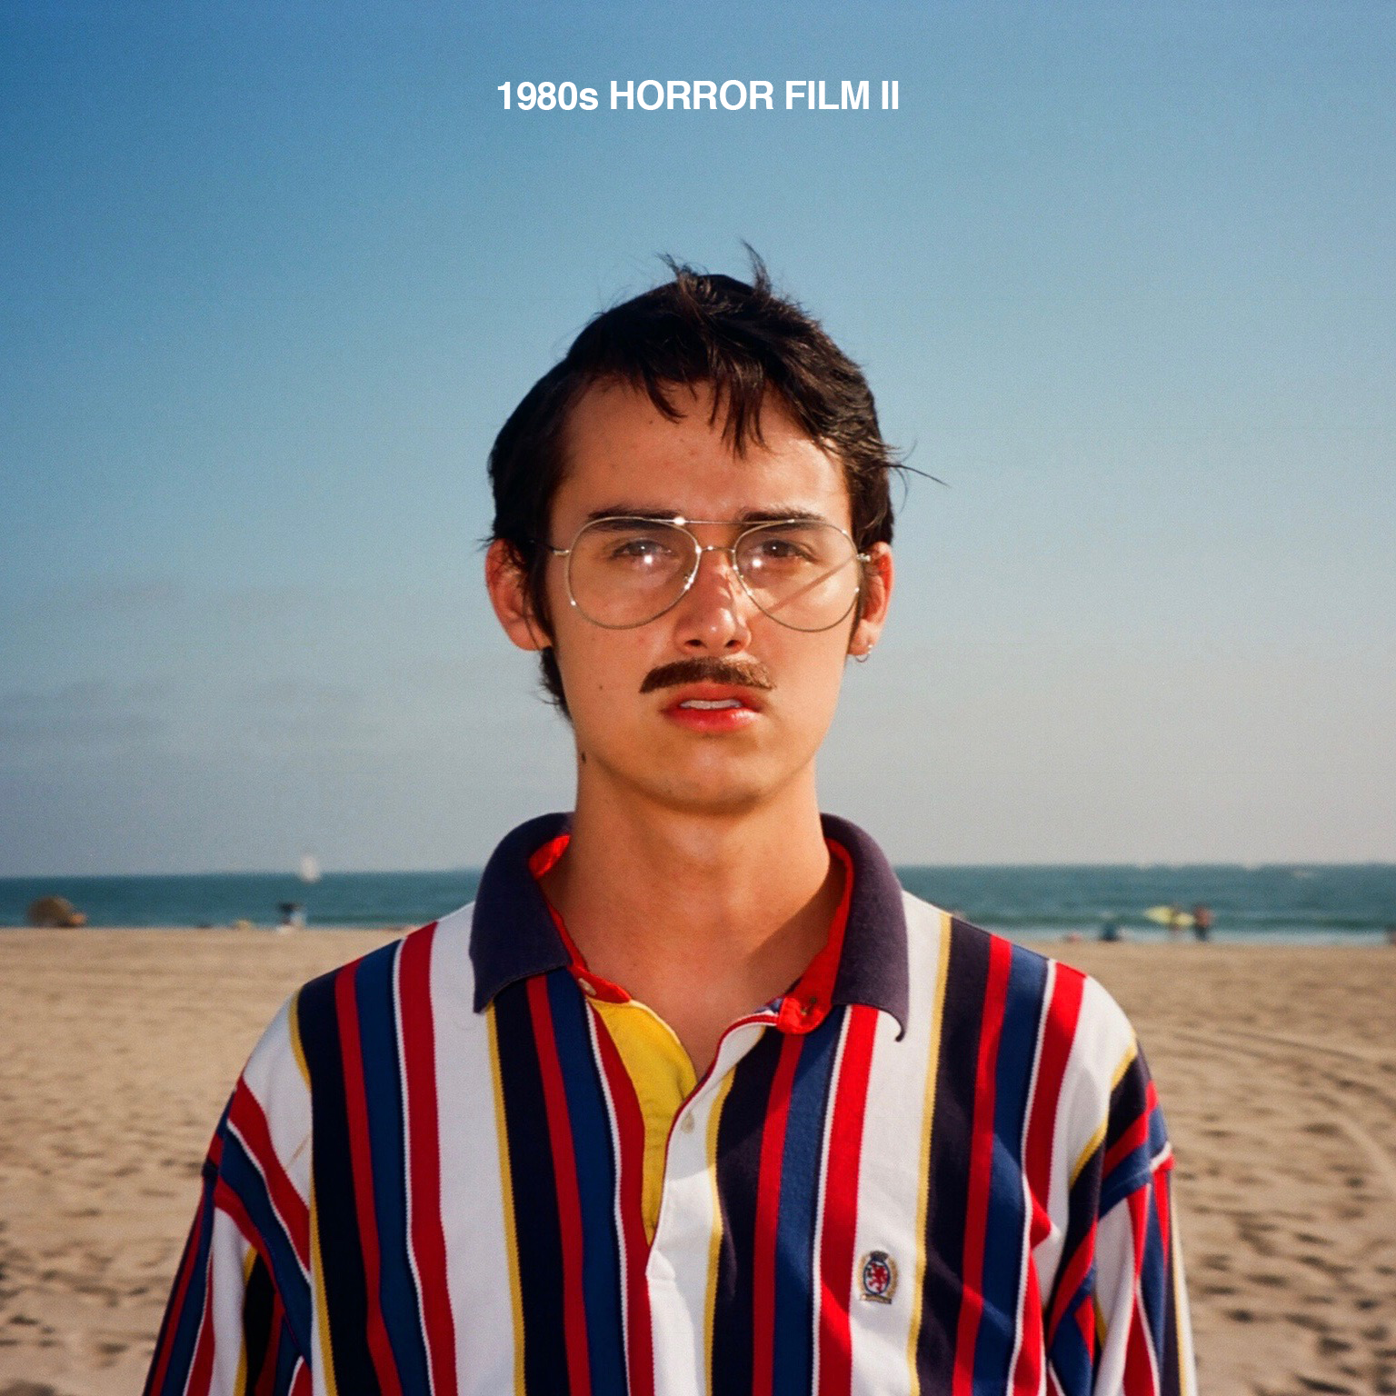

Atlantic recording group Wallows are celebrating spooky season by unveiling their new track “Drunk on Halloween.” The song, produced by Will van Boldrik, is available digitally worldwide today and is paired with a self-directed lyric video. The “morning-after ballad for last night’s Halloween party,” as Flood Magazine called it, mixes “soothing acoustic guitar against a grandiose horn section, all soundtracking a harmony of post-party maturity” while it harkens back to “late-period The Walkmen.” Today also sees the release of “1980s Horror Film II” – Wallows’ nostalgic 80s-inspired recording produced by Stefan Mac that can be heard in their recent Nina Ljeti-directed music video for the fan favorite Spring EP track of the same title.

LISTEN TO “DRUNK ON HALLOWEEN” / WATCH THE LYRIC VIDEO

LISTEN TO “1980s HORROR FILM II” / WATCH THE OFFICIAL MUSIC VIDEO

Wallows acclaimed debut EP, Spring, available now for streaming and download HERE. Produced by GRAMMY® Award-winner John Congleton (St. Vincent, Alvvays, Future Islands), the EP also includes such critically applauded tracks as “These Days” and “Pictures of Girls,” both of which are joined by remarkable companion visuals.

As if all that weren’t enough, Wallows are featured in the premiere episode of VANS Sidestripe Sessions. The two-song performance featuring “Pictures of Girls” and “Pleaser” that was filmed in a giant VANS shoe box is streaming now HERE.

Having spent much of the past year selling out shows from Los Angeles to London, Wallows –Braeden Lemasters, Cole Preston, and Dylan Minnette – are wrapping up 2018 with performances at Austin City Limits Music Festival (October 13th), Voodoo Music & Arts Experience (October 27th), and Camp Flog Gnaw (November 10th and 11th). Additional dates – including a North American headline tour – will be unveiled soon. For updates & tickets, please visit wallowsmusic.com.

FOR MORE ON WALLOWS, PLEASE VISIT:
WALLOWSMUSIC.COM I INSTAGRAM | FACEBOOK I TWITTER I YOUTUBE
ATLANTICRECORDS.COM

# # #

Press inquiries: Corey Brewer, corey.brewer@atlanticrecords.com

