WALLOWS RETURN
WITH DEBUT ALBUM NOTHING HAPPENS, AVAILABLE MARCH 22

PREMIERE NEW SINGLE & VIDEO
“ARE YOU BORED YET? (FEAT. CLAIRO)”

ANNOUNCE HEADLINING
NOTHING HAPPENS WORLD TOUR,
KICKING OFF WITH COACHELLA DEBUT

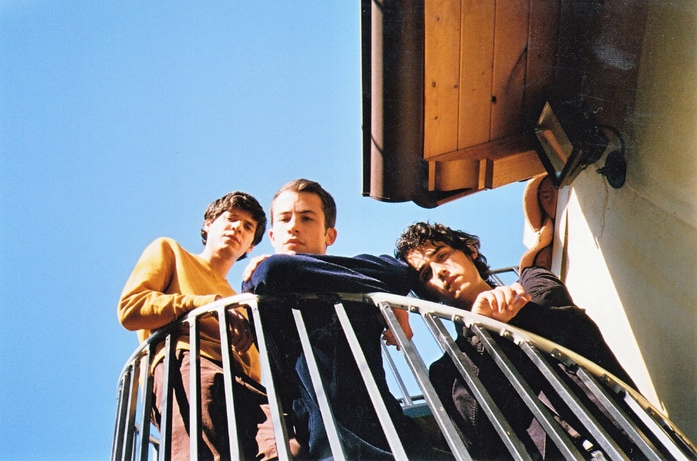
Photo Credit: Alexis Jade Gross

FOR IMMEDIATE RELEASE – February 1, 2019 – Southern California alt-rock trio Wallows quickly established themselves as a band to watch in 2018, and they are now poised for their biggest year yet with the release of their debut album Nothing Happens March 22nd on Atlantic Records. Recorded at Los Angeles’ Sargent Studios, the album sees Wallows reunited with Grammy award-winning producer John Congleton (St. Vincent, Alvvays, Future Islands) and captures the band’s journey towards adulthood through 11 intimate, introspective tracks (see track list below). Wallows offer a first glimpse into Nothing Happens with lead single and video “Are You Bored Yet? (feat. Clairo).” The trippy video, directed by Drew Kirsch (Louis The Child, John Legend, Quinn XCII), features Wallows in a retro karaoke bar surrounded by friends and familiar faces including special appearances by Noah Centineo (To All The Boys I’ve Loved Before, Sierra Burgess Is A Loser), Brian Jones (Vampire Weekend, Human Natural), and Nina Ljeti (1980s Horror Film II music video director), among others. Watch “Are You Bored Yet (feat. Clairo)” here: https://wallows.lnk.to/AreYouBoredYetVideo. The track is available instantly upon pre-ordering Nothing Happens here: https://Wallows.lnk.to/AreYouBoredYet.

Over the past year, Wallows released their debut EP Spring, amassed over 40 million career streams, sold out a headlining tour, played major festivals from Lollapalooza and Austin City Limits to Camp Flog Gnaw and Life is Beautiful, and made their TV debut on The Late Late Show with James Corden. Idolator named single “Pictures of Girls” one of their 100 Best Singles of 2018, declaring it “stood out like a sore thumb in 2018 for all the right reasons,” Stereogum called track “1980s Horror Film” an “openly melodic acoustic guitar ballad that gradually unfolds into a thing of beauty with some help from indie-world superproducer John Congleton,” and Ones To Watch raved “Wallows’ unrestrained brand of indie alt-rock arrives at the perfect intersection between admiration for the alternative ‘90s music scene and newfound heartfelt indie rock for a mixture that’s not quite like anything else.”

Wallows’ live shows are not to be missed; members Braeden Lemasters, Cole Preston, and Dylan Minnette have been playing music together for nearly a decade, and the connection is evident in their incredible, high-energy performances. Following album release, the band will launch their Nothing Happens World Tour with their Coachella debut on Saturday, April 13 and April 20. Wallows will make stops in major cities across the U.S. and Canada, including San Francisco, Dallas, New York, Toronto, and Chicago, before heading overseas for their first-ever European tour (see below for full list of dates). Tickets and limited VIP packages for North America will go on sale Friday, February 8th at 10am local time in all markets except Washington, DC, where tickets will go on sale Thursday, February 7th. VIP packages include early entry into the venue, an intimate acoustic performance, meet & greet, and photo with Wallows, along with an exclusive signed poster, Wallows disposable camera, commemorative VIP laminate, and first access to merchandise. Tickets and VIP packages will be available via wallowsmusic.com.

Fans who pre-order Nothing Happens or limited-edition Nothing Happens bundles through Wallows’ online store will have first access to tickets via a special pre-sale starting Monday, February 4th at 10am local time and running through Thursday, February 7th at 11:59pm local time. The bundle options include a clear vinyl LP, white cassette tape, and clothing ranging from a raglan shirt and corduroy fanny pack to a bucket hat. The full list of bundle options can be seen via https://wallows.lnk.to/NothingHappensD2CPR. Wallows have also teamed up with Urban Outfitters for an exclusive translucent orange vinyl LP, available for pre-order now and in stores on March 22.

Nothing Happens track list

1. Only Friend
2. Treacherous Doctor
3. Sidelines
4. Are You Bored Yet? (feat. Clairo)
5. Scrawny
6. Ice Cold Pool
7. Worlds Apart
8. What You Like
9. Remember When
10. I’m Full
11. Do Not Wait

Wallows Nothing Happens World Tour Dates

April 13 | Indio, CA | Coachella
April 20 | Indio, CA | Coachella
April 22 | Portland, OR | Wonder Ballroom*
April 23 | Vancouver, BC | Venue Nightclub*
April 24 | Seattle, WA | Neumos*
April 26 | San Francisco, CA | The Fillmore*
April 30 | Dallas, TX | House of Blues*
May 1 | Austin, TX | Scoot Inn*
May 2 | Houston, TX | Warehouse Live*
May 4 | Atlanta, GA | Shaky Knees Festival
May 6 | Philadelphia, PA | Union Transfer^
May 7 | Washington, D.C. | 9:30 Club^
May 8 | New York, NY | Irving Plaza^
May 10 | Boston, MA | Paradise Rock Club^
May 11 | Clifton Park, NY | Upstate Concert Hall^
May 12 | Toronto, ON | Danforth Music Hall^
May 14 | Detroit, MI | El Club^
May 15 | Chicago, IL | Metro^
May 16 | Minneapolis, MN | Fine Line Music Café^
May 18 | Boulder, CO | Fox Theatre^
May 19 | Santa Fe, NM | Meow Wolf^
May 20 | Phoenix, AZ | Crescent Ballroom^
June 2 | Amsterdam, Netherlands | Paradiso (Upstairs)
June 3 | Hamburg, Germany | Molotow Sky Bar
June 6 | London, UK | Electric Brixton
June 7 | Manchester, UK | Deaf Institute
June 8 | Glasgow, UK | Stereo
June 10 | Birmingham, UK | Hare and Hounds
June 11 | Leeds, UK | Brudenell Social Club
June 13 | Paris, France | Les Etolies
June 14 | Antwerp, Belgium | JC Bouckenborgh

* Mk.Gee Support
^Joy Again Support

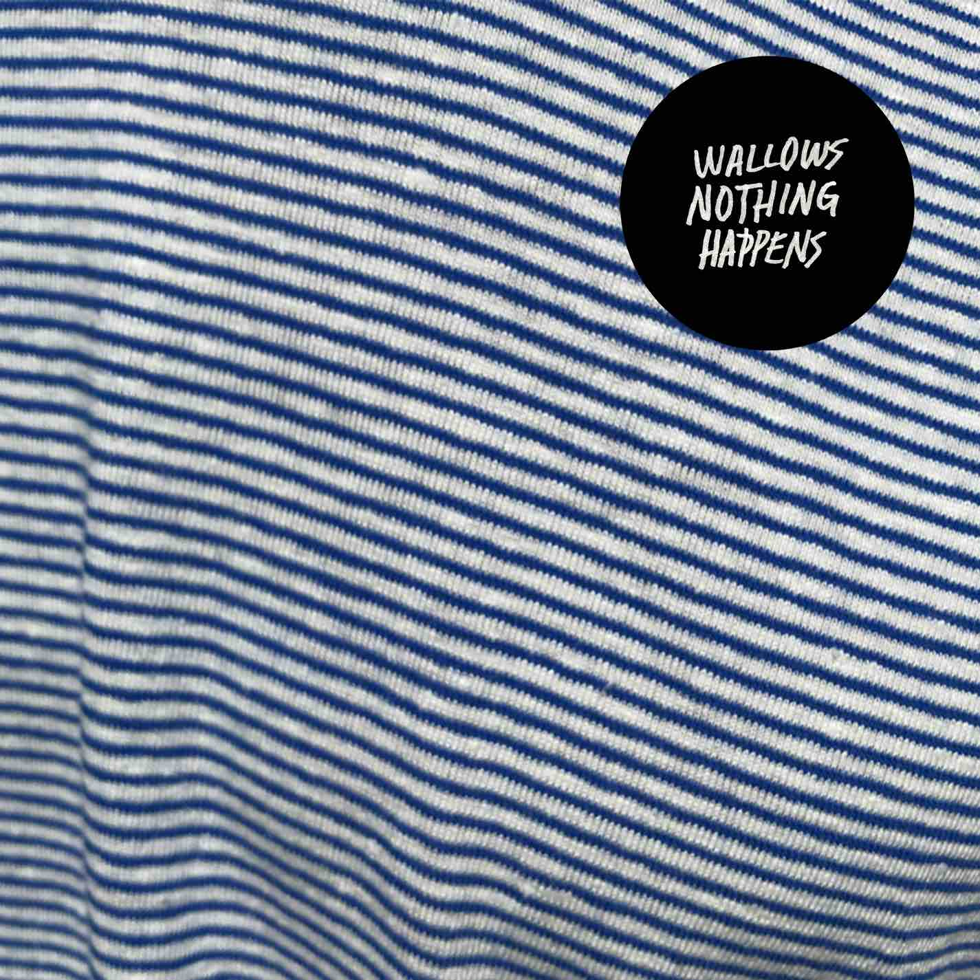

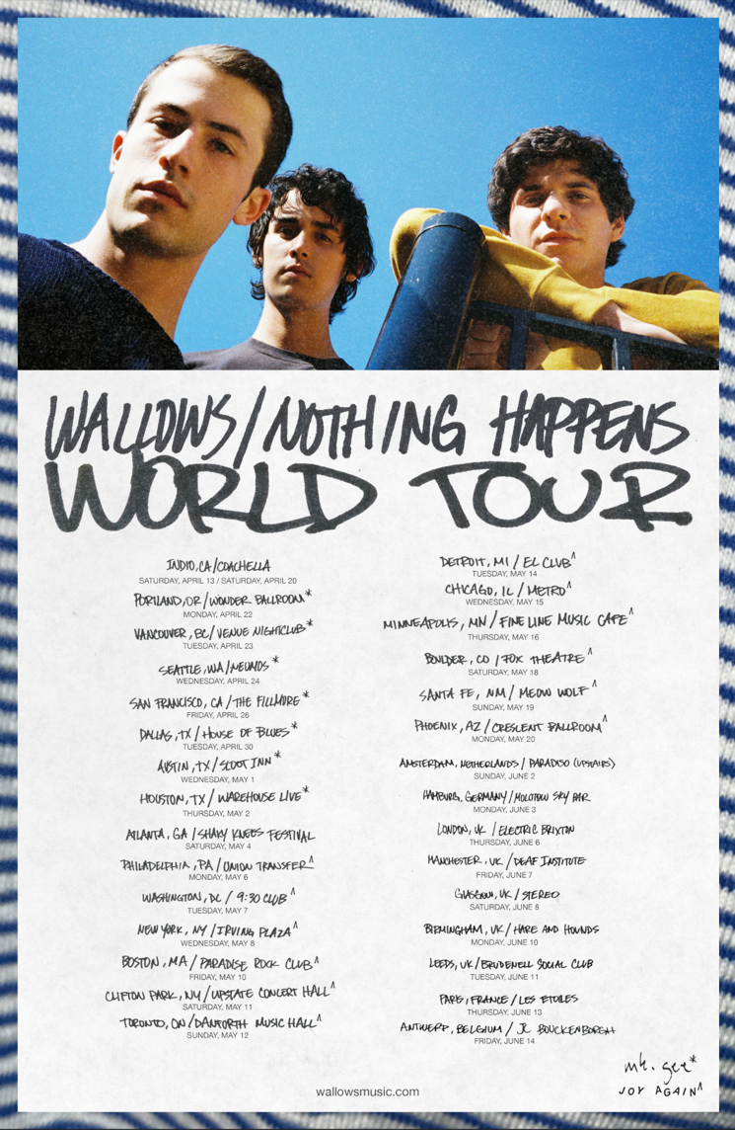
Follow Wallows:

Instagram | Twitter | Facebook
SoundCloud | YouTube | Spotify | Apple Music

Press site: http://press.atlanticrecords.com/wallows/

For more information about Wallows, contact:
Corey.brewer@atlanticrecords.com

BT PR at 646.405.7010:

Benny Tarantini

Benny@btpr.biz

Stefanie Nester

Stefanie@btpr.biz

