WALLOWS GIVE AN ACOUSTIC SPIN TO LATEST SINGLE “OK”
IN AN AT-HOME PERFORMANCE VIDEO

WATCH PERFORMANCE HERE: https://Wallows.lnk.to/OKAcousticVideoPR

FANS CAN ENTER TO WIN A VIDEO CALL WITH THE BAND HERE

“OK” OFFICIAL MUSIC VIDEO HAS OVER 2M VIEWS SINCE RELEASE LAST MONTH

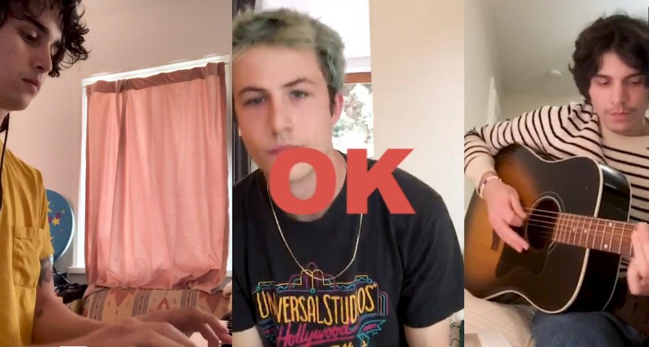
Wallows have released a special, stripped back acoustic performance video of their latest single “OK”, which was recorded at their homes while in quarantine. Watch HERE. “OK” was produced by John Hill (2x GRAMMY-nominee for Producer of the Year) with co-production from Sachi DiSerafino of Joy Again and GRAMMY-winner John DeBold, and is available digitally everywhere HERE. The single also received a charismatic official music video last month that has already amassed over 2M views. Watch HERE.
Wallows are currently running a contest where fans can win a video call with the band for them and a friend. Enter to win HERE.
On the song the band says, “’OK’ is a song about insecurities in a relationship; having a hard time accepting something that feels ‘too good to be true,’ but overall learning to embrace it and accept the love you’re receiving and focusing on returning it. Now, given the state of the world and the health crisis we happen to be in at the time of the song’s release, we feel like the main line/hook of the song, ‘Can we get up and try to feel okay again?,’ sort of takes on a new meaning/purpose. The thought that no matter where we are or how alone and lost we feel right now, we can get up again and try to feel OK. We’re in it together.”
The band is also celebrating an RIAA Gold certification for their smash single “Are You Bored Yet? (feat. Clairo)” (taken from their debut album Nothing Happens) received last month.
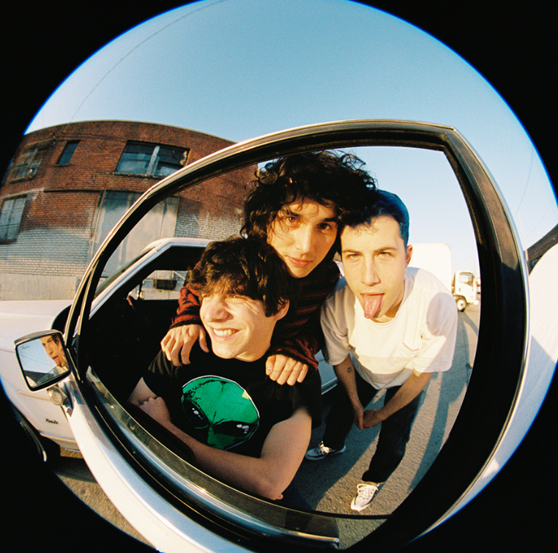
Download press photo HERE; Credit: Anthony Pham

FOR MORE ON WALLOWS, PLEASE VISIT:
WALLOWSMUSIC.COM I FACEBOOK I TWITTER I YOUTUBE I INSTAGRAM | PRESS SITE
Press contact: corey.brewer@atlanticrecords.com
Tour press contact: gabrielle.reese@atlanticrecords.com

