WALLOWS’ “OK” GETS A JUBILENT SPIN FROM
REMI WOLF AND SOLOMONOPHONIC

LISTEN HERE: https://wallows.lnk.to/OKRemix

WALLOWS QUARANTINE-MADE EP ‘REMOTE’ OUT NOW

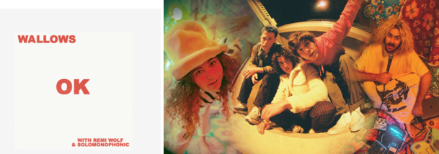
(DL artwork here)
(DL press photos here)

Wallows released heartening single “OK” at the start of quarantine, and today the song gets a euphonic refresh from the magnificent Remi Wolf and Solomonophonic to power us through the remaining dreary days inside. The single is also a musical reunion for Remi and Wallows, as Remi previously co-wrote “These Days” with the band for their Spring EP and lived in a house with Cole Preston while they both attended USC. Listen to “OK (with Remi Wolf & Solomonophonic)” HERE.

Following the original version of “OK” in March, Wallows released their quarantine-made EP ‘Remote’ in October, celebrating with a performance on Jimmy Kimmel Live! (watch here) All songs on ‘Remote’ were produced by Sachi DiSerafino, John DeBold, and Wallows, except for “Nobody Gets Me (Like You)” which was produced by Ariel Rechtshaid (Vampire Weekend, Haim, Adele).

Comprised of Dylan Minnette, Braeden Lemasters and Cole Preston, the members of Wallows have been best friends since the age of 11. Their acclaimed Atlantic Records debut album, Nothing Happens, was produced by GRAMMY® Award-winner John Congleton (St. Vincent, Alvvays, Future Islands) and includes the hit singles, “Are You Bored Yet? (Feat. Clairo)” and “Scrawny.” AYBY is certified Platinum in the US and Mexico, Gold in Australia and has now surpassed 430M global streams. “Are You Bored Yet?” was also named one of Spotify’s predictions for Songs of the Summer 2020 and hit #2 on the Alternative radio chart. On the live front, Wallows 2019 Nothing Happens headline tour sold out and upgraded numerous venues globally. The band also opened for Vampire Weekend in California in 2018 and London in 2019 and have performed at several large festivals including Coachella, Lollapalooza, Austin City Limits and more. Wallows were set for a 2020 headline tour, including performances at Lollapalooza Brazil, Chile & Argentina.

Streaked in neon, 24-year-old California musician Remi Wolf’s songs are anchored by powerhouse vocals, psychedelic pop instrumentals, and lurid lo-fi imagery. With her debut EP You’re A Dog! and its major label follow-up EP, I’m Allergic To Dogs!, earning rave reviews from the likes of Pitchfork, NPR, TIME, The Guardian, The Los Angeles Times, and more, all eyes are on Remi Wolf as she has quickly cemented herself as an unpredictable, genre-bending star in the making.

Jared Solomon p/k/a Solomonophonic is the production genius behind up-and coming LA based artist Remi Wolf. He’s produced and co-written just about all of Remi’s releases, as well as playing guitar in her touring band. Their new music has already landed high profile syncs from the likes of Samsung and Apple. His most recent cuts include Fousheé’s newest single “Single AF” on RCA and two songs on
JAWNY’s new EP For Abby with Interscope. Jared also started his own artist project as Solomonophonic in fall of 2020.

FOR MORE ON WALLOWS, PLEASE VISIT:
WALLOWSMUSIC.COM I FACEBOOK I TWITTER I YOUTUBE I INSTAGRAM | TIK TOK | PRESS SITE
FOR MORE ON REMI WOLF, PLEASE VISIT:
REMIWOLF.COM | FACEBOOK | TWITTER | INSTAGRAM
FOR MORE ON SOLOMONOPHONIC, PLEASE VISIT:
FACEBOOK | TWITTER | INSTAGRAM

Wallows Press contacts: corey.brewer@atlanticrecords.com
gabrielle.reese@atlanticrecords.com

