WALLOWS GO ON A 90’S DREAM ROADTRIP
IN THEIR VIDEO FOR TIMELY NEW SINGLE “OK”

WATCH HERE: https://wallows.lnk.to/OKVideo

FOLLOWING ACCLAIMED DEBUT ALBUM, NOTHING HAPPENS, AVAILABLE NOW

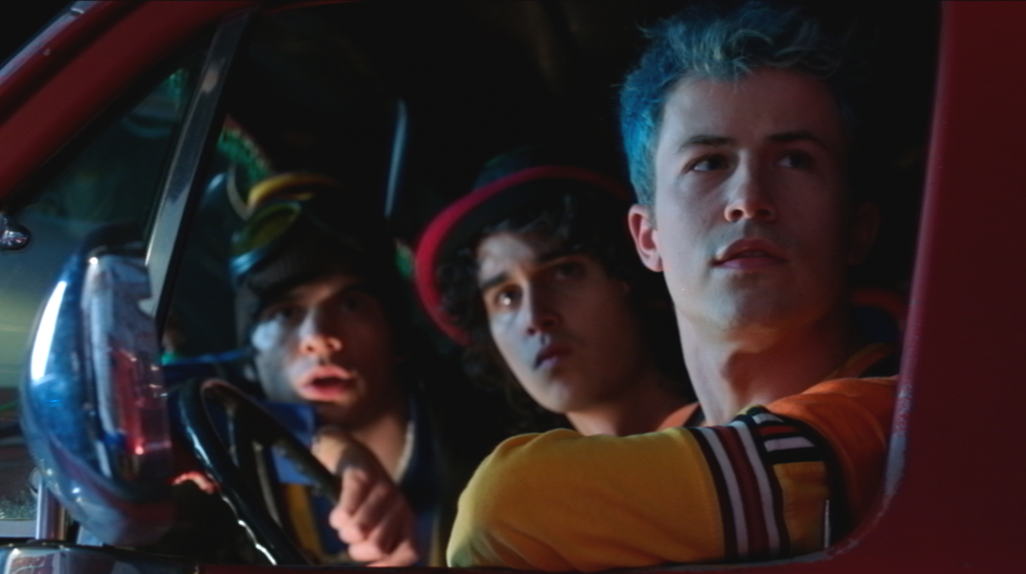

“Dylan Minnette, Braeden Lemasters and Cole Preston lean into pop a little heavier this time around, but they blur the lines enough to keep it interesting. The heavily-distorted bridge, in particular,
is wonderfully odd.” -IDOLATOR

“Wallows are delivering indie-rock dreams in their new single…” -ALT PRESS

“Now, Wallows are back and better than ever in what might be
our favorite track from them yet.” -EUPHORIA

“…a heartening bop that will likely hit home for you,
no matter where you are in the world.” -ONES TO WATCH
Atlantic indie rock band Wallows are back with a 90s-nostalgia tinged official video for new single “OK”, their first release of 2020. Watch the charismatic video, featuring the band and directed by Dillon Dowdell, HERE. The song, produced by John Hill (2x GRAMMY-nominee for Producer of the Year) with co-production from Sachi DiSerafino of Joy Again and GRAMMY-winner John DeBold, is available digitally everywhere HERE.
Wallows says, “’OK’ is a song about insecurities in a relationship; having a hard time accepting something that feels ‘too good to be true,’ but overall learning to embrace it and accept the love you’re receiving and focusing on returning it. Now, given the state of the world and the health crisis we happen to be in at the time of the song’s release, we feel like the main line/hook of the song, ‘Can we get up and try to feel okay again?,’ sort of takes on a new meaning/purpose. The thought that no matter where we are or how alone and lost we feel right now, we can get up again and try to feel OK. We’re in it together.”
A bit more adventurous, the next musical phase of Wallows “sounds different but right,” says the band. It’s a natural evolution of who they’ve grown to be since recording their acclaimed debut album Nothing Happens in 2018, and an exploration of bringing more pop into their sound. They’re eager to introduce fresh material to their fans, record more music and take creative risks. Keep an eye on Wallows for more to come this year.
Comprised of Dylan Minnette, Braeden Lemasters and Cole Preston, the members of Wallows have been best friends since the age of 11. Their acclaimed Atlantic Records debut album, Nothing Happens, is available for streaming and download HERE. Produced by GRAMMY® Award-winner John Congleton (St. Vincent, Alvvays, Future Islands), the album includes the hit singles, “Are You Bored Yet? (Feat. Clairo)” and “Scrawny,” both joined by official companion videos streaming now via YouTube. Wallows have been on the road for their Nothing Happens headline tour where they sold out and upgraded numerous venues globally. The band also opened for Vampire Weekend in California and London and have performed at several large festivals including Coachella, Lollapalooza, Austin City Limits and more. Stay tuned for more updates on Wallows tour schedule for 2020 soon.

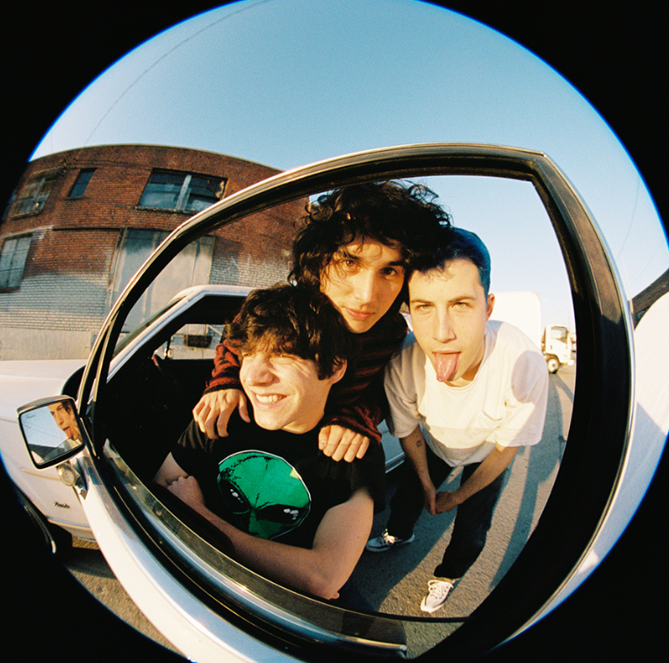
Download press photo HERE; Credit: Anthony Pham

FOR MORE ON WALLOWS, PLEASE VISIT:
WALLOWSMUSIC.COM I FACEBOOK I TWITTER I YOUTUBE I INSTAGRAM | PRESS SITE
Press contact: corey.brewer@atlanticrecords.com
Tour press contact: gabrielle.reese@atlanticrecords.com

