WALLOWS ANNOUNCE ‘REMOTE’ EP OUT OCTOBER 23
PRE-ORDER/PRE-SAVE HERE

RELEASE NEW SINGLE “NOBODY GETS ME (LIKE YOU)” + OFFICIAL MUSIC VIDEO – WATCH HERE

WALLOWS NAMED MTV’S PUSH ARTIST OF THE MONTH FOR SEPTEMBER – WATCH EXCLUSIVE “ARE YOU BORED YET?” PERFORMANCE & MORE HERE

2 SHOWS REMAINING ON VIRTUAL WORLD TOUR- PURCHASE TICKETS & WATCH VIA NO CAP
AT WALLOWS.NOCAPSHOWS.COM

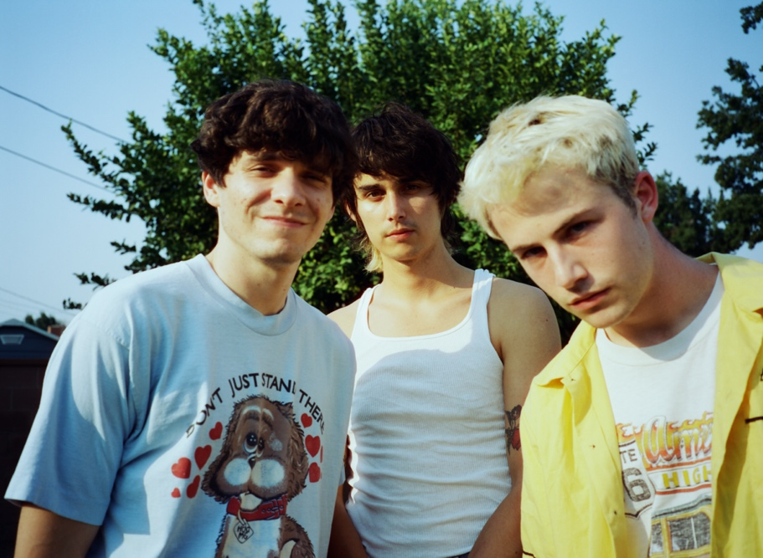
(DL photo here, Photo Credit: Nikoli Partiyeli)

Following the success of their debut album, Nothing Happens, and summer smash “Are You Bored Yet? (feat. Clairo)”, Wallows announce their new quarantine-made EP titled Remote (out October 23), as well as release the first EP single “Nobody Gets Me (Like You)” with an accompanying music video. All songs on Remote were produced by Sachi DiSerafino, John DeBold, and Wallows, except for “Nobody Gets Me (Like You)” which was produced by Ariel Rechtshaid (Vampire Weekend, Haim, Adele). Remote is available to pre-save and pre-order now here (see track list below). Head to wallowsmusic.store to pick up the vinyl version which is pressed on pink vinyl and features the ‘Remote’ logo etched on the b-side, as well new t-shirts, CD, and more.

Collaborating with director Dillon Dowdell for the third time, the music video for “Nobody Gets Me (Like You)” continues the story from Wallows’ single “OK” that was released in April. Watch the video for “Nobody Gets Me (Like You)” HERE.
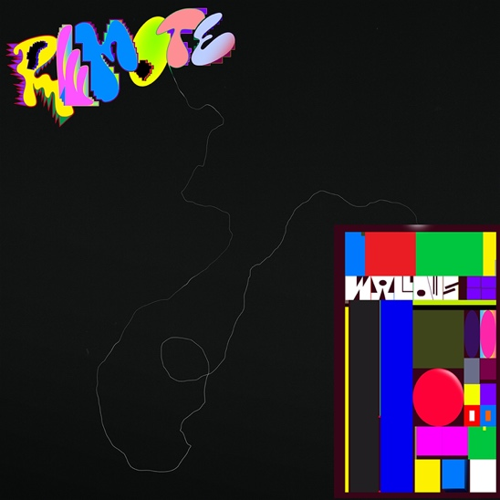
(DL Remote cover art here - designed by Nejc Prah)

REMOTE Track List:
1. Virtual Aerobics
2. Dig What You Dug
3. Nobody Gets Me (Like You)
4. Coastlines
5. Talk Like That
6. Wish Me Luck

“Are You Bored Yet? (feat. Clairo),” taken from Wallows debut album Nothing Happens, has been certified Gold in the US and Australia and has now surpassed 286M global streams. “Are You Bored Yet?” was also named one of Spotify’s predictions for Songs of the Summer 2020 and currently sits in the Top 10 on the Alternative radio chart. Last Friday, MTV revealed Wallows as their September 2020 Push Artist of the Month and kicked off the campaign with a new exclusive live performance video of “Are You Bored Yet?” which can be seen HERE.

The band has 2 shows remaining on their virtual world tour filmed live at The Roxy. The tour features unique performances that have been pre-recorded (while following COVID-19 health and safety guidelines) at LA’s famed The Roxy Theatre – also the location of Wallows’ first ever headline show in 2017. Streaming via NoCap, tickets for the remaining shows are on sale now HERE. Every show is available to watch worldwide and will be archived and available to re-watch until October 4th at 11:59pm PT with the purchase of a ticket. See below for the remaining dates, times and show details. Wallows also shared a behind the scenes tour doc showing the making of the virtual tour – available to watch HERE.
Wallows Live at The Roxy – Virtual World Tour (Air Dates & Show Info):
SUNDAY, SEPTEMBER 13 @ 7pm BST/8pm CEST (11am PT) – ‘UK & Europe Show’ – Wallows have picked their own set list for this show
SUNDAY, SEPTEMBER 27 @ 6pm JST/7pm AEST (2am PT) – ‘AUS, NZ & Asia Show’ – ?????? Tune in to find out what Wallows play for their final set live at The Roxy
FOR MORE ON WALLOWS, PLEASE VISIT:
WALLOWSMUSIC.COM I FACEBOOK I TWITTER I YOUTUBE I INSTAGRAM | TIK TOK | PRESS SITE

Press contacts: corey.brewer@atlanticrecords.com
gabrielle.reese@atlanticrecords.com

