**WALLOWS RELEASE “TRUST FALL” AND “JUST LIKE A MOVIE”**

**BOTH TRACKS PREVIOUSLY AVAILABLE ONLY AS RECORD STORE DAY 2019 7” EXCLUSIVE**

**“TRUST FALL” JOINED BY NEW LYRIC VIDEO STREAMING** [**HERE**](https://www.youtube.com/watch?v=liZ2Wz6r9rg&feature=youtu.be)

**EPIC LIVE ITINERARY INCLUDES SOLD OUT U.S. HEADLINE SHOWS,**

**FESTIVAL APPEARANCE, AND EUROPEAN DATES SUPPORTING VAMPIRE WEEKEND**

**DEBUT LP,** [**NOTHING HAPPENS**](https://nam04.safelinks.protection.outlook.com/?url=https%3A%2F%2Fwallows.lnk.to%2FNothingHappens&data=02%7C01%7CGabrielle.Reese%40atlanticrecords.com%7Cbf79e6a04063499ac81508d73194e826%7C8367939002ec4ba1ad3d69da3fdd637e%7C0%7C0%7C637032387937056659&sdata=4J%2FVmy51QMfnivcooIQAXr4QodOvnYE%2BG314qEchnX8%3D&reserved=0)**, AVAILABLE NOW**

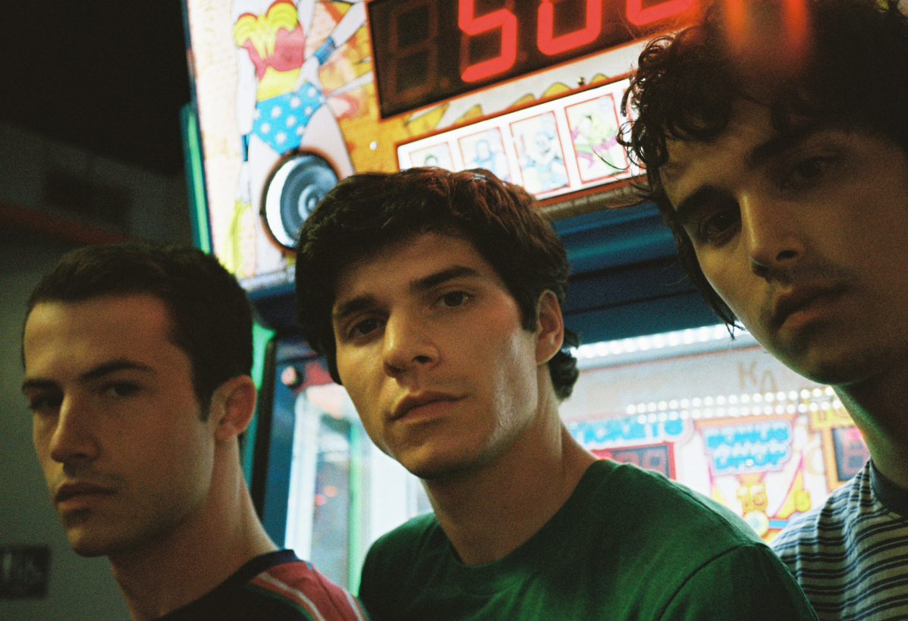

(Photo credit Alexis Jade Gross, [DL here](http://press.atlanticrecords.com/wp-content/uploads/2019/03/Wallows-5-2019-credit-Alexis-Jade-Gross.jpg))

Atlantic recording group **Wallows** has announced today’s wide release of two extraordinary tracks. Previously available exclusively as an official **Record Store Day 2019** physical 7”, “**Trust Fall**” and “**Just Like A Movie**” are now available digitally worldwide - listen [HERE](https://Wallows.lnk.to/TF_JLAM). “**Trust Fall**” is joined by a brand-new lyric video, created by Landon Fleischman, Nikoli Partiyeli and Wallows. Watch the lyric video [HERE](https://www.youtube.com/watch?v=liZ2Wz6r9rg&feature=youtu.be).

On the singles the band said, *“Trust Fall and Just Like A Movie are two songs that we recorded during the sessions for Nothing Happens. When we were coming up with the track list for the album, we felt like these songs fit together in their own unique way and started to think of them as a pair that could exist on their own as singles.”*

“Trust Fall” and “Just Like A Movie” arrive just as Wallows hit the road once more, continuing their Nothing Happens headline World Tour in Charlottesville, Columbus, Cleveland, Indianapolis, Kansas City, and Tulsa (playing Nashville on Wednesday night). Next up, the band will cross the Atlantic for a variety of dates including a trio of massive shows supporting Vampire Weekend in London & Paris, along with their own headline show in Cologne. For tickets and more information, please visit [https://wallowsmusic.com](https://nam04.safelinks.protection.outlook.com/?url=https%3A%2F%2Fwallowsmusic.com%2F&data=02%7C01%7CGabrielle.Reese%40atlanticrecords.com%7Cbf79e6a04063499ac81508d73194e826%7C8367939002ec4ba1ad3d69da3fdd637e%7C0%7C0%7C637032387937056659&sdata=7iExCrwym3t3AbG9Es6jaEGGgmjhs0JMYW9KiHjPHiA%3D&reserved=0).

Wallows’ acclaimed Atlantic Records debut album, [NOTHING HAPPENS](https://nam04.safelinks.protection.outlook.com/?url=https%3A%2F%2Fwallows.lnk.to%2FNothingHappens&data=02%7C01%7CGabrielle.Reese%40atlanticrecords.com%7Cbf79e6a04063499ac81508d73194e826%7C8367939002ec4ba1ad3d69da3fdd637e%7C0%7C0%7C637032387937066657&sdata=X3ufSYEoPD8kyAK%2BRSczSiWKUkJarY1JNmNCAm9glnA%3D&reserved=0), is available now for streaming and download [HERE](https://nam04.safelinks.protection.outlook.com/?url=https%3A%2F%2Fwallows.lnk.to%2FNothingHappens&data=02%7C01%7CGabrielle.Reese%40atlanticrecords.com%7Cbf79e6a04063499ac81508d73194e826%7C8367939002ec4ba1ad3d69da3fdd637e%7C0%7C0%7C637032387937066657&sdata=X3ufSYEoPD8kyAK%2BRSczSiWKUkJarY1JNmNCAm9glnA%3D&reserved=0). Produced by GRAMMY® Award-winner John Congleton (St. Vincent, Alvvays, Future Islands), the album includes the recent hit singles, “[Are You Bored Yet? (Feat. Clairo)](https://nam04.safelinks.protection.outlook.com/?url=https%3A%2F%2Fwallows.lnk.to%2FAreYouBoredYet&data=02%7C01%7CGabrielle.Reese%40atlanticrecords.com%7Cbf79e6a04063499ac81508d73194e826%7C8367939002ec4ba1ad3d69da3fdd637e%7C0%7C0%7C637032387937076651&sdata=7VPu2Y%2Be%2FgNGDFV6f6nFShiqZ1bVvO3rgSWIYZeONg8%3D&reserved=0)” and “[Scrawny](https://nam04.safelinks.protection.outlook.com/?url=https%3A%2F%2Fwallows.lnk.to%2FScrawny&data=02%7C01%7CGabrielle.Reese%40atlanticrecords.com%7Cbf79e6a04063499ac81508d73194e826%7C8367939002ec4ba1ad3d69da3fdd637e%7C0%7C0%7C637032387937076651&sdata=7l%2B1uycGjaeqcBWe3ND6KCwsun%2BwiNpiEAiQ9fwxBsw%3D&reserved=0),” both joined by official companion videos streaming now via [YouTube](https://nam04.safelinks.protection.outlook.com/?url=https%3A%2F%2Fwww.youtube.com%2Fwallowsmusic&data=02%7C01%7CGabrielle.Reese%40atlanticrecords.com%7Cbf79e6a04063499ac81508d73194e826%7C8367939002ec4ba1ad3d69da3fdd637e%7C0%7C0%7C637032387937086645&sdata=4CwG%2BJnv5T7KNxAisjlUz0xZajyRiRSqdgtMcKiV8LE%3D&reserved=0).

Having spent much of the past two years selling out shows from Los Angeles to London, Wallows – Braeden Lemasters, Cole Preston, and Dylan Minnette – had a remarkably busy Summer 2019, with a live itinerary spanning sold out European headline dates and festival sets including Detroit, MI’s Mo Pop Festival and San Francisco’s Outside Lands. A mini-documentary chronicling the tour can be viewed now via YouTube [HERE](https://nam04.safelinks.protection.outlook.com/?url=https%3A%2F%2Fwww.youtube.com%2Fwatch%3Fv%3DlMeZW_9HzmA&data=02%7C01%7CGabrielle.Reese%40atlanticrecords.com%7Cbf79e6a04063499ac81508d73194e826%7C8367939002ec4ba1ad3d69da3fdd637e%7C0%7C0%7C637032387937086645&sdata=bTvyD67f%2BpNZFxCqO0nc%2B2dcysT6Dbl6NajDHIWoI%2Bw%3D&reserved=0).

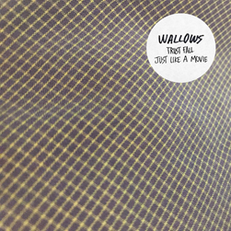

**WALLOWS**

**ON TOUR 2019**

**SEPTEMBER**

6             Charlottesville, VA            Jefferson Theater ^ (SOLD OUT)

7             Columbus, OH                   Newport Music Hall ^ (SOLD OUT)

8             Cleveland, OH                    House of Blues ^

9              Indianapolis, IN                 Deluxe at Old National Centre ^ (SOLD OUT)

11           Kansas City, MO                Madrid Theatre ^

12           Tulsa, OK                             Cain’s Ballroom ^

**NOVEMBER**

10           Pico Rivera, CA                   Tropicalia Festival *

13           London, UK                         Alexandra Palace † (SOLD OUT)

14           London, UK                         Alexandra Palace †

15           Cologne, DE                        Die Kantine

16           Paris, FR                               Zenith †

* Festival Appearance

^ Remo Drive to Support

† supporting Vampire Weekend

FOR MORE ON WALLOWS, PLEASE VISIT:

[WALLOWSMUSIC.COM](https://nam04.safelinks.protection.outlook.com/?url=https%3A%2F%2Fprotect-us.mimecast.com%2Fs%2FkL6lCG6Q8DhKmR6JFkr8--&data=02%7C01%7CGabrielle.Reese%40atlanticrecords.com%7Cbf79e6a04063499ac81508d73194e826%7C8367939002ec4ba1ad3d69da3fdd637e%7C0%7C0%7C637032387937086645&sdata=gp4zrYdL%2FW%2B6n6Ywr8rPJ%2BW86Io4%2Bs9FJ1hr0LjHMIQ%3D&reserved=0) I [FACEBOOK](https://nam04.safelinks.protection.outlook.com/?url=https%3A%2F%2Fprotect-us.mimecast.com%2Fs%2FBwlnCNk50NcDA8zNU8U4l5&data=02%7C01%7CGabrielle.Reese%40atlanticrecords.com%7Cbf79e6a04063499ac81508d73194e826%7C8367939002ec4ba1ad3d69da3fdd637e%7C0%7C0%7C637032387937096642&sdata=rEYxXmSVKNOGEbTXT0Swv8A2NnKZyPyOn4xieBjVjBI%3D&reserved=0) I [TWITTER](https://nam04.safelinks.protection.outlook.com/?url=https%3A%2F%2Fprotect-us.mimecast.com%2Fs%2FENNPCOY58OczJjMAsYJ-H4&data=02%7C01%7CGabrielle.Reese%40atlanticrecords.com%7Cbf79e6a04063499ac81508d73194e826%7C8367939002ec4ba1ad3d69da3fdd637e%7C0%7C0%7C637032387937096642&sdata=YvJB5Ve5S0EfZKohX6kZYNQTRTGpX%2BzwxbgBIyVn5cY%3D&reserved=0) I [YOUTUBE](https://nam04.safelinks.protection.outlook.com/?url=https%3A%2F%2Fprotect-us.mimecast.com%2Fs%2FxII3CL95JLIyAr7PhKmyVC&data=02%7C01%7CGabrielle.Reese%40atlanticrecords.com%7Cbf79e6a04063499ac81508d73194e826%7C8367939002ec4ba1ad3d69da3fdd637e%7C0%7C0%7C637032387937106629&sdata=xdglQiUCVUhBlfjjNwuZQzdlTRKvIBxJyy4XXQyxhFY%3D&reserved=0) I [INSTAGRAM](https://nam04.safelinks.protection.outlook.com/?url=https%3A%2F%2Fprotect-us.mimecast.com%2Fs%2FPvKiCPN5QPs8ORP4FRuzxX&data=02%7C01%7CGabrielle.Reese%40atlanticrecords.com%7Cbf79e6a04063499ac81508d73194e826%7C8367939002ec4ba1ad3d69da3fdd637e%7C0%7C0%7C637032387937106629&sdata=IoAAwz5rvA2lqV9rua2sJBICkZn9mHUw4GBZ%2Fod5aoY%3D&reserved=0) | [PRESS SITE](https://nam04.safelinks.protection.outlook.com/?url=https%3A%2F%2Fprotect-us.mimecast.com%2Fs%2FrI3MCQW57QHM8pY6hnxNbe&data=02%7C01%7CGabrielle.Reese%40atlanticrecords.com%7Cbf79e6a04063499ac81508d73194e826%7C8367939002ec4ba1ad3d69da3fdd637e%7C0%7C0%7C637032387937116627&sdata=tLqW5auwoTs0xlg%2F8UyDTVkZ8BENNXUUrEIMNAyo2js%3D&reserved=0)

Press contact: [corey.brewer@atlanticrecords.com](mailto:corey.brewer@atlanticrecords.com)