FOR IMMEDIATE RELEASE
JULY 27, 2018

WALLOWS RELEASE “UNDERNEATH THE STREETLIGHTS IN THE WINTER OUTSIDE YOUR HOUSE” – NEW SONG & VIDEO OUT NOW

BAND PERFORMING AT LOLLAPALOOZA ON SATURDAY, AUGUST 4TH

DEBUT EP ‘SPRING’ AVAILABLE NOW

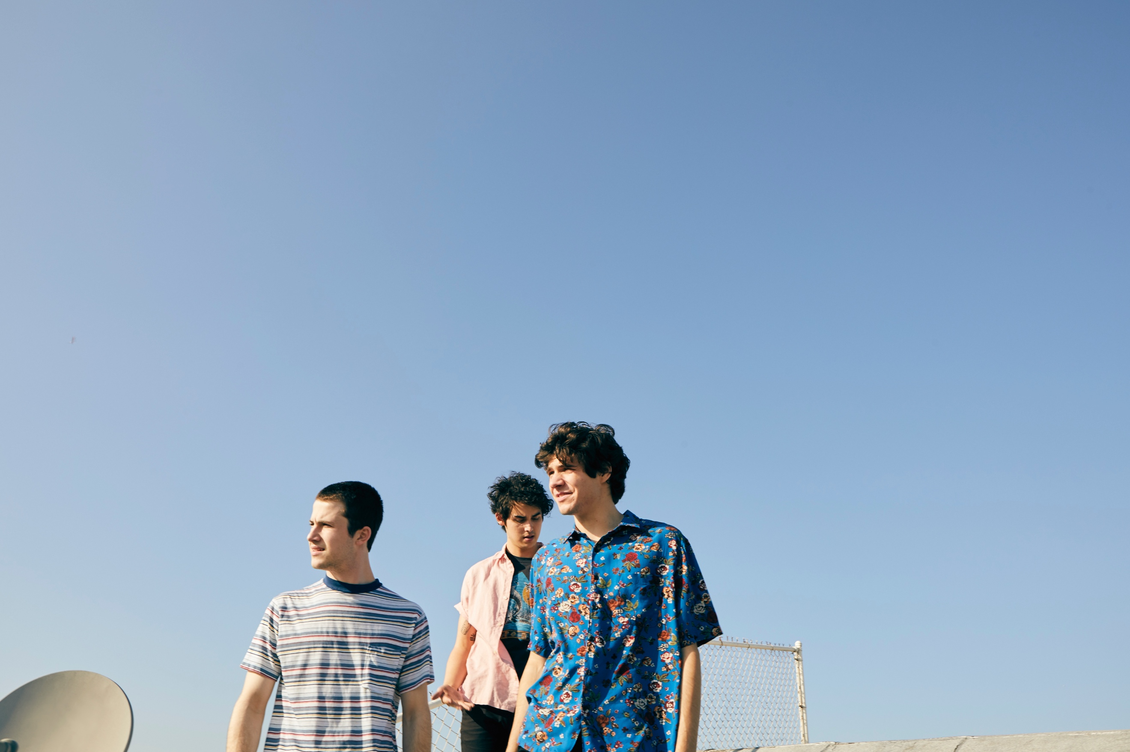
Photo by Jimmy Fontaine

Indie rock trio Wallows have released a new song ahead of their Lollapalooza debut next Saturday, August 4th. “Underneath the Streetlights in the Winter Outside Your House” follows the release of the bands’ EP ‘Spring’ – both of which were produced by GRAMMY-winning producer John Congleton. A new DIY lyric video directed and shot by the band on an iPhone7, just as they did for their “Pleaser” video, accompanies the surprise punk rock song release. Watch the video for “Underneath the Streetlights in the Winter Outside Your House” HERE.

Wallows released their debut EP, ‘Spring’, in April via Atlantic Records. The John Congleton-produced EP has received early praise from PAPER, saying “Wallows is here to restore alt-rock to its former glory…(The band’s) West Coast-infused sound is the sonic equivalent of driving down the Pacific Coast highway in a drop top at sunset. Mutually melancholy and enthusiastic, Wallows has the versatility to satiate soppy souls and raise heart rates — all in all, a welcome anecdote to the times.” The EP features “Pictures of Girls,” which recently earned Wallows their first charted radio single with a debut at #36 on the Mediabase Alternative chart and at #40 on Billboard’s Alternative Songs chart. The band also made their late-night TV debut on The Late Late Show with James Corden in May – watch their performance of “Pictures of Girls” HERE.

Having spent much of the past year selling out headline shows across North America and London, as well as recently opening for Vampire Weekend at a pair of intimate shows in Santa Ana, CA, Wallows will be make stops this Summer & Fall at Chicago, IL’s Lollapalooza (August 4th), Las Vegas, NV’s Life Is Beautiful (September 21st), Austin, TX’s Austin City Limits Music Festival (October 12th – 14th), and New Orleans, LA’s Voodoo Music & Arts Experience (October 26th – 28th). For updates, tickets, and more information, please visit wallowsmusic.com.

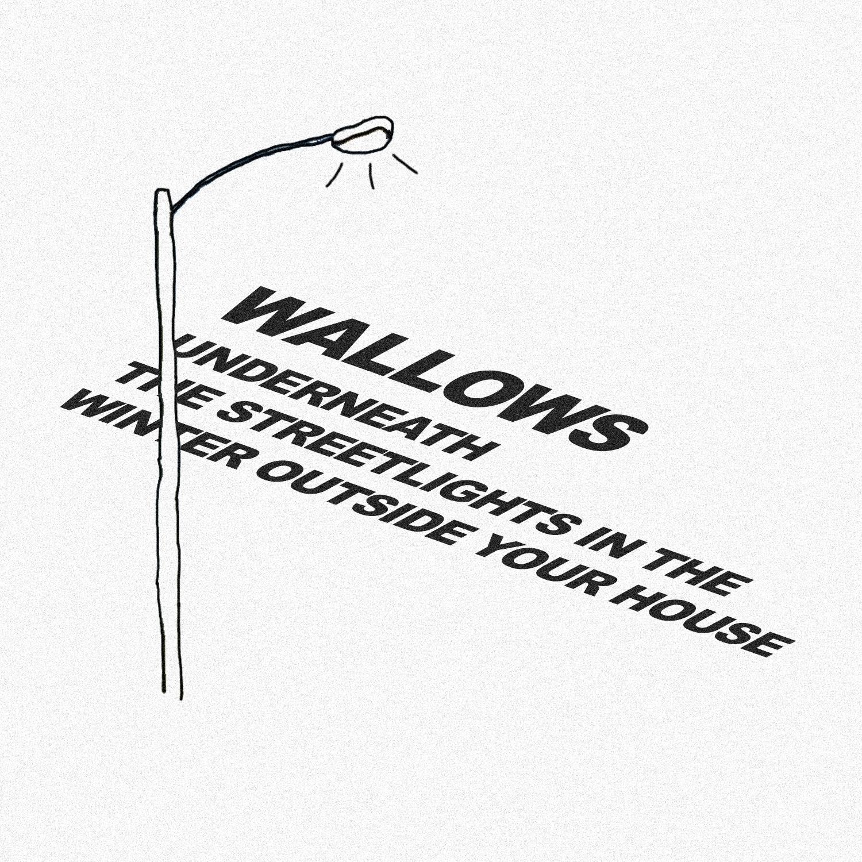
“Underneath the Streetlights in the Winter Outside Your House” Cover Artwork. Designed by Wallows.

FOR MORE ON WALLOWS, PLEASE VISIT:
WALLOWSMUSIC.COM I FACEBOOK I TWITTER I YOUTUBE I ATLANTICRECORDS.COM

# # #

Press inquiries: Corey Brewer – Corey.Brewer@atlanticrecords.com

