**WALLOWS GO ON AN EPIC SPACE JOURNEY**

**IN VIDEO FOR “WISH ME LUCK”**

**WATCH HERE:** [**https://youtu.be/TN2J7ezPGT0**](https://youtu.be/TN2J7ezPGT0)

**TAKEN FROM THEIR QUARANTINE-MADE EP ‘**[**REMOTE**](https://Wallows.lnk.to/RemotePR)**,’ OUT NOW**

**VIDEO COMPLETES THE 3 PART MUSIC VIDEO SERIES-**

**WATCH “**[**OK**](https://www.youtube.com/watch?v=NSNcGYkp8v8)**” (PART I) & “**[**NOBODY GETS ME (LIKE YOU**](https://www.youtube.com/watch?v=nwA3y36pe7w&ab_channel=Wallows)**)” (PART II)**

**RIAA-CERTIFIED PLATINUM SINGLE “**[**ARE YOU BORED YET? (FEAT. CLAIRO**](https://www.youtube.com/watch?v=wIgmyE5Juzw)**)” IS #4 AT ALT RADIO**

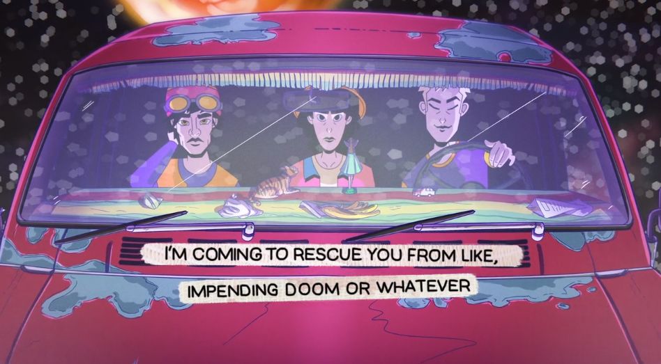

([DL press photos here](https://press.atlanticrecords.com/wallows/))

Following last week’s release of their quarantine-made EP ‘[**Remote**](https://wallows.lnk.to/RemotePR)**,’ Wallows**have released the official music video for EP single “Wish Me Luck” today, directed by Dillon Dowdell. The animated video sees Wallows on an epic space journey, completing the ‘Curly Fry Trilogy’ storyline that began with their “[OK](https://www.youtube.com/watch?v=NSNcGYkp8v8)” official music video and was followed by their “[Nobody Gets Me (Like You)”](https://www.youtube.com/watch?v=nwA3y36pe7w&ab_channel=Wallows) video. Watch the “Wish Me Luck” video [HERE.](https://youtu.be/TN2J7ezPGT0)

All songs on ‘Remote’ were produced by **Sachi DiSerafino, John DeBold**, and Wallows, except for “Nobody Gets Me (Like You)” which was produced by **Ariel Rechtshaid** (Vampire Weekend, Haim, Adele). Listen to ‘Remote’[HERE](https://wallows.lnk.to/RemotePR) and check out ‘Remote’ merchandise, including the pink vinyl which features a B-side Remote logo etching, [HERE](https://wallowsmusic.store/).

Wallows says, *‘Remote’ is a special project for us. We finished it all without seeing each other in person by sending each other voice memos and spending hours chatting on FaceTime. Though the lyrics don’t reflect on or reference our time staying at home, the music wouldn’t have turned out the way it did if not for quarantine. Big love to our producers and friends Sachi DiSerafino and John DeBold for working around the clock with us. We hope you enjoy it as much as we do.”*

The band has been celebrating the release of ‘Remote’ with a bunch of activities, and still to come are a Reddit AMA on Thursday (10/29), and a [TikTok Altrocktober](https://newsroom.tiktok.com/en-us/tiktoks-altrocktober-kicks-off-on-a-high-note) session and performance for Rolling Stone’s [Fridays For Unity](https://www.rollingstone.com/music/music-news/selena-gomez-jeff-tweedy-rolling-stone-fridays-for-unity-1075457/) event series this Friday (10/30). For more information on how to join in, please check Wallows’ social media channels (@wallowsmusic).

(DL ‘Remote’ cover art [here](https://press.atlanticrecords.com/wallows/) - designed by [Nejc Prah](https://nejcprah.com/about))

**‘Remote’Track List:**

1. Virtual Aerobics

2. Dig What You Dug

3. Nobody Gets Me (Like You)

4. Coastlines

5. Talk Like That

6. Wish Me Luck

With Election Day only 6 days away, Wallows are asking fans “Are You Registered Yet?” On October 30th, the band will be airing a performance of “OK” as part of Rolling Stone’s Fridays For Unity, a nationwide virtual music and conversation event series featuring some of the United States’ greatest entertainers and influential politicians. The event encourages voter engagement and will be broadcast on the [Rolling Stone YouTube page](https://www.youtube.com/channel/UC-JblcinswY50lrUdSaRNEg) at 8pm EST. The band also recently partnered with [HeadCount](https://nam04.safelinks.protection.outlook.com/?url=https%3A%2F%2Fwww.headcount.org%2F&data=02%7C01%7CGabrielle.Reese%40atlanticrecords.com%7Cede163908fa04f14fbdf08d7c08403a6%7C8367939002ec4ba1ad3d69da3fdd637e%7C0%7C0%7C637189545885089637&sdata=uTfKQ306bwo29SWDgtepKGcMihEzVH32g%2F0HZCblRQU%3D&reserved=0), a non-partisan organization that promotes participation in democracy through music, culture, and digital media, for National Voter Registration Day. For one day only, the band gave away a download of “Bad Remake” – the last never-before-heard track from *the Nothing Happens* album sessions – if you checked your voter status, registered or pledged to vote. However, you can still get ready to vote [HERE](https://smarturl.it/WallowsVote).

“[Are You Bored Yet? (feat. Clairo)](https://www.youtube.com/watch?v=wIgmyE5Juzw),” taken from Wallows debut album *Nothing Happens*, has been certified **Platinum** in the US and Mexico, Gold in Australia and has now surpassed 345M global streams. “Are You Bored Yet?” was also named one of Spotify’s predictions for [Songs of the Summer 2020](https://nam04.safelinks.protection.outlook.com/?url=https%3A%2F%2Fvariety.com%2F2020%2Fmusic%2Fnews%2Fsongs-of-summer-predictions-spotify-beyonce-stallion-baby-1234645468%2F&data=02%7C01%7CGabrielle.Reese%40atlanticrecords.com%7C5dc7b3c454804d0ae26c08d847e6eea8%7C8367939002ec4ba1ad3d69da3fdd637e%7C0%7C0%7C637338404482516694&sdata=Yx0U0WLmI7QDzJ9GVVzHlU%2BmhyZHpWXDiN9egGy5kQw%3D&reserved=0) and has hit the top 5 on the Alternative radio chart. Featured as MTV’s Push Artist of the Month for September, an exclusive performance of “Are You Bored Yet?” is available to watch [HERE](http://www.mtv.com/video-playlists/yz976h/push-discover-mtv-push-artist-wallows/5dwv6v), along with a performance of ‘Remote’ EP single “Nobody Gets Me (Like You)” + more. The band was also recently nominated “Best Push” at the MTV EMA’s- you can vote [HERE.](https://www.mtvema.com/vote/bestpush/)

**FOR MORE ON WALLOWS, PLEASE VISIT:**

[WALLOWSMUSIC.COM](https://nam04.safelinks.protection.outlook.com/?url=https%3A%2F%2Fwallowsmusic.com%2F&data=02%7C01%7CGabrielle.Reese%40atlanticrecords.com%7Ce6a5a257147d4159ca6b08d821ef52cf%7C8367939002ec4ba1ad3d69da3fdd637e%7C0%7C0%7C637296659049334396&sdata=wt28n9Is9PxQZ8jz%2F5ruXEnyeDIUR5kia8jU4imOMgU%3D&reserved=0) I [FACEBOOK](https://nam04.safelinks.protection.outlook.com/?url=https%3A%2F%2Fwww.facebook.com%2Fwallowsmusic%2F&data=02%7C01%7CGabrielle.Reese%40atlanticrecords.com%7Ce6a5a257147d4159ca6b08d821ef52cf%7C8367939002ec4ba1ad3d69da3fdd637e%7C0%7C0%7C637296659049344385&sdata=vjSE%2FAotHme7zrsAkvwn3QR2Giu5U%2FIIfmoqV8G3qvQ%3D&reserved=0) I [TWITTER](https://nam04.safelinks.protection.outlook.com/?url=https%3A%2F%2Ftwitter.com%2Fwallowsmusic&data=02%7C01%7CGabrielle.Reese%40atlanticrecords.com%7Ce6a5a257147d4159ca6b08d821ef52cf%7C8367939002ec4ba1ad3d69da3fdd637e%7C0%7C0%7C637296659049344385&sdata=pbCjWIMSEsnfSXCyEcrxH8nEecO%2BtvHEl%2F2P4BXUIYk%3D&reserved=0) I [YOUTUBE](https://nam04.safelinks.protection.outlook.com/?url=https%3A%2F%2Fwww.youtube.com%2Fwallowsmusic&data=02%7C01%7CGabrielle.Reese%40atlanticrecords.com%7Ce6a5a257147d4159ca6b08d821ef52cf%7C8367939002ec4ba1ad3d69da3fdd637e%7C0%7C0%7C637296659049354389&sdata=aYRFq4K8NbqGry8zQ5tqNB0uuwIlreI9P86IADPGio4%3D&reserved=0) I [INSTAGRAM](https://nam04.safelinks.protection.outlook.com/?url=https%3A%2F%2Fwww.instagram.com%2Fwallowsmusic%2F&data=02%7C01%7CGabrielle.Reese%40atlanticrecords.com%7Ce6a5a257147d4159ca6b08d821ef52cf%7C8367939002ec4ba1ad3d69da3fdd637e%7C0%7C0%7C637296659049354389&sdata=x3bryZj0jZZ4E4EN3YMdu7jjsiZ0RDFM%2BNzuN4njVXI%3D&reserved=0) | [TIK TOK](https://www.tiktok.com/@wallows) | [PRESS SITE](https://nam04.safelinks.protection.outlook.com/?url=http%3A%2F%2Fpress.atlanticrecords.com%2Fwallows%2F&data=02%7C01%7CGabrielle.Reese%40atlanticrecords.com%7Ce6a5a257147d4159ca6b08d821ef52cf%7C8367939002ec4ba1ad3d69da3fdd637e%7C0%7C0%7C637296659049364377&sdata=FnfLgT14ocKNJ8v%2B0exQnVr%2B7zDaMnigsAT4EHZ9V10%3D&reserved=0)

Press contacts: [corey.brewer@atlanticrecords.com](mailto:corey.brewer@atlanticrecords.com)

[gabrielle.reese@atlanticrecords.com](mailto:gabrielle.reese@atlanticrecords.com)