FOR IMMEDIATE RELEASE
JUNE 28, 2019

WHY DON’T WE DROPS NEW TRACK “COME TO BRAZIL”

SMASH SINGLE “8 LETTERS” CERTIFIED GOLD
+ PERFORMANCE SET FOR AUSTRALIA’S 2019 LOGIE AWARDS

BREAKOUT POP GROUP SET TO RETURN FOR TODAY SHOW
CITI CONCERT SERIES IN ROCKEFELLER PLAZA ON LABOR DAY

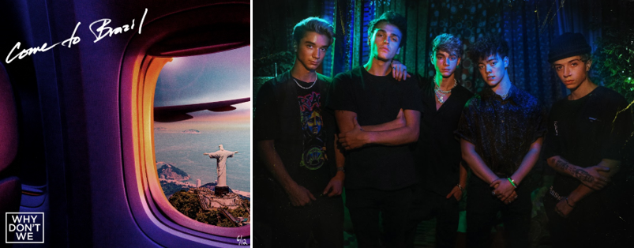
DOWNLOAD HIGH-RES IMAGES

STREAM “COME TO BRAZIL”: https://wdw.lnk.to/ComeToBrazilPR

“One of pop music’s biggest breakout stories” – NBC’s TODAY
“Artist To Watch” – ROLLING STONE
“the next generation’s all-American boy band” – PAPER
“The Next Boy Band Taking Over The World” – NYLON

Atlantic recording artists Why Don’t We have released their sixth new track of 2019, “Come To Brazil” – available now via all DSPs. Written/produced in collaboration with JKash (Charlie Puth, Maroon 5) and The Futuristics (G-Eazy, Selena Gomez), the release marks the band’s most hands-on studio cut thus far with all five members sharing writing credit on the summer-ready smash.

“’Come To Brazil’ is the ultimate Why Don’t We summer song” said the band. “We had a big part in the writing and production on this one – we feel it’s true to our more urban side and pushes some boundaries. It’s our favorite song we’ve made so far and we hope you all can vibe with it!”

“Come To Brazil” arrives amidst an exciting month for Why Don’t We, highlighted by the RIAA-Gold certification of last year’s explosive Top 20 single “8 Letters” – which alone accounts for 185 million of the band’s over 1 billion global audio and video streams. The group was also just announced as performers at Australia’s prestigious 2019 Logie Awards, airing this weekend.

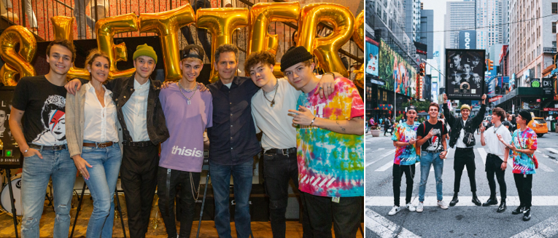
From left: Jonah Marais, Julie Greenwald (Chairman & COO, Atlantic Records), Daniel Seavey, Corbyn Besson, Craig Kallman (Chairman & CEO, Atlantic Records), Zach Herron, Jack Avery  DOWNLOAD HIGH-RES IMAGE | From left: Corbyn Besson, Jonah Marais, Daniel Seavey, Zach Herron, Jack Avery  DOWNLOAD HIGH-RES IMAGE  (credit: Zack Caspary)
Known for their prolific and creative output, “Come To Brazil” continues a steady flow of new releases from Why Don’t We – also including collaborative single “I Don’t Belong In This Club” with Macklemore, “Unbelievable,” “Big Plans,” “Cold In LA,” and their soundtrack contribution to STXFilm’s UglyDolls, “Don’t Change.”

Why Don’t We is gearing up for the second leg of their biggest headline run to date, the 8 Letters Tour, resuming July 18th in Costa Mesa, CA. The tour’s wildly successful and completely sold out first leg included stops in Los Angeles, Boston, Chicago, and New York City – where the band sold out the legendary Radio City Music Hall in just two hours. The group was also recently announced as part of the 2019 TODAY Show Citi Concert Series line-up, returning once again to Rockefeller Plaza on Labor Day (Sept. 2nd) following last year’s performance which garnered one of the largest crowds of the summer. For ticketing details, tour updates, and more, please visit www.whydontwemusic.com.

***

Amassing more than 1 billion global audio streams, 4 million Instagram followers, and total You Tube views exceeding 450 million with over 2.8 million subscribers in under 3 years, Why Don’t We has become one of pop music’s biggest breakout stories. Taking an innovative and unconventional approach towards releasing new music and actively engaging their rapidly growing fanbase, the prolific young group – the quintet ranges in age from 18-21 years old – put out their first five EPs in under 12 months. The group closed 2017 on a high note, performing on the entire iHeartRadio Jingle Ball Tour, including the New York City stop at Madison Square Garden where they shared the stage with Taylor Swift, Ed Sheeran and more. Their 2018 inaugural full length album, 8 Letters, debuted in the top 10 on the Billboard 200 at #9 and immediately shot to #1 on US iTunes’ Overall Albums chart (along with topping charts in over 20 more territories around the globe) – while the title track is RIAA-certified Gold, hit Top 20 at Pop radio and boasts over 185 million global audio and video streams to date. The band has sold out back-to-back North American headlining tours, and is currently on the road for their most extensive 8 Letters Tour (which included a stop at New York City’s Radio City Music Hall which sold out in under two hours). High profile national television appearances include performances on NBC’s TODAY Show (including back-to-back summer concerts in Rockefeller Plaza), ABC’s Good Morning America, nationally syndicated Live with Kelly and Ryan, CBS’s The Late Late Show with James Corden, ABC's Jimmy Kimmel Live! and more. Press highlights include features in Rolling Stone, Entertainment Weekly, Billboard, PAPER and TIME among others. WHY DON’T WE is: Daniel Seavey, Zach Herron, Corbyn Besson, Jonah Marais, and Jack Avery

***

WHY DON’T WE
8 LETTERS NORTH AMERICAN TOUR

July 18 – Costa Mesa, CA – OC Fair
July 19 – San Diego, CA – Cal Coast Credit Union Open Air Theatre
July 20 – Las Vegas, NV – PARK Theater
July 22 – Paso Robles, CA – California Mid-State Fair
July 25 – Kansas City, MO – Starlight Amphitheatre
July 26 – Rogers, AR – Walmart AMP
July 27 – St. Louis, MO – Fabulous Fox Theatre
July 28 – Nashville, TN – Ascend Amphitheater
July 30 – Louisville, KY – The Louisville Palace
August 1 – Boca Raton, FL – Mizner Park Amphitheatre
August 2 – Jacksonville, FL – Daily’s Place Amphitheater
August 3 – Raleigh, NC – The Red Hat Amphitheater
August 5 – Baltimore, MD – Pavilion
August 6 – Albany, NY – Palace Theatre
August 8 – Gilford, NH – Bank of New Hampshire Pavilion
August 9 – Uncasville, CT – Mohegan Sun Arena
August 10 – Philadelphia, PA – The Met
August 11 – Moon Township, PA – UPMC Events Center
August 13 – Springfield, IL – Illinois State Fair
August 14 – Lincoln, NE – Pinnacle Bank Arena
August 18 – Park City, KS – Hartman Arena
August 20 – Charleston, SC – Volvo Car Stadium
August 21 – Pelham, AL – Oak Mountain Amphitheatre
August 25 – Cincinnati, OH – PNC Pavilion at Riverbend
August 26 – Grand Rapids, MI – Devos Performance Hall
August 28 – Cleveland, OH – Jacobs Pavilion
August 29 – Syracuse, NY – New York State Fair
August 31 – Allentown, PA – The Great Allentown Fair

CONNECT:
WHYDONTWEMUSIC.COM | TWITTER | INSTAGRAM | FACEBOOK | YOUTUBE | ASSETS

CONTACT:
Glenn Fukushima | glenn.fukushima@atlanticrecords.com
Ted Sullivan | ted.sullivan@atlanticrecords.com

