WHY DON’T WE ANNOUNCE EXCLUSIVE LAUNCH PARTY ON ROBLOX, IN PARTNERSHIP WITH ATLANTIC RECORDS

The multi-talented band will perform four songs including three from their recently released sophomore album ‘The Good Times and the Bad Ones’ exclusively on the Roblox platform

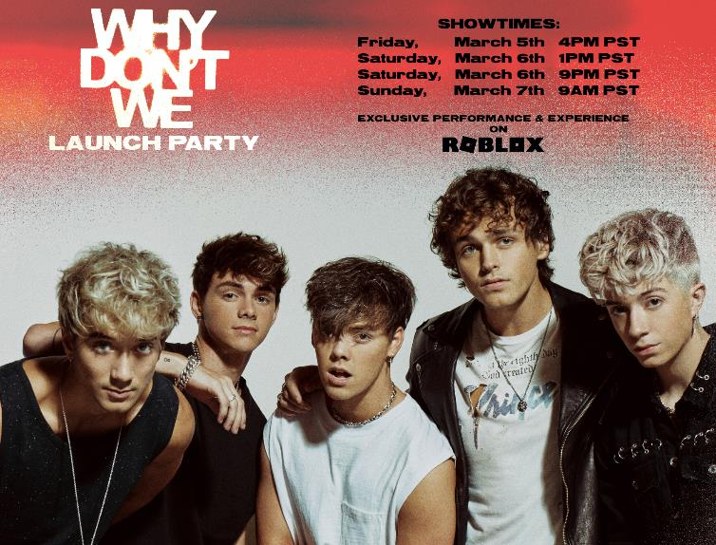

Watch the Why Don’t We Launch Party Trailer

SAN MATEO, Calif. - March 4, 2021 - Roblox, a global online platform bringing millions of people together through play, and multi-talented Signature Entertainment/Atlantic Records recording artist, Why Don’t We, announced today the band’s first Launch Party on the Roblox platform to celebrate their recently released sophomore album, ‘The Good Times and the Bad Ones’. The Launch Party on Roblox will take place on Friday, March 5th at 4 pm PST. Three additional performances are scheduled throughout the weekend to give the global Roblox community an opportunity to enjoy this exclusive show.

Why Don’t We released ‘The Good Times and the Bad Ones’ earlier this year and earned their highest debut on the Billboard 200 at #3 and their first #1 album on the album sales chart. The album features smash single “Fallin’ (Adrenaline),” which has amassed over 142 million global streams and over 26 million video views since release. The single exploded onto the Top 40 radio chart, debuting at #35 before quickly ascending to #21 and earning the band their first career Billboard Hot 100 entry at #37. The band also preceded the album release with videos for standout tracks “Lotus Inn” and “Slow Down” (the latter of which samples The Smashing Pumpkins classic “1979”).

Created by Atlantic Records in partnership with Roblox developer, Melon Dev, The Why Don’t We Launch Party brings the band into the Metaverse. Fans will get to enjoy an exclusive live performance of the band’s most popular songs, shop limited edition virtual band merchandise, including digital avatars for each band member, play mini games, and complete fun quests prior to the first performance. In addition, the band will host a Q&A after their performance and answer questions from the community.

“Having spent so many hours on Roblox, it’s awesome that we get to connect with our fans in this community we know so well,” said Zach Herron of Why Don’t We. “While we’ve missed being on tour and interacting with our fans all over the world, being able to connect in this way is bringing fandom to a whole new level. Literally anyone can join the party, no matter where they are, so we’re excited to see everyone this weekend on Roblox.”

Roblox has become a go-to destination for music artists to connect with their fans and for the community to access artists. The Why Don’t We Launch Party is the second event of its kind that the Roblox platform has hosted following the award-winning Ava Max Launch Party last Fall, which was also developed in partnership with Atlantic Records.

“Ultimately our goal is to champion the artists, and Roblox helps us do that by giving them an opportunity to connect with fans and promote their music in new ways,” said Paul Sinclair, General Manager & EVP, Atlantic Records. “Why Don’t We are crazy talented, and we want to get their music heard by as many fans as possible. With their huge online/social media presence and Roblox’s popularity among their key audience, this partnership is a no-brainer.”

“At its roots music is a form of communication, a way to connect people, and something artists have missed this past year due to the pandemic,” said Jon Vlassopulos, Vice President and Global Head of Music for Roblox. “We are focused on creating these types of immersive, rich experiences in the Roblox Metaverse and are excited to bring the Roblox community the chance to connect with Why Don’t We and enjoy this exclusive show together with friends.”

Attending the Why Don’t We Music Launch Party
Full Launch Party details and information on how to sign up for a free Roblox account to enter the Why Don’t We Launch Party can be found here. Roblox users can attend any of the four showtimes throughout the weekend. Watch the Why Don’t We Launch Party Trailer here.

SHOWTIMES
Friday, March 5, 2021 @ 4:00 pm PST
Saturday, March 6, 2021 @ 1:00 pm PST
Saturday, March 6, 2021 @ 9:00 pm PST
Sunday, March 7, 2021 @ 9:00 am PST

About Why Don’t We
Why Don’t We is Daniel Seavey, Corbyn Besson, Jonah Marais, Jack Avery, and Zach Herron. Since their debut in 2016, Why Don’t We has amassed over 3.5 billion global career streams, over 750 million YouTube views, 5 million Instagram followers, two RIAA Platinum-certified singles, four RIAA Gold-certified singles, two Top 20 singles at Pop radio, and a Top 10 Billboard 200 debut album. Taking an innovative and unconventional approach towards releasing new music and actively engaging their rapidly growing fanbase, the band put out their first five EPs within their first year together and followed shortly after with their inaugural full-length 8 Letters album in 2018. Soon after, 2019 saw the release of new singles monthly, including standouts “Big Plans,” “I Don’t Belong In This Club” featuring Macklemore, & the Ed Sheeran-penned/Steve Mac-produced hit “What Am I.”

The band has sold out back-to-back North American and global headline tours, in addition to performing on historic stages such as Radio City Music Hall (selling out the venue in under two hours) and Madison Square Garden (as part of the iHeartRadio Jingle Ball Tour). Furthermore, Why Don’t We took home the award for “Choice Music Group” at the 2019 Teen Choice Awards, received a nomination for “Best Group” at the 2019 MTV Video Music Awards, and has made high profile national television appearances on NBC’s TODAY Show (including back-to-back summer concerts in Rockefeller Plaza), ABC’s Good Morning America, nationally syndicated Live with Kelly and Ryan, The Ellen DeGeneres Show, CBS’s The Late Late Show with James Corden, ABC's Jimmy Kimmel Live!, and more.

About Roblox
Roblox’s mission is to build a human co-experience platform that enables shared experiences among billions of users. Every day, more than 32.6 million people around the world have fun with friends as they explore millions of immersive digital experiences. All of these experiences are built by the Roblox community, made up of over eight million creators. We believe in building a safe, civil, and diverse community—one that inspires and fosters creativity and positive relationships between people around the world. For more information, please visit corp.roblox.com.

About Warner Music Group
With a legacy extending back over 200 years, Warner Music Group (WMG) today brings together artists, songwriters, and entrepreneurs that are moving entertainment culture across the globe. Operating in more than 70 countries through a network of affiliates and licensees, WMG’s Recorded Music division includes renowned labels such as Asylum, Atlantic, Big Beat, Canvasback, Elektra, Erato, First Night, Fueled by Ramen, Nonesuch, Parlophone, Reprise, Rhino, Roadrunner, Sire, Spinnin’, Warner Records, Warner Classics, and Warner Music Nashville. WMG’s music publishing arm, Warner Chappell Music, has a catalog of over one million copyrights spanning every musical genre, from the standards of the Great American Songbook to the biggest hits of the 21st century. Warner Music Group is also home to ADA, the independent artist and label services company, as well as consumer brands such as Songkick, the live music app; EMP, the merchandise e-tailer; and UPROXX, the youth culture destination. Follow Warner Music Group on Instagram, Twitter, Facebook, and LinkedIn.

FOR MORE INFORMATION CONTACT:

Why Don’t We
SHEILA RICHMAN (ATLANTIC RECORDS)
SHEILA.RICHMAN@ATLANTICRECORDS.COM
TED SULLIVAN (ATLANTIC RECORDS)
TED.SULLIVAN@ATLANTICRECORDS.COM
DVORA ENGLEFIELD (LEDE COMPANY)
DVORA.ENGLEFIELD@LEDECOMPANY.COM
COURTNI ASBURY (LEDE COMPANY)
COURTNI.ASBURY@LEDECOMPANY.COM
CHRIS IACULLO (LEDE COMPANY)
CHRIS.IACULLO@LEDECOMPANY.COM

Roblox Corporation
BRIAN JAQUET
BJAQUET@ROBLOX.COM

Warner Music Group
SUMMER WILKIE (WARNER MUSIC)
SUMMER.WILKIE@WMG.COM

Atlantic Records
SHEILA RICHMAN (ATLANTIC RECORDS)
SHEILA.RICHMAN@ATLANTICRECORDS.COM
TED SULLIVAN (ATLANTIC RECORDS)
TED.SULLIVAN@ATLANTICRECORDS.COM

