FOR IMMEDIATE RELEASE
DECEMBER 7, 2020

Why Don’t We turn back time at “Lotus Inn”

Multi-talented band’s sophomore full-length album
The Good Times and The Bad Ones arrives January 15th via Atlantic Records
+ available for pre-order/pre-save now

“Fallin’ (Adrenaline)” continues to explodes on Charts, with high-octane performances on Jimmy Kimmel Live! & The Ellen DeGeneres Show

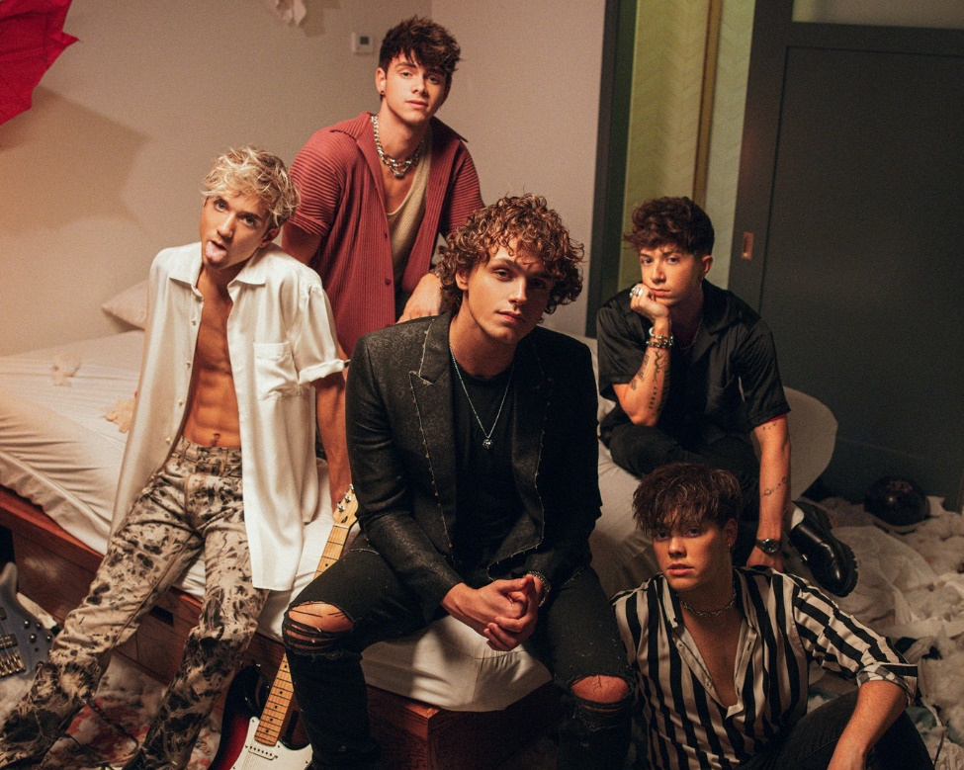
DOWNLOAD HIGH-RES IMAGES

WATCH/STREAM “LOTUS INN”: https://WhyDontWe.lnk.to/LotusInnPR
PRE-SAVE/PRE-ORDER ALBUM: https://whydontwe.lnk.to/TGTATBO

Multi-talented band Why Don’t We let loose on “Lotus Inn,” the second track from their highly anticipated sophomore full-length album, The Good Times and The Bad Ones – arriving January 15th via Atlantic Records and available for pre-order/pre-save now (including a limited edition fan deluxe edition and exclusive cover art). “Lotus Inn” arrives alongside a Dillon Dowdell-directed (Wallows) video, seeing the band relive and rewind an epic night of debauchery alongside actress/influencer Tessa Brooks, while the song’s inspiration was sparked from the 2010 film Percy Jackson & the Olympians: The Lightning Thief.

“‘Lotus Inn’ is a song we wrote to end our live show with, it has that epic encore feeling,” explains Jonah. “We were inspired by the ‘lotus-eaters’ in ‘The Odyssey,’ and a scene from the first ‘Percy Jackson’ book/movie (‘The Lightning Thief’) where they get stuck in ‘The Lotus Hotel and Casino’ – indulging in lotus flowers and drinks before they realize a few hours had actually gone on for days. Our lyric ‘staying at the Lotus Inn’ captures the idea that while partying can be a hell of a time, it can definitely side track you.”

Self-penned and co-produced by the group, The Good Times and The Bad Ones marks a new chapter kickstarted through a combination of deft musicality and bold experimentation. The 10-track collection also features their smash single “Fallin’ (Adrenaline)” (LINK) – which has amassed over 70 million global streams and over 19 million video views since release. The single exploded onto the Top 40 radio chart, debuting at #35 before quickly ascending to #21 and earning the band their first career Billboard Hot 100 entry at #37. The past month has also seen Why Don’t We return to ABC’s Jimmy Kimmel Live! and make their debut on The Ellen DeGeneres Show with high-octane performances, in addition to releasing an acoustic version of the single (LINK) and a viral stripped cover of Aly & AJ’s “Potential Breakup Song” (LINK).

Leading into the release of “Lotus Inn,” Why Don’t We teased fans with an extensive digital campaign prompting reservations and more at the elusive hotel. The band has also partnered with YouTube Originals to give a behind-the-scenes look at the creation of The Good Times and The Bad Ones via their new “30 Days With” documentary series, premiering December 9th.

Following three years spent primarily on the road, the Los Angeles quintet – Daniel Seavey, Corbyn Besson, Jonah Marais, Jack Avery, and Zach Herron – went dark on social media in January to delve into the studio and write, record and produce their next chapter themselves. Breaking their hiatus last month, the group started a social media frenzy with a mysterious #WhereIsWDW campaign that amassed over 5.5 million impressions in under six days. Their return also marked the beginning of the band’s partnership with HeadCount and Atlantic Records’ task force ATL Votes to encourage voter registration.

Since their debut in 2016, Why Don’t We has amassed over 3 billion global career streams, over 700 million YouTube views, 5 million Instagram followers, two RIAA Platinum-certified singles, four RIAA Gold-certified singles, two Top 20 singles at Pop radio, and a Top 10 Billboard 200 debut album. Taking an innovative and unconventional approach towards releasing new music and actively engaging their rapidly growing fanbase, the band put out their first five EPs within their first year together and followed shortly after with their inaugural full-length 8 Letters album in 2018. Last year saw the release of new singles monthly, including standouts “Big Plans,” “I Don’t Belong In This Club” featuring Macklemore, & the Ed Sheeran-penned/Steve Mac-produced hit “What Am I.”

The band has sold out back-to-back North American and global headline tours, in addition to performing on historic stages such as Radio City Music Hall (selling out the venue in under two hours) and Madison Square Garden (as part of the iHeartRadio Jingle Ball Tour). Furthermore, Why Don’t We took home the award for “Choice Music Group” at the 2019 Teen Choice Awards, received a nomination for “Best Group” at the 2019 MTV Video Music Awards, and has made high profile national television appearances on NBC’s TODAY Show (including back-to-back summer concerts in Rockefeller Plaza), ABC’s Good Morning America, nationally syndicated Live with Kelly and Ryan, CBS’s The Late Late Show with James Corden, ABC's Jimmy Kimmel Live! and more.

WHY DON’T WE is: Daniel Seavey, Corbyn Besson, Jonah Marais, Jack Avery, and Zach Herron

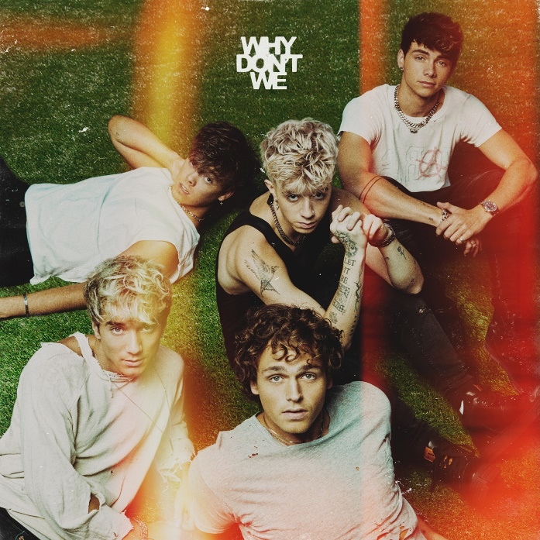
DOWNLOAD HIGH-RES IMAGES

CONNECT:
WHYDONTWEMUSIC.COM | TWITTER | INSTAGRAM | FACEBOOK | YOUTUBE | ASSETS

