FOR IMMEDIATE RELEASE
DECEMBER 17, 2020

Why Don’t We cuts loose on “SLOW DOWN”

Multi-talented band sample The Smashing Pumpkins on carefree new track

Sophomore full-length album The Good Times and The Bad Ones
Featuring Explosive single “Fallin’ (Adrenaline)” & “Lotus Inn”
arrives January 15th via Atlantic Records – pre-order/pre-save now!

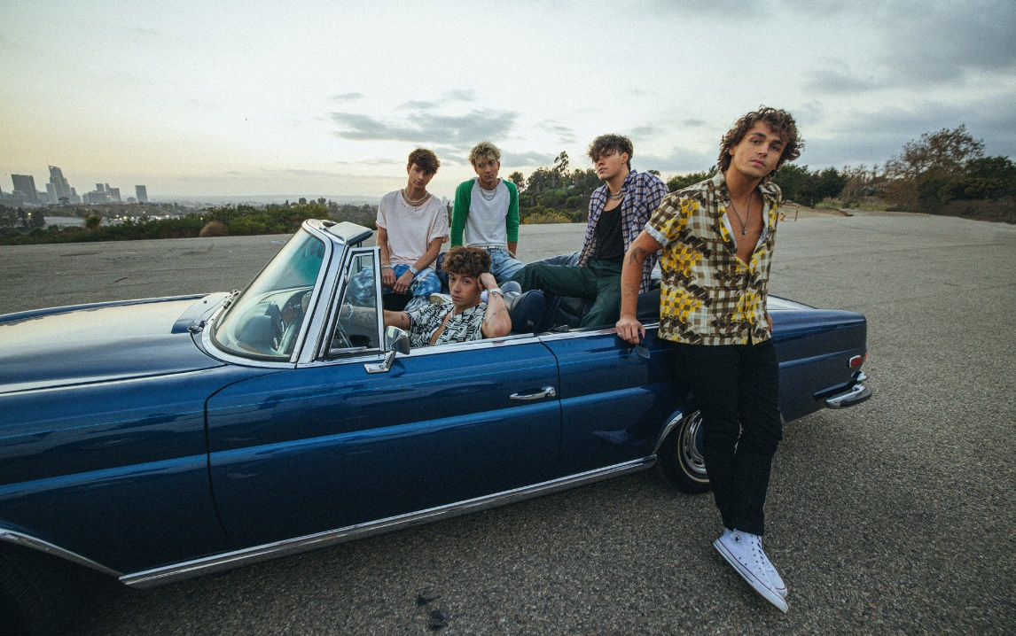
DOWNLOAD HIGH-RES IMAGES

WATCH/STREAM “SLOW DOWN”: https://WhyDontWe.lnk.to/SlowDownPR
PRE-SAVE/PRE-ORDER ALBUM: https://whydontwe.lnk.to/TGTATBO

Multi-talented band Why Don’t We have premiered “Slow Down,” the latest off their highly anticipated sophomore full-length album, The Good Times and The Bad Ones (arriving January 15th via Atlantic Records and available for pre-order/pre-save now). The track, sampling The Smashing Pumpkins classic “1979,” arrives alongside an Isaac Rentz-directed video (making it’s broadcast premiere via MTV) that sees the band cut loose and pay homage with a cruise through California.

"’1979’ is such a beautiful song,” said Daniel. “It’s so universal. Anyone can listen and enjoy it. When we were writing ‘Slow Down,’ we wanted to make it just as special. The song is personal and easy to listen to all at the same time. It’s nostalgic and new all at once."

Self-penned and co-produced by the group, The Good Times and The Bad Ones marks a new chapter kickstarted through a combination of deft musicality and bold experimentation. The 10-track collection also features their smash single “Fallin’ (Adrenaline)” (LINK), which has amassed over 80 million global streams and over 21 million video views since release. The single exploded onto the Top 40 radio chart, debuting at #35 before quickly ascending to #21 and earning the band their first career Billboard Hot 100 entry at #37. The past month has also seen Why Don’t We return to ABC’s Jimmy Kimmel Live! and make their debut on The Ellen DeGeneres Show with high-octane performances, in addition to releasing an acoustic version of the single (LINK) and a viral stripped cover of Aly & AJ’s “Potential Breakup Song” (LINK).

The Good Times and The Bad Ones also features new track “Lotus Inn” (LINK), which premiered last week alongside a Dillon Dowdell-directed (Wallows) video that amassed over 1 million views in just 24 hours. The video also served as setting for the band’s premiere episode of their YouTube Originals “30 Days With” docu-series (LINK), giving a behind-the-scenes look at the creation of their new album.

Following three years spent primarily on the road, the Los Angeles quintet – Daniel Seavey, Corbyn Besson, Jonah Marais, Jack Avery, and Zach Herron – went dark on social media in January to delve into the studio and write, record and produce their next chapter themselves. Breaking their hiatus last month, the group started a social media frenzy with a mysterious #WhereIsWDW campaign that amassed over 5.5 million impressions in under six days. Their return also marked the beginning of the band’s partnership with HeadCount and Atlantic Records’ task force ATL Votes to encourage voter registration.

Since their debut in 2016, Why Don’t We has amassed over 3 billion global career streams, over 700 million YouTube views, 5 million Instagram followers, two RIAA Platinum-certified singles, four RIAA Gold-certified singles, two Top 20 singles at Pop radio, and a Top 10 Billboard 200 debut album. Taking an innovative and unconventional approach towards releasing new music and actively engaging their rapidly growing fanbase, the band put out their first five EPs within their first year together and followed shortly after with their inaugural full-length 8 Letters album in 2018. Last year saw the release of new singles monthly, including standouts “Big Plans,” “I Don’t Belong In This Club” featuring Macklemore, & the Ed Sheeran-penned/Steve Mac-produced hit “What Am I.”

The band has sold out back-to-back North American and global headline tours, in addition to performing on historic stages such as Radio City Music Hall (selling out the venue in under two hours) and Madison Square Garden (as part of the iHeartRadio Jingle Ball Tour). Furthermore, Why Don’t We took home the award for “Choice Music Group” at the 2019 Teen Choice Awards, received a nomination for “Best Group” at the 2019 MTV Video Music Awards, and has made high profile national television appearances on NBC’s TODAY Show (including back-to-back summer concerts in Rockefeller Plaza), ABC’s Good Morning America, nationally syndicated Live with Kelly and Ryan, CBS’s The Late Late Show with James Corden, ABC's Jimmy Kimmel Live! and more.

WHY DON’T WE is: Daniel Seavey, Corbyn Besson, Jonah Marais, Jack Avery, and Zach Herron

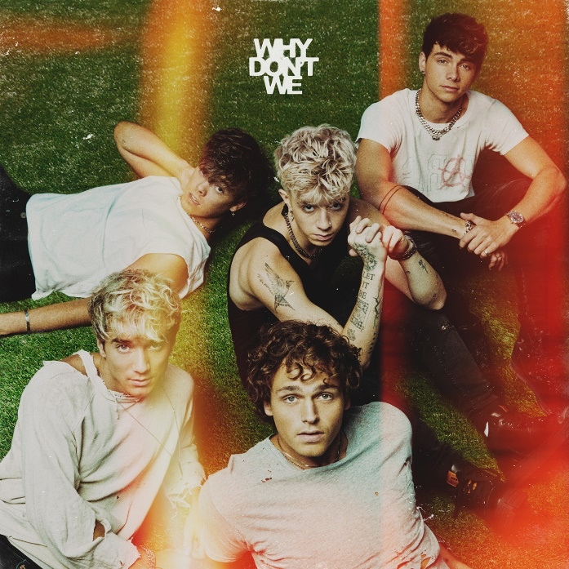
DOWNLOAD HIGH-RES IMAGES

CONNECT:
WHYDONTWEMUSIC.COM | TWITTER | INSTAGRAM | FACEBOOK | YOUTUBE | ASSETS

