FOR IMMEDIATE RELEASE
JANUARY 15, 2021

Why Don’t We release new album
The Good Times and The Bad Ones

Multi-talented band’s sophomore full-length available now,
featuring Explosive single “Fallin’ (Adrenaline),” “Lotus Inn” & “Slow Down”

High profile TV performances slated for The Late Late Show with James Corden, Good Morning America & The Kelly Clarkson Show

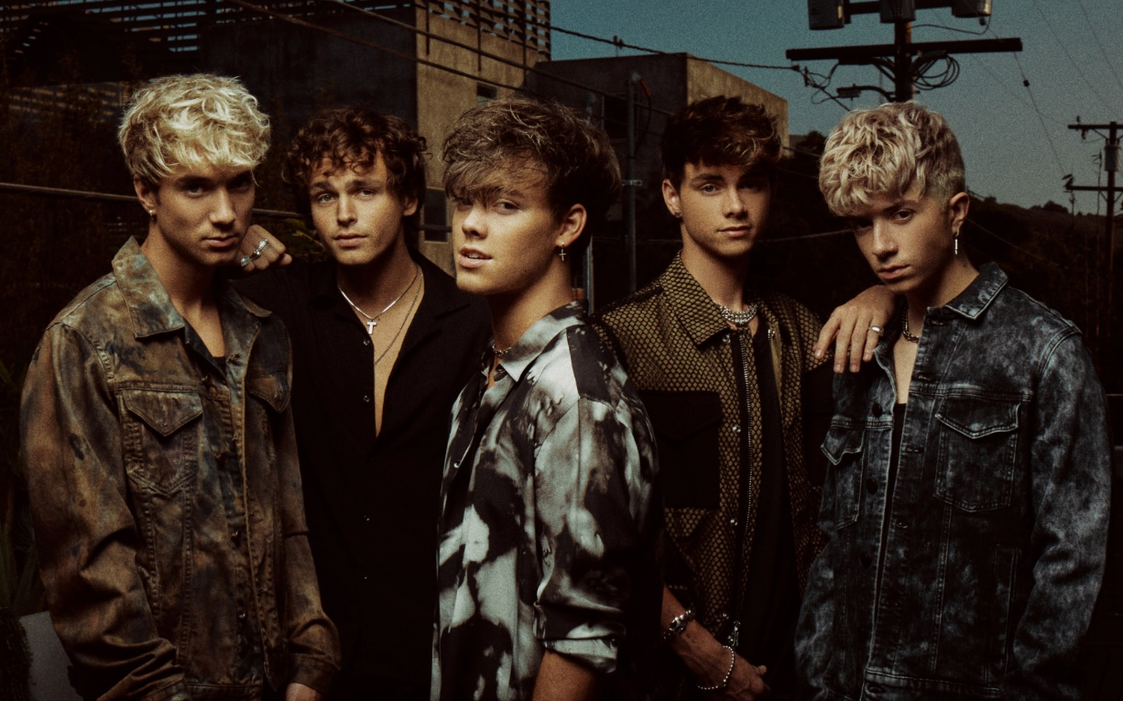
DOWNLOAD HIGH-RES IMAGES

STREAM THE GOOD TIMES AND THE BAD ONES: https://whydontwe.lnk.to/TGTATBO

Multi-talented band Why Don’t We have released their highly anticipated sophomore full-length album, The Good Times and The Bad Ones – available now via Atlantic Records. Self-penned and co-produced by the group – with additional production and programming from the likes of Travis Barker (“Slow Down,” “Lotus Inn,” “Look At Me”), Skrillex (“For You”) & Timbaland (“Stay”) – the 10-track collection marks a new chapter kickstarted through a combination of deft musicality and bold experimentation. The album arrives alongside a moving performance video of standout track “Grey,” a vulnerable and emotional ballad showcasing a new side of the band – watch here.

“Writing and co-producing our own music has been one of the most rewarding experiences for us,” explains Corbyn. “In the past four years we’ve become confident enough to reinvent ourselves, becoming the band we always hoped to be.”

“It was time to do this ourselves,” says Daniel. “These are our ideas, melodies, and thoughts.”

Why Don’t We kicked off their album release last night with a TV-debut performance of “Lotus Inn” on CBS’s The Late Late Show with James Corden, with additional performances scheduled for today (Jan 15) on ABC’s Good Morning America and next Tuesday (Jan 19) on NBC’s The Kelly Clarkson Show. The appearances follow their debut performance on The Ellen DeGeneres Show and return to ABC’s Jimmy Kimmel Live! with high-octane performances capping off 2020.

The Good Times and The Bad Ones features smash single “Fallin’ (Adrenaline),” which has amassed over 100 million global streams and over 23 million video views since release. The single exploded onto the Top 40 radio chart, debuting at #35 before quickly ascending to #21 and earning the band their first career Billboard Hot 100 entry at #37. The band also preceded the album release with videos for standout tracks “Lotus Inn” and “Slow Down” (the latter of which samples The Smashing Pumpkins classic “1979”), in addition to dropping a wide variety of physical album configurations including signed editions, three alternate covers, collectable zine booklet & more via whydontwemusic.com/store.

Following three years spent primarily on the road, the Los Angeles quintet – Daniel Seavey, Corbyn Besson, Jonah Marais, Jack Avery, and Zach Herron – went dark on social media in early 2020 to delve into the studio and write, record and produce their next chapter themselves. Breaking their hiatus nearly ten months later, the group started a social media frenzy with a mysterious #WhereIsWDW campaign that amassed over 5.5 million impressions in under six days. Their return also marked the beginning of the band’s partnership with HeadCount and Atlantic Records’ task force ATL Votes to encourage voter registration, and with YouTube Originals for their “30 Days With” docu-series that gave fans a behind-the-scenes look at the creation of their new album.

Since their debut in 2016, Why Don’t We has amassed over 3 billion global career streams, over 750 million YouTube views, 5 million Instagram followers, two RIAA Platinum-certified singles, four RIAA Gold-certified singles, two Top 20 singles at Pop radio, and a Top 10 Billboard 200 debut album. Taking an innovative and unconventional approach towards releasing new music and actively engaging their rapidly growing fanbase, the band put out their first five EPs within their first year together and followed shortly after with their inaugural full-length 8 Letters album in 2018. Soon after, 2019 saw the release of new singles monthly, including standouts “Big Plans,” “I Don’t Belong In This Club” featuring Macklemore, & the Ed Sheeran-penned/Steve Mac-produced hit “What Am I.”

The band has sold out back-to-back North American and global headline tours, in addition to performing on historic stages such as Radio City Music Hall (selling out the venue in under two hours) and Madison Square Garden (as part of the iHeartRadio Jingle Ball Tour). Furthermore, Why Don’t We took home the award for “Choice Music Group” at the 2019 Teen Choice Awards, received a nomination for “Best Group” at the 2019 MTV Video Music Awards, and has made high profile national television appearances on NBC’s TODAY Show (including back-to-back summer concerts in Rockefeller Plaza), ABC’s Good Morning America, nationally syndicated Live with Kelly and Ryan, The Ellen DeGeneres Show, CBS’s The Late Late Show with James Corden, ABC's Jimmy Kimmel Live! and more.

WHY DON’T WE is: Daniel Seavey, Corbyn Besson, Jonah Marais, Jack Avery, and Zach Herron

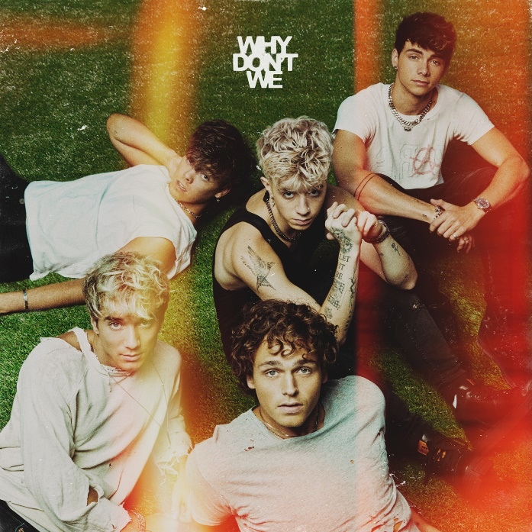
DOWNLOAD HIGH-RES IMAGES

Why Don’t We
The Good Times and The Bad Ones
1. Fallin’ (Adrenaline)
2. Slow Down
3. Lotus Inn
4. Be Myself
5. Love Song
6. Grey
7. For You
8. I’ll Be Ok
9. Look at Me
10. Stay

CONNECT:
WHYDONTWEMUSIC.COM | TWITTER | INSTAGRAM | FACEBOOK | YOUTUBE | ASSETS

