FOR IMMEDIATE RELEASE
DECEMBER 2, 2019

WHY DON’T WE IS “WITH YOU THIS CHRISTMAS”

Breakout pop group’s monumental new SINGLE “WHAT AM I”
penned by Ed Sheeran & produced by Steve Mac APPROACHING TOP 20 AT POP radio

WHY DON’T WE EMBARK ON 2019 IHEARTRADIO JINGLE BALL TOUR

11th new song of 2019 available now

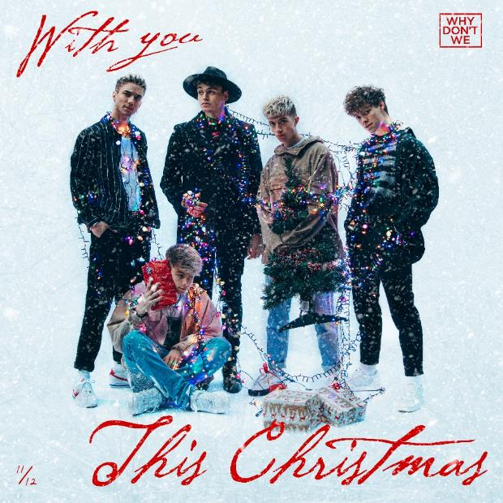
DOWNLOAD HIGH-RES IMAGES

STREAM “WITH YOU THIS CHRISTMAS”: LINK
WATCH “WHAT AM I” music video: LINK

Breakout pop group Why Don’t We have dropped their eleventh new song of 2019, “With You This Christmas” – available now via Atlantic Records. The track, penned and produced by the group, arrives as their performances kick off on the 2019 iHeartRadio Jingle Ball Tour, with upcoming at stops in Dallas, Philadelphia, Atlanta & more (full routing below).

“With You This Christmas” follows the release of Why Don’t We’s monumental new single “What Am I,” which continues its ascent to #21 at Pop radio this week while boasting over 75.4 million streams and 13.4 million video views. Since release, the band has performed “What Am I” on NBC’s TODAY Show Citi Concert Series, MTV’s TRL and ABC’s Live with Kelly & Ryan, in addition to hosting six widely successful merch pop-up shops across the US. Penned by Ed Sheeran and produced by Steve Mac, “What Am I” marks the triumphant follow up to “8 Letters” – the RIAA-Gold certified Top 20 single which alone accounts for 247 million of the band’s over 1.4 billion global streams.

2019 proved to be an exciting year for Why Don’t We, highlighted by their biggest headline run to date, the widely popular and sold out 8 Letters Tour, which just wrapped its global domination last week after final stops in Australia and New Zealand. Known for their prolific and creative output, the group has maintained a steady flow of monthly new releases this year – recently including a Live and Unplugged Session of “What Am I” that further highlights the band’s musicality – in addition to taking home the award for Choice Music Group at the 2019 Teen Choice Awards and receiving a nomination for Best Group at the 2019 MTV Video Music Awards

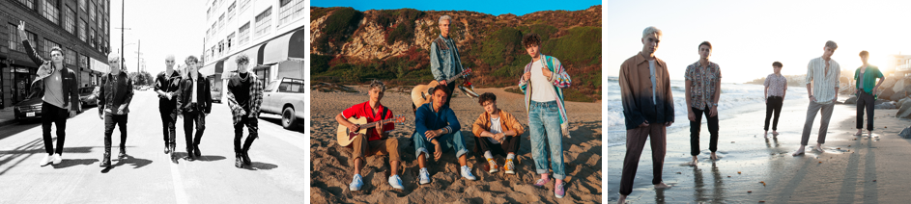
DOWNLOAD HIGH-RES IMAGES

***

“One of pop music’s biggest breakout stories” – NBC’s TODAY
“Artist To Watch” – ROLLING STONE

Amassing more than 1.4 billion global audio streams, 4.3 million Instagram followers, and total You Tube views exceeding 541 million with over 3.1 million subscribers in just 3 years, Why Don’t We has become one of pop music’s biggest breakout stories. Taking an innovative and unconventional approach towards releasing new music and actively engaging their rapidly growing fanbase, the prolific young group – the quintet ranges in age from 18-21 years old – put out their first five EPs in under 12 months. After only a year together, the group earned a highly coveted spot on the entire iHeartRadio Jingle Ball Tour, including the New York City stop at Madison Square Garden where they shared the stage with Taylor Swift, Ed Sheeran and more. Their 2018 inaugural full length album, 8 Letters, debuted in the top 10 on the Billboard 200 at #9 and immediately shot to #1 on US iTunes’ Overall Albums chart (along with topping charts in over 20 more territories around the globe) – while the title track is RIAA-certified Gold, hit Top 20 at Pop radio and boasts over 247 million global streams to date. The band has sold out back-to-back North American headlining tours, and is currently on the road for their most extensive 8 Letters Tour (which included a stop at New York City’s Radio City Music Hall which sold out in under two hours). High profile national television appearances include performances on NBC’s TODAY Show (including back-to-back summer concerts in Rockefeller Plaza), ABC’s Good Morning America, nationally syndicated Live with Kelly and Ryan, CBS’s The Late Late Show with James Corden, ABC's Jimmy Kimmel Live! and more. Press highlights include features in Rolling Stone, Entertainment Weekly, Billboard, PAPER and TIME among others. WHY DON’T WE is: Daniel Seavey, Zach Herron, Corbyn Besson, Jonah Marais, and Jack Avery

TOUR:
Dec 3 – Dallas, TX @ Dickies Arena (106.1 KISS FM Jingle Ball)
Dec 9 – Minneapolis, MN @ Xcel Energy Center (101.3 KDWB Jingle Ball)
Dec 10 – Indianapolis, IN @ Bankers Life Fieldhouse (99.5 ZPL Jingle Jam)
Dec 11 – Philadelphia, PA @ Wells Fargo Arena (Q102’s Jingle Ball)
Dec 13 – Wilkes-Barre, PA @ Kirby Center (98.5 KRZ Let It Show)
Dec 15 – Boston, MA @ TD Garden (KISS 108’s Jingle Ball)
Dec 16 – Washington, DC @ Capital One Arena (Hot 99.5)
Dec 17 – Cincinnati, OH @ Madison Theater (KISS 107.1 KISSmas Concert)
Dec 18 – Chicago, IL @ All State Arena (103.5 KISS FM’s Jingle Ball)
Dec 19 – Memphis, TN @ Landers Center (Q107.5 Jingle Jam)
Dec 20 – Atlanta, GA @ State Farm Arena (Power 96.1 Jingle Ball)
Dec 22 – Ft. Lauderdale, FL @ BB&T Center (Y100’s Jingle Ball)

CONNECT:
WHYDONTWEMUSIC.COM | TWITTER | INSTAGRAM | FACEBOOK | YOUTUBE | ASSETS

CONTACT:
Glenn Fukushima | glenn.fukushima@atlanticrecords.com
Ted Sullivan | ted.sullivan@atlanticrecords.com

