FOR IMMEDIATE RELEASE
OCTOBER 2, 2020

SWEDEN’S WINONA OAK ANNOUNCES
SHE EP, OUT OCTOBER 23

SHARES NEW SINGLE & VIDEO
“PIANO IN THE SKY”

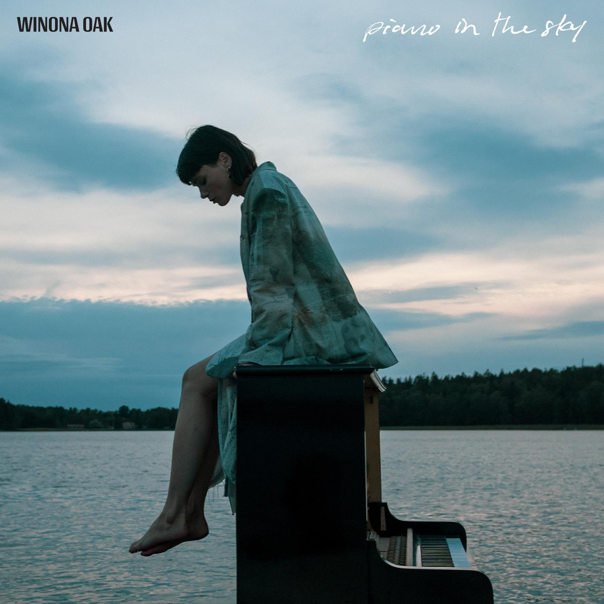

WATCH “PIANO IN THE SKY”

Stream/Buy “Piano in the Sky”:
https://winonaoak.lnk.to/PianoInTheSky

Pre-save the SHE EP:
https://WinonaOak.lnk.to/PreSaveSHE

“magnetizing...a true testament to her unprecedented singing abilities, and it’s a refreshingly authentic look into the multi-faceted vocalist’s emotional psyche" - V Magazine

Winona Oak has announced the upcoming release of her sophomore EP, SHE, on October 23rd and shared a new single from it, “Piano in the Sky”. SHE follows the release of her debut EP CLOSURE (Neon Gold / Atlantic Records) earlier this year. Winona’s haunting and fragile vocal on “Piano in the Sky” is wounded but resilient as she contemplates finding the courage to exit a relationship. The accompanying video, directed by Julian Gillstrom, finds her alone in the Swedish nature, an island of one on a lake just her and a piano. Watch it here.

Winona recently released “With Myself”, a defiant anthem of self-reliance that launched the SHE EP campaign last month, accompanied by a remix by Belgian artist/producer Taska Black that fills the original with lush atmospherics and trap rhythms that bring out a seductive yet foreboding noir quality in the song. Listen to it HERE. “With Myself” introduces a confident, fearless, and independent Winona Oak.

Winona first caught the public’s attention when she collaborated with The Chainsmokers on their viral hit single “Hope”. The song, which was co-written by Winona and features her stunning lead vocals, has amassed over 350 million streams globally and recently RIAA-certified gold in the US. Her debut single “He Don’t Love Me” is a paean to finding strength in your own self-worth. The track has been a runaway success, amassing 50 million streams across all platforms to date. Her sophomore single “Break My Broken Heart” followed suit, amassing over 13 million streams across all platforms globally. Both singles are featured on the CLOSURE EP.

Born and raised in the Nordic forests of Sweden on a small crop of land called Sollerön - known as the Island of the Sun - Winona Oak is every bit as enchanting as her origin story. With a childhood spent encountering more animals than people, she grew up a trained horse acrobat and pursued creative expression however she could, writing poetry and songs from a young age. Born into a musical family, Winona sang throughout her youth and began playing violin at 5 years old and piano at 9 years.

After moving to Stockholm to pursue her passion for music, a leap of faith to attend Neon Gold Records’ writing retreat in the Nicaraguan jungle in 2017 led her to Australian electronic maestro What So Not. She would go on to co-write his next two singles "Better" and "Stuck In Orbit", eventually stepping into the spotlight as both the writer and featured artist on his 2018 single "Beautiful", which took home the 2019 AIR Award for Best Independent Dance Single at the Australian Independent Music Awards. In 2018 she also released a cover of “Don’t Save Me” from fellow Neon Gold Records signees HAIM for the label’s 10 year anniversary compilation: NGX: Ten Years of Neon Gold. The minimal production allows Winona Oak’s ethereal voice to shine through, slower than the original and drenched in ethereal melancholy.

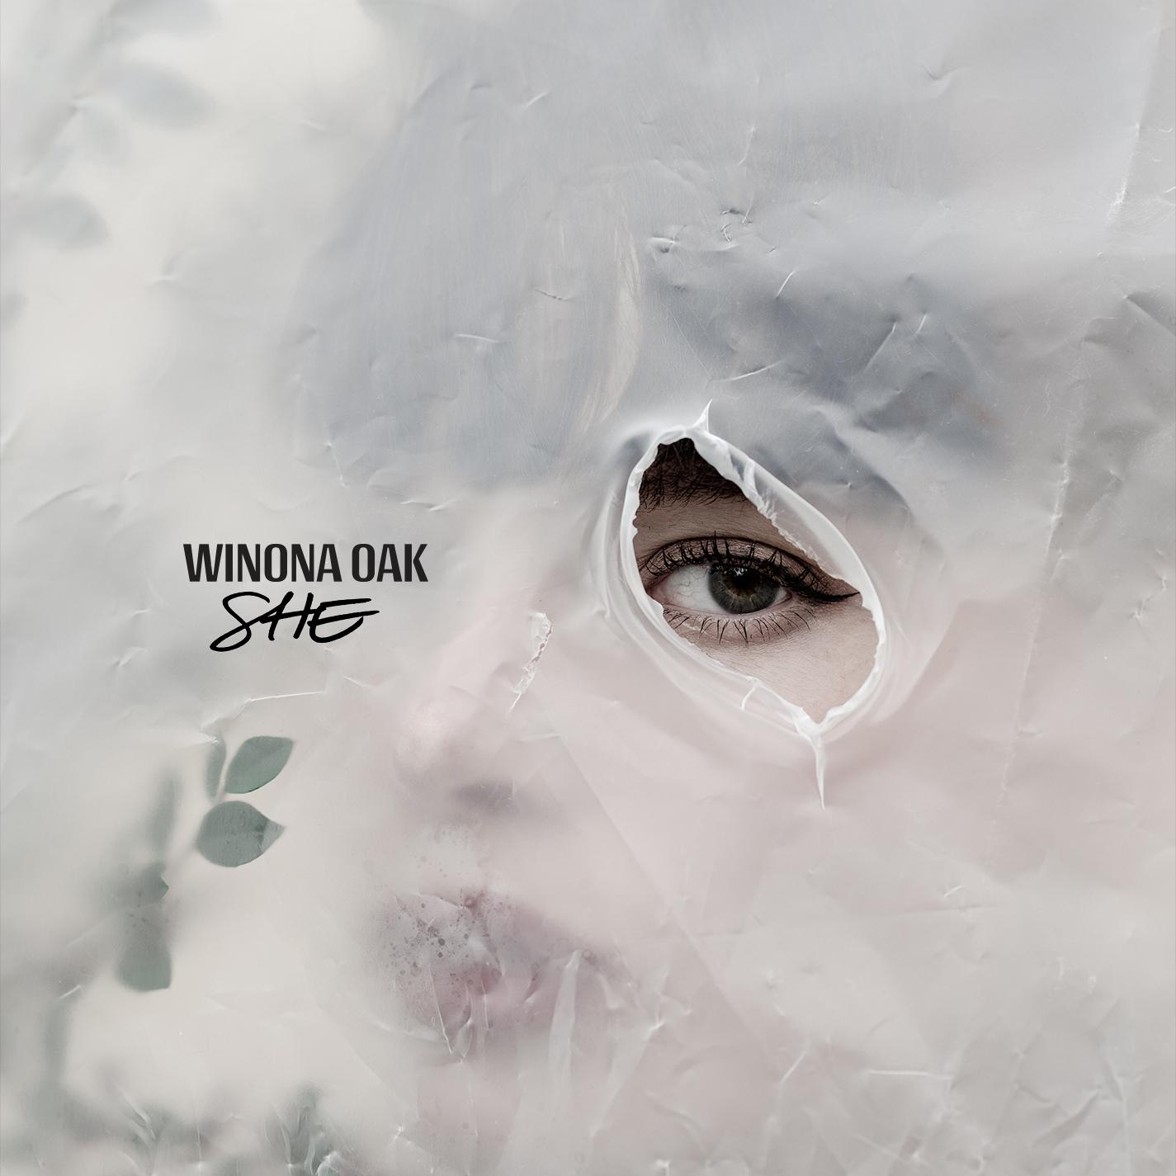

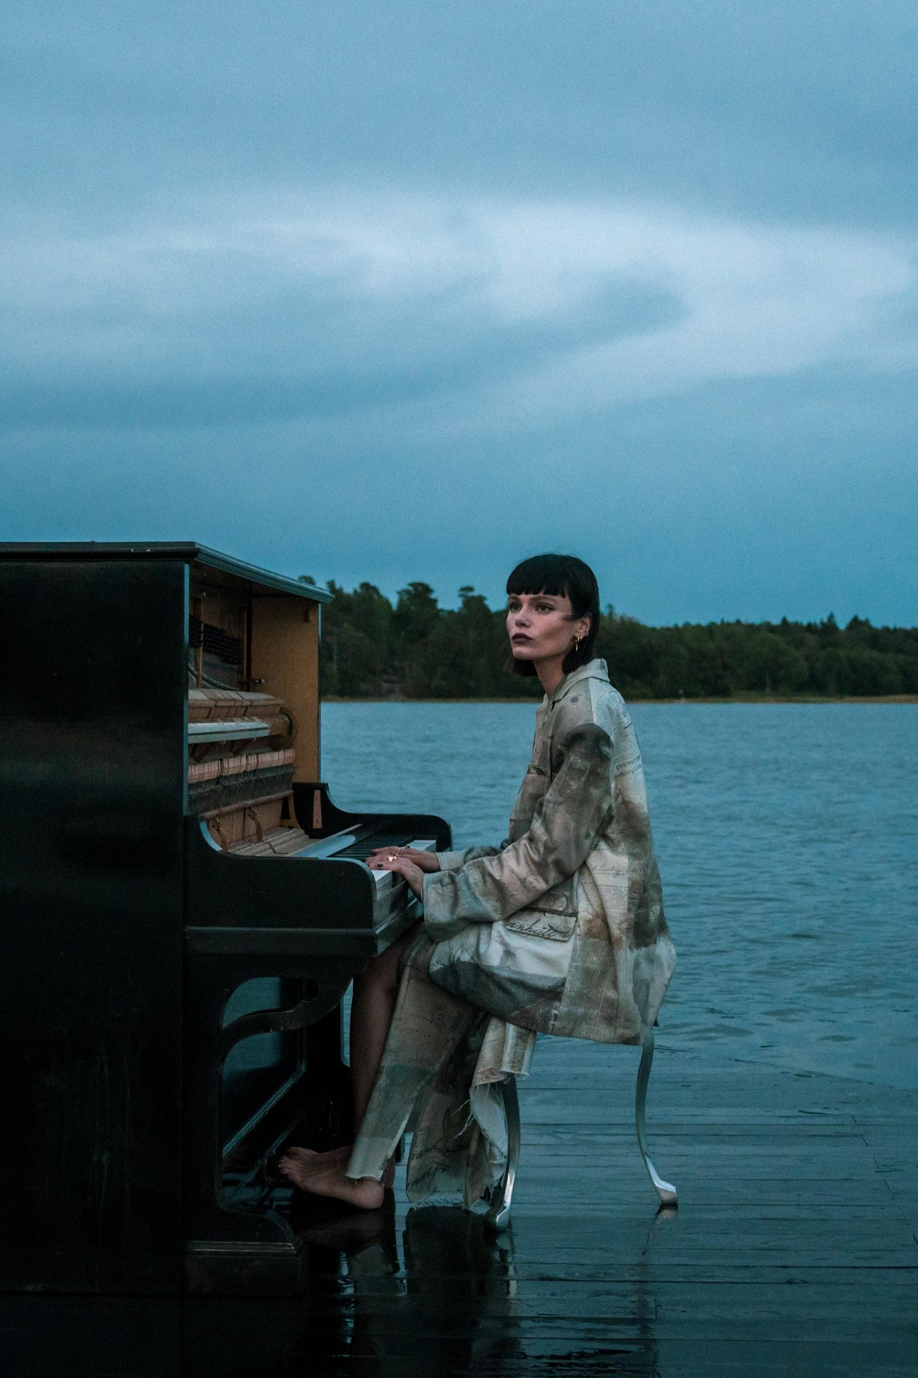
Photo: Julian Gillstrom, single art, video stills HERE

https://www.instagram.com/winonaoak/
https://twitter.com/winonaoak
Spotify
Apple Music
YouTube

For more on Winona Oak, please reach out to:
Kelly McWilliam - Kelly.McWilliam@atlanticrecords.com

