FOR IMMEDIATE RELEASE
JANUARY 22, 2020

WINONA OAK CALLS FOR “WINTER RAIN”

RISING POP SONGSTRESS RETURNS WITH STUNNING NEW SINGLE

MESMERIZING TRACK FEATURED ON EXPANDED EDITION
OF ACCLAIMED NEW EP, SHE

LISTEN TO “WINTER RAIN” HERE
WATCH THE VIDEO HERE
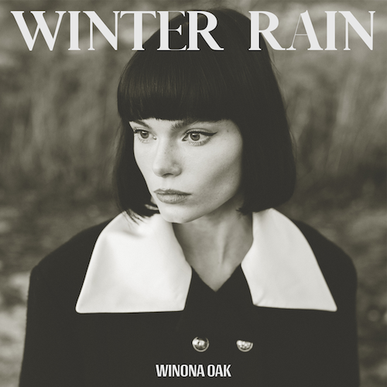
DOWNLOAD ARTWORK HERE

Rising pop songstress Winona Oak has unveiled a mesmerizing new single - “Winter Rain” is available now HERE. The track is joined by a strikingly surreal music video directed by Julian Gillstrom and featuring stunning clothing from Chanel, Alexander McQueen and Acne Studios – watch it now HERE.

“’Winter Rain’ describes how it feels when someone’s turning guarded and distant in a relationship,” Winona shared. “The numbing coldness when they’re slowly pushing you out of their life. The ice running through your blood when you can’t stop wondering if they don’t love you anymore. But maybe it’s just all in your head?”

“Winter Rain” will also be showcased on the newly expanded edition of Winona’s recent SHE EP. SHE was released last fall and was highlighted by the critically lauded tracks “With Myself,” “Piano In The Sky,” and the remarkable “SHE.”

SHE was met with widespread critical acclaim with PAPER premiering the official video for the EP’s title track and stating, “Winona Oak is a name you should know...After listening to the danceable, somber and contemplative SHE, you'll understand why.” Winona celebrated SHE with a stirring live performance of the title track as part of CBS’ The Late Show with Stephen Colbert’s #PLAYATHOME series.

Winona followed with the release of “She (Stripped),” a stunning new version of the title track, as well as a number of exclusive remixes, including reworked renditions by Belgian artist/producer Taska Black (streaming HERE) and Los Angeles trio MUNA (streaming HERE).

WHAT THE CRITICS ARE SAYING ABOUT WINONA OAK
“magnetizing...a true testament to her unprecedented singing abilities, and it’s a refreshingly authentic look into the multi-faceted vocalist’s emotional psyche" – V MAGAZINE

“Lyrically, the electro-pop musician pays homage to strong women in every respect, delivering body and sex-positive anthems, and touching on important topics such as mental health and self-love.” – PAPER

“From the Nordic forests of Sweden, on a small crop of land called Sollerön, known as the ‘Island of the Sun,’ emerges singer-songwriter Winona Oak. Her music, the product of her upbringing, is just as enchanting as its setting, surrounded by nature and wildlife.”
– AMERICAN SONGWRITER

“An impossible to ignore artist. Ethereal, mesmerizing…”
– ONES TO WATCH

“staggeringly good” – IDOLATOR

“With enchantingly rich vocals and a knack for effortlessly characterizing life scenarios, Winona is soon to be backed by a new hoard of fans.” – POPULAR TV

CONNECT WITH WINONA OAK
INSTAGRAM | TWITTER |SPOTIFY | APPLE MUSIC | YOUTUBE

For more on Winona Oak, please reach out to:
Kelly McWilliam - Kelly.McWilliam@atlanticrecords.com

