SWEDEN’S WINONA OAK SHARES
“WITH MYSELF (TASKA BLACK REMIX)”
LISTEN HERE

DEBUT CLOSURE EP OUT NOW HERE

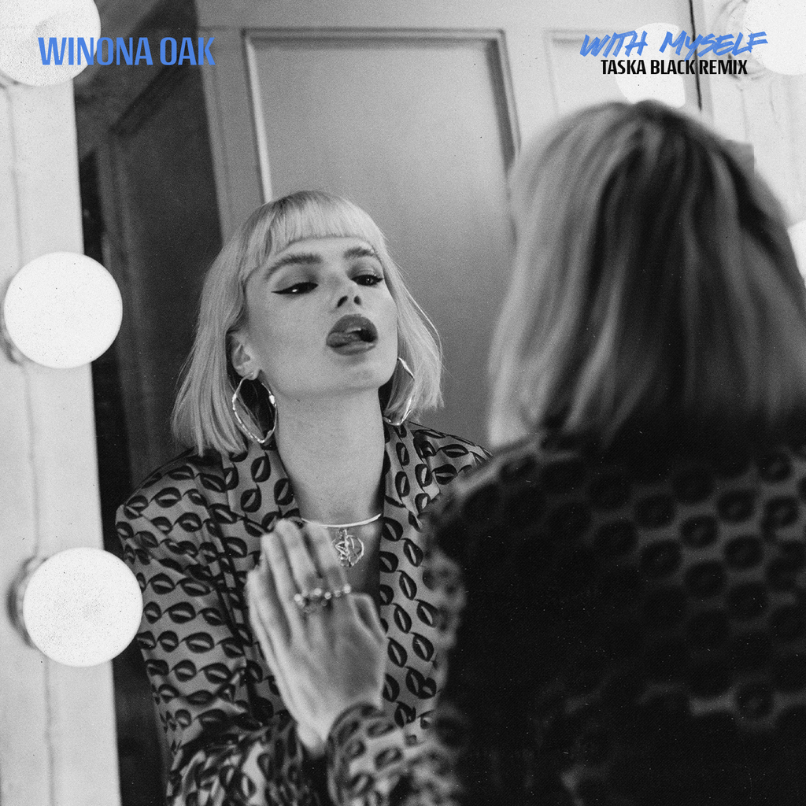
photo: Julian Gillstrom, single art, video stills HERE, remix cover HERE

“magnetizing...a true testament to her unprecedented singing abilities, and it’s a refreshingly authentic look into the multi-faceted vocalist’s emotional psyche" - V Magazine

Winona Oak has shared a remix of her latest single “With Myself” by Belgian artist/producer Taska Black. The remix underscores the defiance and resilience of the Swedish artist’s original with lush atmospherics and trap rhythms that bring out a seductive yet foreboding noir quality in the song. Listen to it HERE.

Following the release of her debut EP CLOSURE (Neon Gold / Atlantic Records) earlier this year, Winona Oak gave us a taste of where she is going next with her current single “With Myself” HERE and the accompanying music video HERE, which was shot in New York just before the pandemic. They reveal a very confident, fearless, and independent Winona Oak.

In recent weeks, the rising artist has also released “Who Can Sail” HERE from the compilation album At Home With The Kids and “Another Story” from her EP, CLOSURE .

Winona first caught the public’s attention when she collaborated with The Chainsmokers on their viral hit single “Hope”. The song, which was co-written by Winona and features her stunning lead vocals, has amassed over 500 million streams globally. Her debut single “He Don’t Love Me” is a paean to finding strength in your own self-worth. The track has been a runaway success, amassing 48.9 million streams across all platforms to date. Her sophomore single “Break My Broken Heart” followed suit, amassing over 13 million streams across all platforms globally. Both singles are featured on the CLOSURE EP.

Born and raised in the Nordic forests of Sweden on a small crop of land called Sollerön - known as the Island of the Sun - Winona Oak is every bit as enchanting as her origin story. With a childhood spent encountering more animals than people, she grew up a trained horse acrobat and pursued creative expression however she could, writing poetry and songs from a young age. Born into a musical family, Winona sang throughout her youth and began playing violin at 5 years old and piano at 9 years.

After moving to Stockholm to pursue her passion for music, a leap of faith to attend Neon Gold Records’ writing retreat in the Nicaraguan jungle in 2017 led her to Australian electronic maestro What So Not. She would go on to co-write his next two singles "Better" and "Stuck In Orbit", eventually stepping into the spotlight as both the writer and featured artist on his 2018 single "Beautiful", which took home the 2019 AIR Award for Best Independent Dance Single at the Australian Independent Music Awards. In 2018 she also released a cover of “Don’t Save Me” from fellow Neon Gold Records signees HAIM for the label’s 10 year anniversary compilation: NGX: Ten Years of Neon Gold. The minimal production allows Winona Oak’s ethereal voice to shine through, slower than the original and drenched in ethereal melancholy.

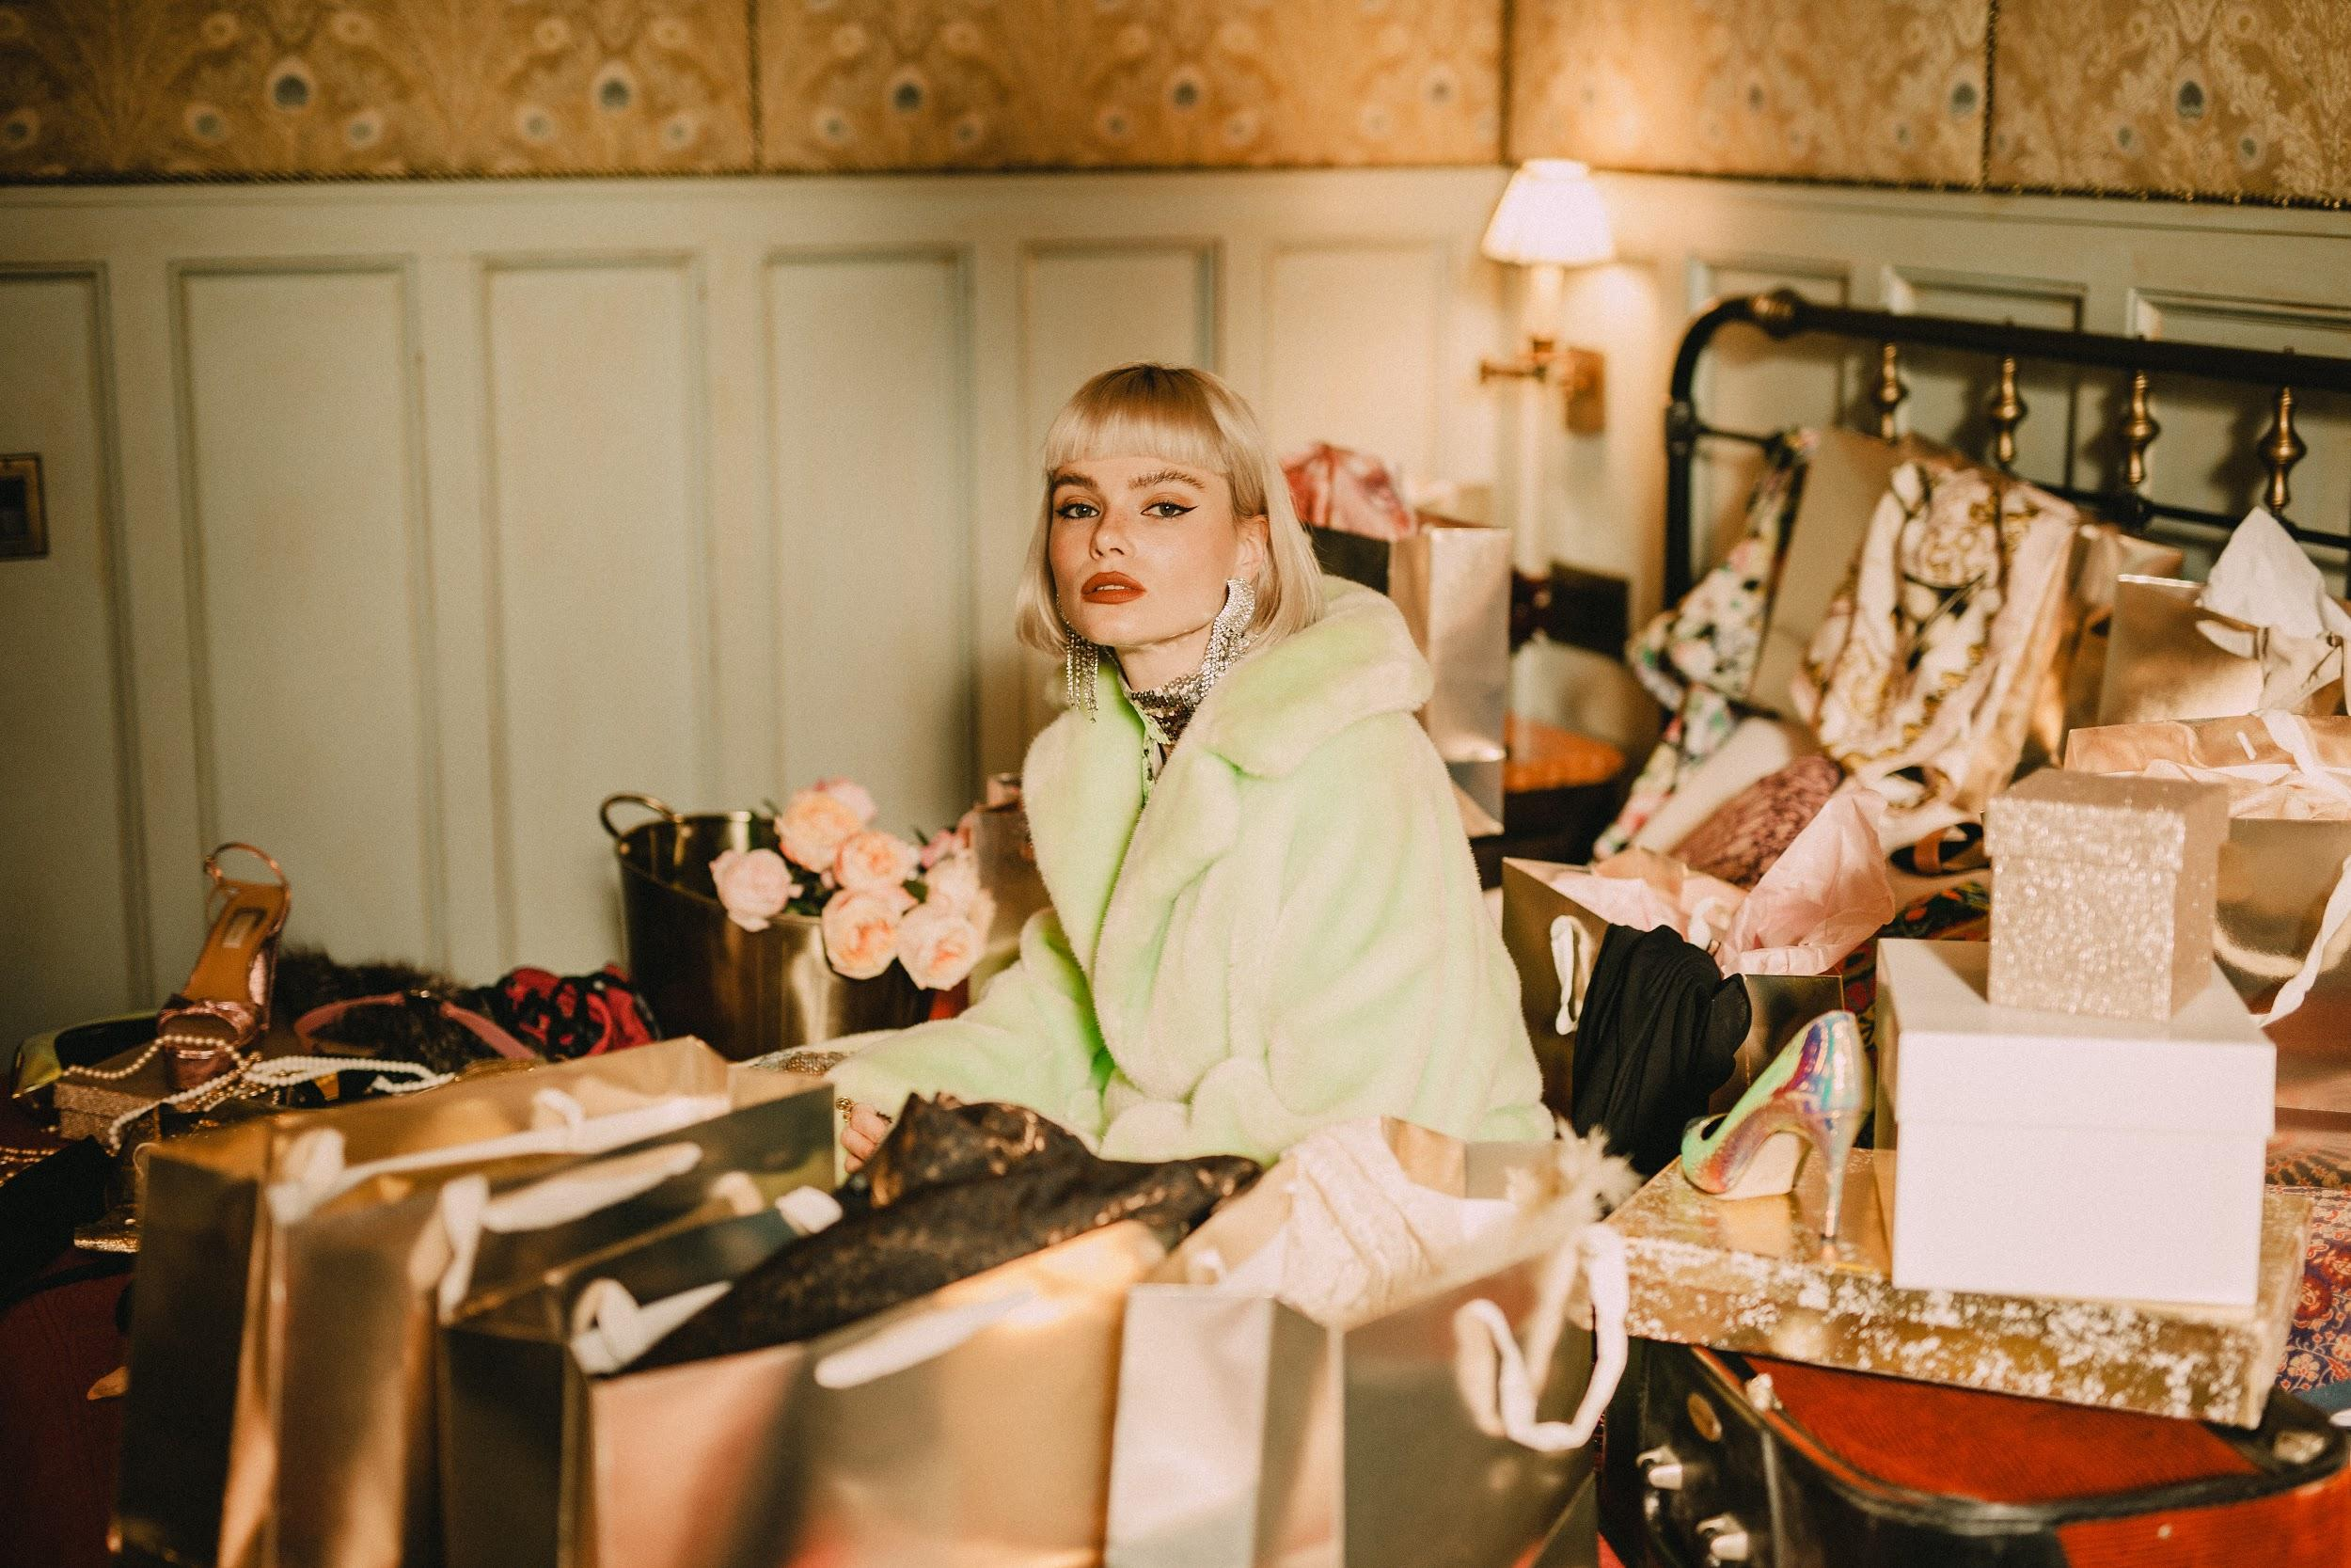
photo: Julian Gillstrom, single art, video stills HERE

https://www.instagram.com/winonaoak/
https://twitter.com/winonaoak
Spotify
Apple Music
YouTube

For more on Winona Oak, please reach out to:
Gold Atlas - Inge Colsen - inge@goldatl.as - 212-203-5240
Aleix Martinez - aleix@goldatl.as - 862-755-9703
Kelly McWilliam - Kelly.McWilliam@atlanticrecords.com

