FOR IMMEDIATE RELEASE
FEBRUARY 18, 2021

DAVID GUETTA REMIXES JASON DERULO’S “LIFESTYLE (FEAT. ADAM LEVINE)”

STREAM “LIFESTYLE (FEAT. ADAM LEVINE) [DAVID GUETTA SLAP HOUSE MIX]”
JASONDERULO.LNK.TO/GUETTASLAPHOUSEMIX

STREAM/DOWNLOAD “LIFESTYLE (FEAT. ADAM LEVINE)”
JASONDERULO.LNK.TO/LIFESTYLE

WATCH OFFICIAL DANCE VIDEO:
JASONDERULO.LNK.TO/LIFESTYLEDANCEVIDEO

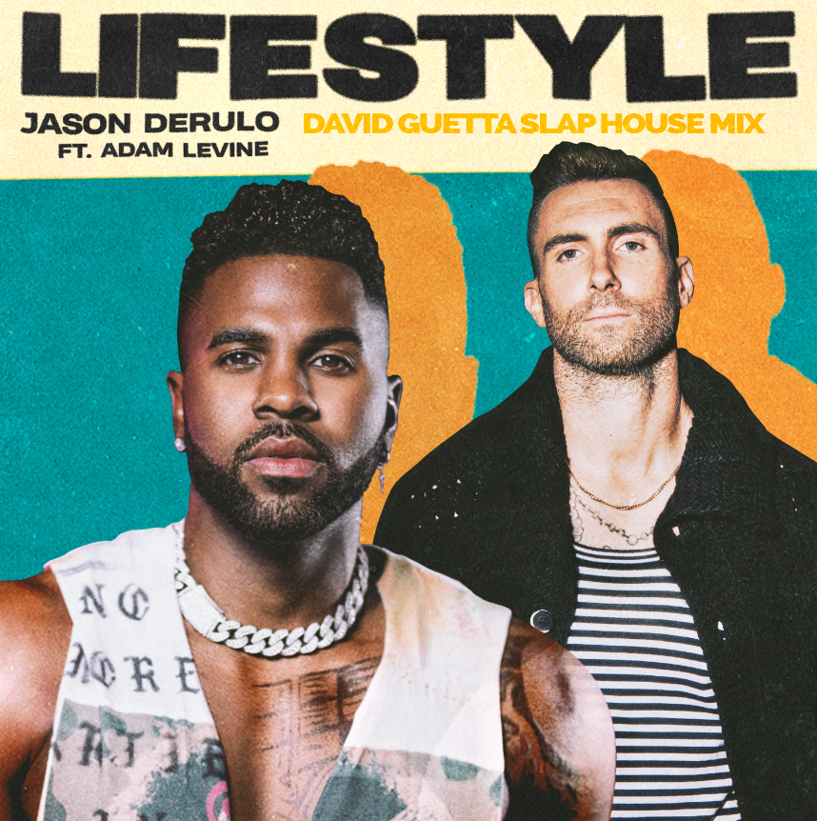
DOWNLOAD HIGH-RES COVER ART HERE

Global DJ superstar David Guetta releases a slap house remix of multi-platinum global superstar Jason Derulo’s “Lifestyle (Feat. Adam Levine).” The remix is available now via Future History/APG/Atlantic Records at all DSPs and streaming services HERE. Download or stream the original HERE. Watch the official dance video streaming via YouTube HERE.

With more than 43 million followers and over 985 million likes thus far, Jason Derulo is currently among TikTok‘s top 10 superstars and the most popular active platinum-selling musician across the entire platform. “Lifestyle (Feat. Adam Levine)” sees Derulo joining forces for the first time ever with the one and only Adam Levine, frontman for the three-time GRAMMY® Award-winning multi-platinum band Maroon 5, who are one of pop music’s most enduring artists and also one of the 21st century’s biggest acts.

“Lifestyle (Feat. Adam Levine)” marks the latest in a seemingly endless run of blockbuster releases from Derulo, including such worldwide hits as last year’s “Take You Dancing“ and Jawsh 685 & Jason Derulo’s 2x RIAA platinum certified chart-topper, “Savage Love (Laxed – Siren Beat).” The latter track – and its official BTS remix (available for streaming and download HERE) – proved an unstoppable international sensation upon its arrival last summer, peaking at #1 on Billboard’s “Hot 100” as well as atop charts in 16 additional countries around the world. What’s more, “Savage Love” now boasts over 625 million worldwide streams and has been featured in more than 10 million user-created TikTok videos thus far. As if all that weren’t enough, “Savage Love” is joined by an official studio music video now with over 119 million views via Derulo’s official YouTube channel HERE; in addition, an official lyric video accompanying the BTS remix has earned over 127 million views HERE.

CONNECT WITH JASON DERULO
OFFICIAL | INSTAGRAM | TWITTER | FACEBOOK | YOUTUBE | TIKTOK

CONNECT WITH ADAM LEVINE
INSTAGRAM | TWITTER | FACEBOOK | TIKTOK

CONNECT WITH DAVID GUETTA
INSTAGRAM | TWITTER | FACEBOOK | YOUTUBE

PRESS CONTACTS:
JASON DERULO
FAIRLEY MCCASKILL | FAIRLEY.MCCASKILL@ATLANTICRECORDS.COM

ADAM LEVINE
CARLEEN DONOVAN | CARLEEN@THEORIEL.CO

