FOR IMMEDIATE RELEASE
FEBRUARY 19, 2021

DON’T TOUCH MY TRUCK: CHEVROLET MAKES TIKTOK DEBUT WITH MUSIC VIDEO FEATURING SILVERADO AND PLATINUM-SELLING ARTIST BRELAND

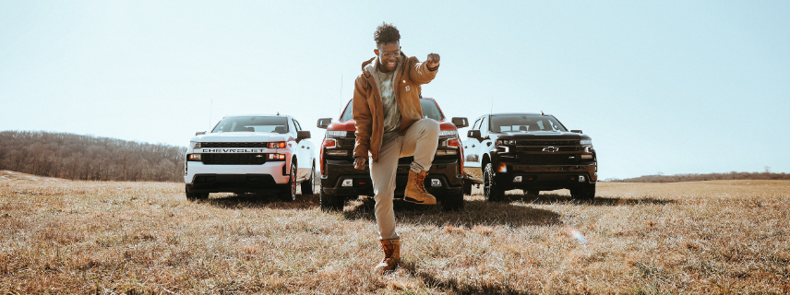

Chevrolet today released a rebooted music video of the hit song “My Truck,” written and performed by the platinum-selling artist BRELAND. Marking the vehicle brand’s TikTok debut, “My Truck” features revamped song lyrics highlighting the Chevy Trucks lineup and dynamic visuals that feature Silverado in a starring role.

The “My Truck” music video is viewable now on Chevrolet’s new TikTok profile, which just launched this February. Chevrolet is one of only a few automotive brands with a channel on TikTok and plans to reach new audiences through the platform.

“Chevy is a brand that loves celebrating trucks and the people who own them,” said Steven Majoros, vice president of Chevrolet Marketing. “BRELAND’s song ‘My Truck’ is so exciting because it is a great representation of why truck customers love their vehicles – they offer a source of adventure, fun, and capability. The reboot of ‘My Truck’ will definitely be a new anthem for Chevy Truck customers.”

While filming the music video, Chevrolet leveraged three distinct locations across Nashville, Tenn. These backdrops not only highlight the beauty of the city, but also represent the diversity of truck customers. Within the video, Chevrolet pairs each location with unique Chevrolet Silverado trims, including the Silverado LT Trail Boss, Silverado LT Trail Boss Midnight Edition and Silverado Custom, showcasing the variety of models available for all types of owners.

“Chevy was the perfect collaborator to breathe new life into ‘My Truck’ because they truly understand what makes truck culture so special.” said BRELAND. “They appreciate that truck enthusiasts are getting younger and more diverse, and that insight was the inspiration for the original version of the song. Coming to the table with that shared perspective made the collaborative process of rewriting ‘My Truck’ so much fun.”

To find more information about the “My Truck” video collaboration and behind-the-scenes footage, please visit webcargo.net/l/0YEqWVpg8S/.

ABOUT CHEVROLET
Founded in 1911 in Detroit, Chevrolet is now one of the world's largest car brands, available in 79 countries with more than 3.2 million cars and trucks sold in 2020. Chevrolet models include electric and fuel-efficient vehicles that feature engaging performance, design that makes the heart beat, passive and active safety features and easy-to-use technology, all at a value. More information on Chevrolet models can be found at www.chevrolet.com.

ABOUT BRELAND
New Jersey-born BRELAND began writing songs as a teenager, inspired by a diverse collection of sounds and eclectic artists like the Beatles, Rascal Flatts, Prince, and his number-one influence, Stevie Wonder. While attending Georgetown University, BRELAND knocked on every possible music-industry door and eventually broke through as a songwriter, landing a number of high-profile cuts with rappers like Elhae and YK Osiris. But as he continued to work on his own music, BRELAND soon posted “My Truck” on social media as a challenge to determine whether he could elicit 500 comments – and after smashing that goal, self-released the track to multi-platform success. Along with paving the way for BRELAND’s signing to Bad Realm Records /Atlantic Records, the “My Truck” official video sparked headline-worthy streaming success, including hitting #1 on Spotify’s Global Viral 50 and US Viral 50 charts. Praised by Rolling Stone as “1,000 percent the whole package,” BRELAND has been featured in leading press outlets like Genius, Paper, USA TODAY and Billboard’s “Emerging Artists Spotlight,” and last April released a remix of “My Truck” featuring Country superstar Sam Hunt alongside an official video. BRELAND’s self-titled EP debut arrived in May 2020, featuring both versions of “My Truck” and five other standout co-writes – including the incredible animated visual to “Hot Sauce.” Following his debut EP, BRELAND released a two-song compilation in honor of Juneteenth, Rage & Sorrow.

BRELAND CONTACT:
Fairley McCaskill
Atlantic Records
Fairley.mccaskill@atlanticrecords.com

CHEVY CONTACT:
Kyle Suba
Chevrolet Communications
Kyle.Suba@Chevrolet.com

