FOR IMMEDIATE RELEASE
FEBRUARY 28TH, 2020

GRAMMY AWARD-WINNING RODDY RICCH REVEALS HIGHLY-ANTICIPATED
CINEMATIC COMPANION TO “THE BOX”

“THE BOX” LOGS A 7TH WEEK AT #1 ON BILLBOARD HOT 100
CROWNS THE HOT R&B/HIP-HOP & HOT RAP SONGS

RAPPER LAUNCHES HIS HOME DÉCOR COMPANY RICCH ESSENTIALS
PRE-ORDER “BITCH DON’T WEAR NO SHOES IN MY HOUSE” WELCOME MAT HERE

PLEASE EXCUSE ME FOR BEING ANTISOCIAL DEBUTED AT NO. 1 ON BILLBOARD 200
SPENT FOUR NON-CONSECUTIVE WEEKS AT #1

3X GRAMMY® AWARD-NOMINATED RAPPER RECENTLY WRAPPED
HIS DEBUT HEADLINE TOUR, THE SOLD-OUT ANTISOCIAL TOUR

PLEASE EXCUSE ME FOR BEING ANTISOCIAL AVAILABLE NOW HERE

WATCH “THE BOX” HERE

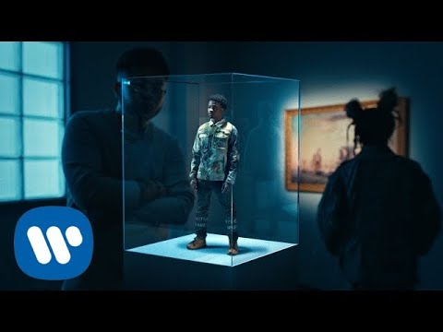
DOWNLOAD HIGH-RES COVER ART HERE

GRAMMY® Award-winning and 3x GRAMMY® Award-nominated rapper Roddy Ricch unveils today the companion visual to his chart-dominating, breakout track “The Box.” The highly cinematic official video, co-directed by Christian Breslauer and Roddy Ricch, arrives on the single’s 7th non-consecutive week at #1 on the Billboard’s Hot 100. The Compton rapper also launched his home décor company this week – Ricch Essentials. The line’s debut item, the ‘Bitch Don’t Wear No Shoes In My House” welcome mat,’ is now available for pre-order HERE. Watch “The Box” HERE; Please Excuse Me For Being Antisocial available now to stream/download HERE.

“The Box” continues to crown the Hot R&B/Hip-Hop charts and Hot Rap Songs charts. Please Excuse Me for Being Antisocial also spent four non-consecutive weeks at #1 on the Billboard 200 albums chart; last artist to have four separate visits to No 1. On that chart was Taylor Swift’s 1989 in February 2015. He also made his debut late night performance on The Tonight Show Starring Jimmy Fallon with back to back performances of “The Box” and “Ballin,” where he brought out Mustard.

Roddy is the first rapper to have two weeks with concurrent #1’s as a lead artist on their first chart toppers since Kanye West did it with “Gold Digger” and Late Registration in September 2005. With Please Excuse Me For Being Antisocial topping the Top 200 for a third week, Roddy is the first rapper to spend three weeks at #1 on their debut album since 50 Cent in 2003 with Get Rich Or Die Tryin. Roddy is the first hip-hop artist to have #1’s on the Top 200 and Hot 100 charts in the same week since Drake did in the week ending August 8th of 2018 with Scorpion and “In My Feelings.” He is the only artist besides Drake to have accomplished this feat in hip-hop in the last couple years. Both Post Malone and Travis Scott both narrowly missed the achievement in 2018. PLEASE EXCUSE ME FOR BEING ANTISOCIAL is the first debut rap album to return to the number one spot on the US albums chart since The Game’s The Documentary fifteen years ago.

PLEASE EXCUSE ME FOR BEING ANTISOCIAL debuted at number 1 on the Billboard 200 chart and Rolling Stone Top 200 Albums chart with his album PLEASE EXCUSE ME FOR BEING ANTISOCIAL. 16-song set, which includes features from Gunna, Ty Dolla $ign, and Mustard, earned 101,500 album-equivalent units in its first week. His long awaited major label debut album, PLEASE EXCUSE ME FOR BEING ANTISOCIAL, is available now via Atlantic Records HERE.

PLEASE EXCUSE ME FOR BEING ANTISOCIAL includes iconic features from such superstars as Meek Mill, Ty Dolla $ign, Mustard, and Lil Durk alongside such stellar new singles as “Tip Toe (Feat. A Boogie Wit Da Hoodie),” “Start Wit Me (Feat. Gunna),” and “Big Stepper,” all of which are joined by companion visuals streaming now at the official Roddy Ricch YouTube channel HERE. “Tip Toe (Feat. A Boogie Wit Da Hoodie)” arrived mere days after Ricch was honored with three prestigious GRAMMY® Award nominations, which include “Best Rap Performance” and “Best Rap Song” for Nipsey Hussle’s “Racks In The Middle (Feat. Roddy Ricch & Hit-Boy),” as well as a “Best Rap/Sung Performance” nod for Mustard’s “Ballin (Feat. Roddy Ricch).” The electrifying new track arrived with an equally spectacular companion video, directed by Christian Breslauer (YNW Melly, Chris Brown) and streaming HERE.

Ricch – who recently heralded PLEASE EXCUSE ME FOR BEING ANTISOCIAL with an incredible halftime performance at the Los Angeles Clippers’ victory over the Houston Rockets on November 22nd, streaming HERE – is set to embark on his epic first-ever North American headline tour. The Antisocial Tour begins Saturday, December 28th at Los Angeles, CA’s world-famous Hollywood Palladium and then continues into February 2020. For complete details and ticket information, please visit www.roddyricchofficial.com/tour.

Named earlier this year to the 2019 XXL Freshman Class, Ricch has just been nominated for two leading BET Hip Hop Awards, including “Best New Artist” and “Best Mixtape,” the latter honoring 2018’s FEED THA STREETS II, available for streaming and download HERE. The mixtape – which marked Ricch’s SoundScan/Billboard 200 chart debut – sees him teaming up with some of hip hop’s top studio superstars, including Scott Storch (Post Malone, T.I., Young Thug), Cassius Jay (Cardi B, Migos, Gucci Mane), and hot emerging producer Sonic. FEED THA STREETS II is highlighted by such tracks as “Every Season” and “Die Young,” both available at all DSPs and streaming services. The “Die Young” companion visual – also directed by JD Films – also proved a viral favorite, with individual YouTube views exceeding 79 million HERE.

Wise beyond his years, schooled in real-life struggles, and eloquently effective, Roddy Ricch clearly and concisely conveys truth by way of cinematic rhymes and catchy hooks. The self-proclaimed “illustrator of the streets” uploaded his first single, “Ricch N****” to SoundCloud in 2016 and immediately caught fire, generating more than 200,000 streams within two months. He followed up with his debut mixtape, FEED THA STREETS, streaming HERE. The project includes the breakthrough hit single, “Fucc It Up,” accompanied by a smash companion video, now boasting close to 30 million individual views via Roddy Ricch’s official YouTube channel HERE.

As if all that weren’t enough, Ricch teamed with Marshmello for 2018’s worldwide hit single, “Project Dreams,” joined by an official video currently with over 61 million YouTube views HERE. More recently, Roddy teamed with Mustard for the GRAMMY® Award-nominated smash, “Ballin’ (Feat. Roddy Ricch),” joined by a companion visual boasting over 34 million views HERE. In addition, Roddy went in depth on “Ballin” in an exclusive installment of Genius’ “Verified,” streaming HERE.

PLEASE EXCUSE ME FOR BEING ANTISOCIAL
TRACKLISTING
- Intro
- The Box
- Start Wit Me (Feat. Gunna)
- Perfect Time
- Moonwalkin (Feat. Lil Durk)
- Big Stepper
- Gods Eyes
- Peta (Feat. Meek Mill)
- Boom Boom Room
- High Fashion (Feat. Mustard)
- Bacc Seat (Feat. Ty Dolla $ign)
- Roll Dice
- Prayers To The Trap God
- Tip Toe (Feat. A Boogie Wit Da Hoodie)
- War Baby

RICCH ESSENTAILS
Pre-order official welcome mats HERE
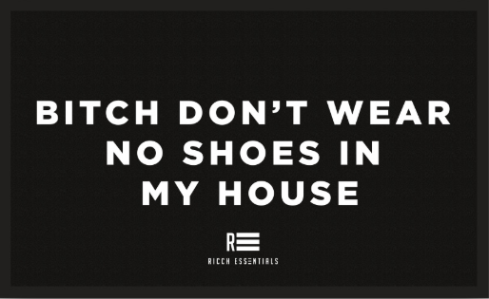 | 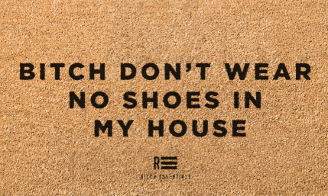 | 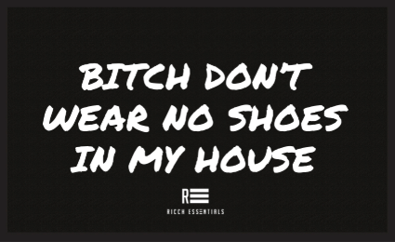

# # #
CONNECT WITH RODDY RICCH
OFFICIAL I TWITTER | SOUNDCLOUD | YOUTUBE | INSTAGRAM

PRESS CONTACT
Brittany Bell | Brittany.Bell@atlanticrecords.com

