FOR IMMEDIATE RELEASE
MARCH 1, 2021

ATLANTIC WELCOMES JASON DERULO TO GROUNDBREAKING ROSTER

MULTI-PLATINUM GLOBAL SUPERSTAR CELEBRATES HIS
FUTURE HISTORY LABEL PARTNERSHIP WITH ATLANTIC RECORDS

LISTEN TO RECENT SINGLE “LIFESTYLE” FT. ADAM LEVINE:
JASONDERULO.LNK.TO/LIFESTYLE

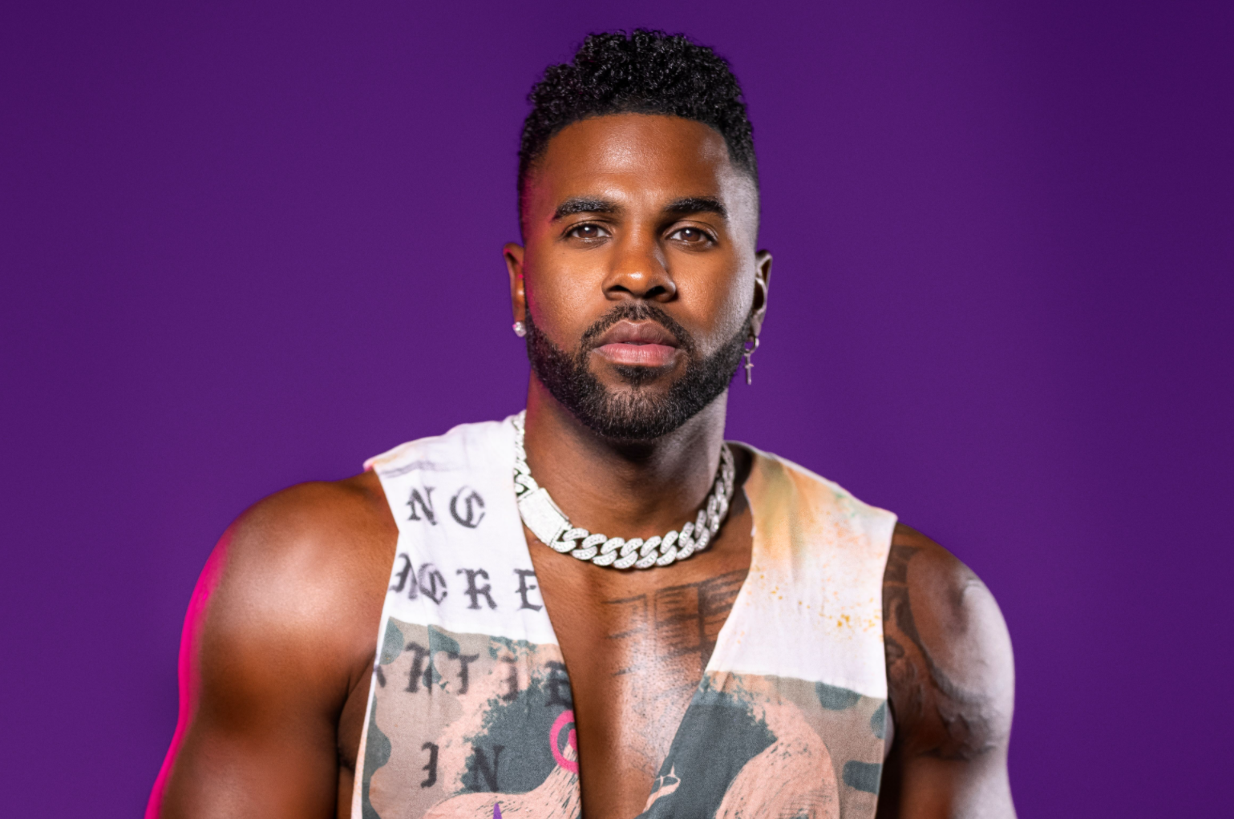
DOWNLOAD HIGH-RES PHOTO

Atlantic Records is proud to announce the signing of multi-platinum global superstar Jason Derulo to its historic roster. This signing also celebrates an incredible partnership with Derulo’s Future History label and Atlantic Records. “Lifestyle” ft. Adam Levine is available now via Future History/APG/Atlantic Records at all DSPs and streaming services HERE. Variety broke the story HERE.

“For this next phase of my career finding a 50/50 partner and owning my masters was important to me, and the fact that Atlantic understood my vision from a creative and business perspective makes this a perfect match,” says Jason Derulo. “I want to thank Julie, Craig, and the entire Atlantic team and all the fans who continue to support me. I couldn’t be more excited to have found a home. I’m gearing up for the most exciting era of my career. I can’t stress enough how great it feels to be with an incredible label that believes in my vision as much as I believe in their abilities to move mountains in the music industry globally.”

“Jason’s relationship with WMG began with a string of multi-platinum successes at Warner Records,” notes Atlantic Records’ Craig Kallman, Chairman/CEO and Julie Greenwald, Chairman/COO. “Over this past year, we’ve been fortunate to work successfully alongside him through our partnership with Mike Caren’s APG, which led naturally to bringing Jason fully into the Atlantic family with this new long-term deal. He’s an amazing singer and songwriter, an incredible dancer, and a phenomenal performer, and we’re thrilled to welcome him to the label.”

As the 11th most popular TikTok account with more than 43 million followers and over 992 million likes thus far, Jason Derulo is currently among TikTok’s top superstars and the most popular active platinum-selling musician across the entire platform. His astronomical success on the platform has made the pop sensation a force to be reckoned with as his original TikTok sounds have inspired over 10 million videos and counting.

Most recently, global DJ superstar David Guetta put his touch on the remix of “Lifestyle” ft. Adam Levine. The single marks the latest in a seemingly endless run of mega hit releases from Derulo, including such worldwide smashes as “Take You Dancing” and Jawsh 685 & Jason Derulo’s 2x RIAA platinum certified chart-topper, “Savage Love (Laxed – Siren Beat).” The latter track and its official BTS remix proved an unstoppable international sensation upon its arrival last summer, peaking at #1 on Billboard’s Hot 100 as well as atop charts in 16 additional countries around the world. “Savage Love” now boasts over 625 million worldwide streams.

CONNECT WITH JASON DERULO
OFFICIAL | INSTAGRAM | TWITTER | FACEBOOK | YOUTUBE | TIKTOK

PRESS CONTACT
FAIRLEY MCCASKILL | FAIRLEY.MCCASKILL@ATLANTICRECORDS.COM

