FOR IMMEDIATE RELEASE
MARCH 19, 2021

BRELAND GOES “CROSS COUNTRY” WITH MICKEY GUYTON
LISTEN HERE

NEW VERSION OF THE ACCLAIMED SINGLE OUT TODAY

TUNE IN: BRELAND TO PERFORM NATIONAL ANTHEM AT SUNDAY’S (3/21) NASCAR CUP SERIES RACE AT ATLANTA MOTOR SPEEDWAY

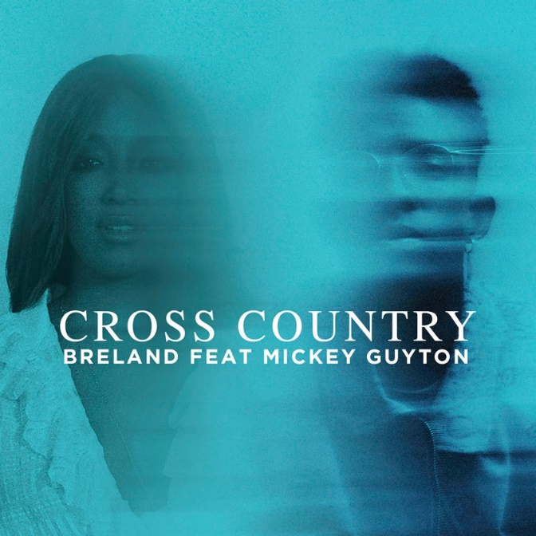
DOWNLOAD HIGH-RES ARTWORK HERE

Bad Realm Records / Atlantic Records breakout talent BRELAND is fueling up his personal and powerful single “Cross Country,” with a brand-new rendition featuring GRAMMY-nominated singer/songwriter Mickey Guyton, out today. The autobiographical track resonates with each of their respective journeys into the spotlight and comes on the heels of Guyton’s soul-stirring GRAMMY performance.

LISTEN TO BRELAND’S “CROSS COUNTRY” (FEAT. MICKEY GUYTON) HERE

The star-studded addition of Guyton follows an outpouring of praise for “Cross Country” since its release on February 26. Named a “Song You Need to Know” by Rolling Stone claiming “It’s the kind of emotive storytelling country music was built on”, the song was lauded by The New York Times’ “The Playlist” as "pop-friendly, crisply melodic, tender" and "something of a rebuke, especially to those who might still be inclined to police country music’s borders." Billboard noted BRELAND's ability to showcase "a totally different side — and his enchanting singing voice" in their "First Country" compilation of the best new Country songs, while NPR featured it on their New Music Friday playlist.

Set to share his revered vocals with an audience coast to coast, BRELAND will perform the national anthem on Sunday (3/21) ahead of the NASCAR Cup Series race at the Atlanta Motor Speedway. The appearance will broadcast at 3:00 P.M. on FOX.

BRELAND continues to charge into 2021 full-speed after partnering with Chevrolet for the launch of the brand’s TikTok channel, releasing a rebooted music video for his PLATINUM-certified smash “My Truck.” He is currently starring in Tommy Jeans’ Spring ‘21 campaign in Macy’s stores across the country featuring musicians, poets, and activists from diverse walks of life sharing their unique perspectives on utilizing music to drive social change.

CONNECT WITH BRELAND
INSTAGRAM | FACEBOOK | TWITTER | YOUTUBE | SOUNDCLOUD
CONNECT WITH MICKEY GUYTON
INSTAGRAM | FACEBOOK | TWITTER | YOUTUBE | SOUNDCLOUD
ABOUT BRELAND
New Jersey-born BRELAND began writing songs as a teenager, inspired by a diverse collection of sounds and such eclectic artists as the Beatles, Rascal Flatts, Prince, and his number-one influence, Stevie Wonder. While attending Georgetown University, BRELAND knocked on every possible music-industry door and eventually broke through as a songwriter, landing a number of high-profile cuts with rappers like Elhae and YK Osiris. As he continued to work on his own music, BRELAND posted “My Truck” on social media as a challenge to determine whether he could elicit 500 comments – and, after smashing that goal, self-released the track to multi-platform success. Along with paving the way for BRELAND’s signing to Bad Realm Records/Atlantic Records, the “My Truck” official video sparked headline-worthy streaming success, including hitting #1 on Spotify’s Global Viral 50 and US Viral 50 charts. Praised by Rolling Stone as “1,000 percent the whole package,” BRELAND has been featured in leading press outlets like Genius, Paper, USA TODAY and on Billboard’s “Emerging Artists Spotlight.” His self-titled debut EP arrived May 2020 featuring the “My Truck” remix with country superstar Sam Hunt, followed by a two-song compilation in honor of Juneteenth, Rage & Sorrow. BRELAND is kicking off 2021 with his brand-new single "Cross Country," along with its official music video.

ABOUT MICKEY GUYTON
Mickey Guyton was born in Arlington, Texas and began singing in church at a young age. She was drawn to a variety of artists with big voices including Dolly Parton, Cece Winans, Whitney Houston and LeAnn Rimes. After signing to Capitol Records Nashville, Mickey’s first appearance was an all-star concert at the White House captured by PBS. In 2015 she released her self-titled EP featuring her debut single “Better Than You Left Me.” The following year she was nominated for her first Academy of Country Music Award for New Female Vocalist. Mickey returned to the ACM Awards in 2019 performing “I’m Standing With You” from the BREAKTHROUGH movie soundtrack alongside Chrissy Metz, Carrie Underwood, Lauren Alaina and Maddie & Tae. This last year, Mickey performed her first solo ACM Awards performance of “What Are You Gonna Tell Her?” with labelmate Keith Urban’s accompaniment on piano. The performance, which HITS called “…a Whitney Houston/Beyoncé power-vocal rendition of the glass-ceiling reckoning…” was named one of the best performances of the night. Mickey released her EP, Bridges, last September, which includes “What Are You Gonna Tell Her?”, hailed by Variety as “country music’s song of the year”, as well as, “Black Like Me,” a song Mickey co-wrote in March 2019 at a cross-genre writing camp. Due to demand, “Black Like Me” was released in June 2020 and was named one of the Top 10 songs of 2020 by NPR, Billboard and The Associated Press. Mickey recently made history as the first Black female solo artist to earn a GRAMMY nomination in a country category (Best Country Solo Performance) for “Black Like Me” which she performed as part of the awards ceremony. In addition, Mickey was just announced as a co-host along with Keith Urban for the 56th Academy of Country Music Awards airing on CBS April 18. Mickey and her music have been featured recently by The New York Times, CBS This Morning, NPR, Today, Billboard, The Los Angeles Times, Entertainment Weekly, ELLE, The Washington Post, Paste, Rolling Stone, The Wall Street Journal, American Songwriter and Pollstar.

MEDIA CONTACTS
For BRELAND:
Fairley McCaskill / Fairley.McCaskill@atlanticrecords.com
Jensen Sussman / jensen@sweettalkpr.com

For Mickey Guyton:
Lori Christian / Lori.Christian@umusic.com
Ailie Birchfield / Ailie.Birchfield@umusic.com

