FOR IMMEDIATE RELEASE
MARCH 27th, 2020

THE KID LAROI HOPS ON BANKROL HAYDEN’S “COSTA RICA”

EXPANSIVE 38-DATE TOUR WITH LIL MOSEY CURRENTLY POSTPONED
STAY TUNED FOR UPDATES HERE
WATCH HIS EUROPEAN TOUR VLOG HERE

THE VIRAL HIT “COSTA RICA” RECENTLY AMASSED OVER 50M COMBINED STREAMS
WATCH HERE
STREAM/DOWNLOAD HERE

STREAM/DOWNLOAD “COSTA RICA” FT. THE KID LAROI:
bankrol.lnk.to/CostaRicaRemix

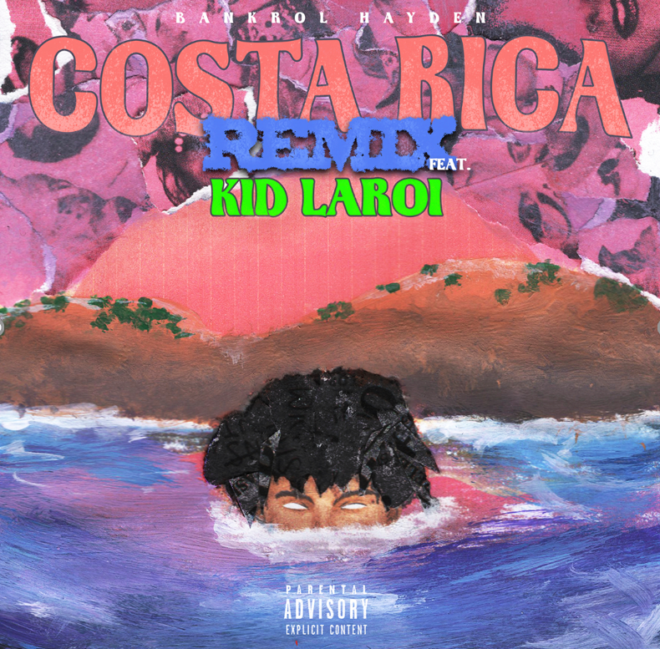
DOWNLOAD HIGH-RES ARTWORK HERE

Atlantic recording artist Bankrol Hayden is staying busy during the Corona madness. So much so, that he hit up The Kid LAROI to hop on “Costa Rica”. Listen to the new track HERE. Part 2 follows the success of the original “Costa Rica,” which recently amassed over 50 million combined streams. “Costa Rica” is available now via Atlantic Records at all DSPs and streaming services HERE; an official companion video premiered on the Modesto, CA-based artist’s wildly popular YouTube channel HERE, and has over 6.2 million views to date.

Bankrol Hayden is currently on the cover of Spotify’s Clout Culture (565k followers). The track is featured on popular Spotify playlists such as Shisha Lounge (721k followers), Most Necessary (2.4M followers), Clout Culture (565k followers), and more. It’s also featured on popular Apple Music playlists The Plug, The New Bay, Rap Life Videos and Gymflow. “Costa Rica” debuted on Spotify’s US and Global viral charts last month, seeing placement on Germany Viral 50, UK Viral 50, Netherlands Viral 50 and more.

Bankrol was recruited to support Lil Mosey on his Certified Hitmaker North American Tour 2020, which followed the European leg that recently wrapped. The expansive 38-date tour kicked off in San Francisco, CA earlier this month, but has since been postponed. Stay up-to-date on tour updates HERE. Watch Bankrol Hayden’s European tour leg vlog HERE; watch the crowd go wild to his viral hit “Costa Rica” at his Norway tour date HERE.

The California native heralded “Costa Rica” with an exclusive preview on his hugely influential Instagram page, joined by fellow social media sensation/artist Einer Bankz. The track marks the latest in a series of increasingly well-liked singles for Bankrol Hayden, following such viral smashes as “B.A.N.K.R.O.L.,” “29,” and “Brothers (Feat. Luh Kel),” the latter now boasting over 70 million worldwide streams thus far.

At just 18 years old, Bankrol Hayden is fast proving a phenomenon, earning fans around the globe with his positive brand of soulful, pop-forward hip-hop. The talented teen broke out in 2017 with a series of viral YouTube videos, including the breakthrough hit, “Drumsticks” feat. MBO ZAY. Along with his musical efforts, Bankrol Hayden is also a major digital influencer and entrepreneur with a combined social media reach exceeding 1.5 million, including a tremendously popular Instagram earning over 150,000 likes per post.

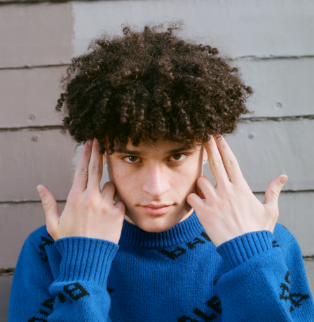
DOWNLOAD HIGH RES PRESS PHOTO HERE
PHOTO CREDIT AIDAN CULLEN

CONNECT WITH BANKROL HAYDEN
INSTAGRAM | TWITTER | YOUTUBE

For additional press assets, please visit his press site HERE.

PRESS CONTACT
FAIRLEY.MCCASKILL@ATLANTICRECORDS.COM

TOUR CONTACT
CHANDLER.OWEN@ATLANTICRECORDS.COM

