FOR IMMEDIATE RELEASE
APRIL 30, 2021

LIL EAZZYY IS ROOKIE OF THE YEAR

CHICAGO RAPPER DROPS MAJOR LABEL DEBUT MIXTAPE
STREAM ROOKIE OF THE YEAR

WITH FEATURES FROM G HERBO, TAY KEITH, BIZZY BANKS & IV JAY

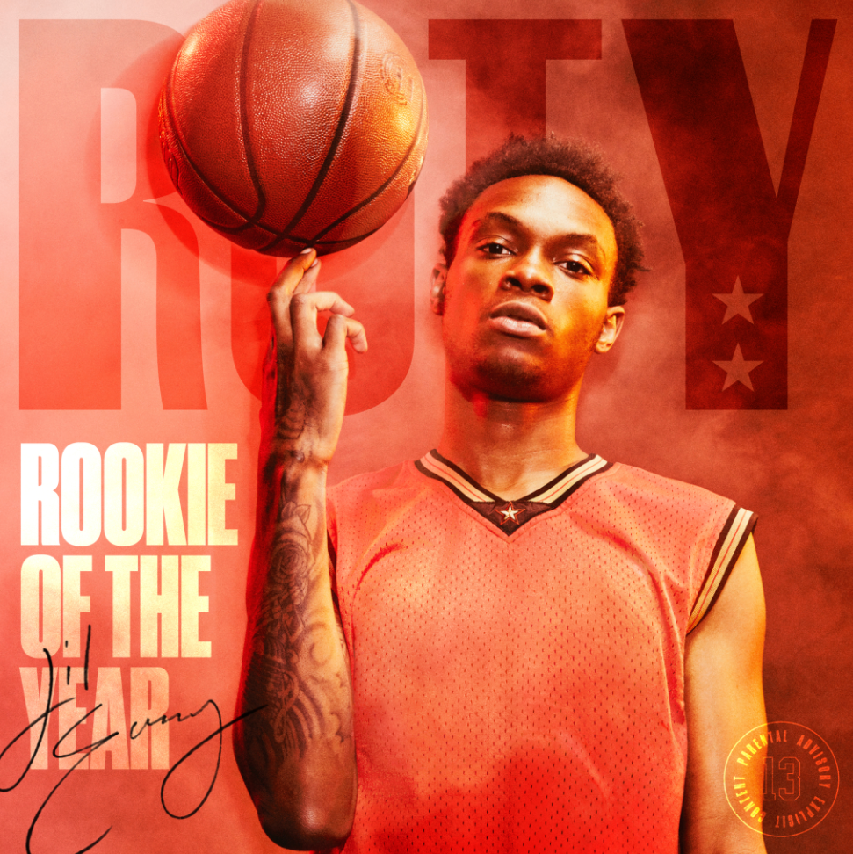
DOWNLOAD HIGH-RES COVERART

In any sport, rookie year sets the tone for the future. Traditionally, the NBA has recognized lifelong champions with the coveted title of Rookie of the Year. Now hip-hop has its 2021 entry into this exclusive winner’s circle. After racking up 100 million-plus streams and landing on Rappers to Watch in 2021 lists by Complex, UPROXX, and more, Lil Eazzyy positions himself as the game’s next champion on his debut mixtape Rookie of the Year.

“I wanted to come out with the strongest mixtape of the year,” he exclaims. “I love basketball, so I always knew the title was going to be Rookie of the Year. This is literally my rookie year in rap, and I believe I’m the best person getting into the business right now.”

The Chicago native backed up this claim by locking himself in the studio, logging marathon sessions and devoting countless hours to his craft. In early 2021, he flew out to Los Angeles and recorded the bulk of Rookie of the Year on the West Coast. Lil Eazzyy teamed up with fellow Chicago native G Herbo for the “Onna Come Up Remix,” racking up more than 31.4 million streams and over 2.4 million views of its official video. He continued to charged up this next chapter with “Freestyle,” where he punched in with relentless rhymes, illuminating his dizzying lyricism. He maintained this momentum with the hypnotic grind of “Yes Or No” [feat. IV JAY]. Meanwhile, the single “Hunnid or Better” [feat. Bizzy Banks] hinges on his rapid-fire flow punctuated by lyrical acrobatics. Brooklyn drill phenomenon Bizzy Banks pulls up with an equally menacing guest spot, cutting through the airy synths.

“I just want people to listen to the full project top-to-bottom,” he leaves off. “This is what I love to do, and I hope you get to know me through the music.”

ABOUT LIL EAZZYY
Driven by a fiercely competitive spirit, Chicago rap phenomenon Lil Eazzy puts up bars with Steph Curry-level accuracy, while tenaciously tearing through production with enough endurance and stamina to last four quarters plus overtime. Coming out of the gate swinging as a high school senior, he announced himself with “Finesse” in 2019 before posting up millions of streams via “Listen Up,” “Letter To Tracy,” and “Yerk Attack.”

Almost in tandem with his graduation, “Onna Come Up” popped off as a viral phenomenon, reaching 1 million streams per week in September 2020 and continues to trend upward on the Spotify US Top 200 while amassing over 69.5 million streams to date. The track was featured in video montages by top Fortnite players such as Chronic Hazard, cxltures, Yusa, Keeny, Fakeify, and more. It vaulted to #6 on the Spotify US Viral 50 and #14 on the Global Viral 50 in addition to capturing #21 on Rolling Stone’s Breakthrough 25 chart.

The single lit the fuse for Underrated, his debut EP which Lyrical Lemonade touted as The 8th Best Chicago Project of 2020. The Chicago rapper covered prominent playlists such as Spotify’s Rap Caviar and Most Necessary, Tidal’s Viral Hype and New Midwest, Amazon’s Breakthrough Hip Hop. Spotify’s premier playlist Rap Caviar named him one of the top ten artists to watch in 2020. He also landed on Rappers to Watch in 2021 lists by Complex, UPROXX, and more. Plus, he joined the bill of Cyberwurld Fest headlined by Playboi Carti for his first live virtual performance.

ROOKIE OF THE YEAR TRACK LISTING
- Introduction (Produced by DVLP and Kyle Van Riper)
- Spinnin ft. Tay Keith (Produced by Tay Keith)
- Why (Produced by Westen Weiss)
- Hunnid Or Better ft. Bizzy Banks (Produced by Iceberg, Maddox Grayson, and Sam Beats)
- MVP (Produced by Westen Weiss and BeazyTymes)
- Trials (Produced by Nick Mira)
- Ride Together (Produced by Westen Weiss and BeazyTymes)
- Warning (Produced by Pressrecordbeatz and Kid Marquis)
- Play For Keeps (Produced by Westen Weiss and Smash David)
- Freestyle (Produced by Laykx)
- Pain For This (Produced by Nick Mira)
- Yes Or No ft. IV JAY (Produced by Iceberg, Sephgotwaves, and Shoki)
- Outta Pocket (Produced by Hugo Black)
- Onna Come Up ft. G Herbo [Remix] (Produced by Hugo Black)

CRITICS REACT TO LIL EAZZYY:
The new movement of voices for the Chicago streets is in full swing, and Lil Eazzyy is chief among them.
COMPLEX

Eazzyy raps in rolling, rapid, and sometimes melodic cadence that other journalists have compared to Polo G and G Herbo, but Eazzyy raps with such polish and athleticism that similarities fade. You’re only focused on catching every bar.
SPIN

Lil Eazzyy has clearly made a beyond sturdy case as to why he is a completely different kind of artist . . . he is on a mission to blaze a trail of his own in the Chicago music scene.
LYRICAL LEMONADE

[Lil Eazzyy] is beginning to live out his dreams, tasting early rap success and garnering national recognition.
XXL
For additional information + press assets, visit his press site HERE.
PHOTO CREDIT: JIMMY FONTAINE

CONNECT WITH LIL EAZZYY
TWITTER | INSTAGRAM | SPOTIFY | YOUTUBE | SOUNDCLOUD

LIL EAZZYY PRESS CONTACT
BRITTANY BELL | BRITTANY.BELL@ATLANTICRECORDS.COM

