FOR IMMEDIATE RELEASE
MAY 8TH, 2020

BRELAND CHARGES AHEAD WITH NEW TRACK "HORSERIDE" TODAY (MAY 8)

FOLLOWS STREAMING SMASH "MY TRUCK" AND
SAM HUNT REMIX

HIGHLY-ANTICIPATED EP DEBUT, BRELAND, ARRIVING MAY 22
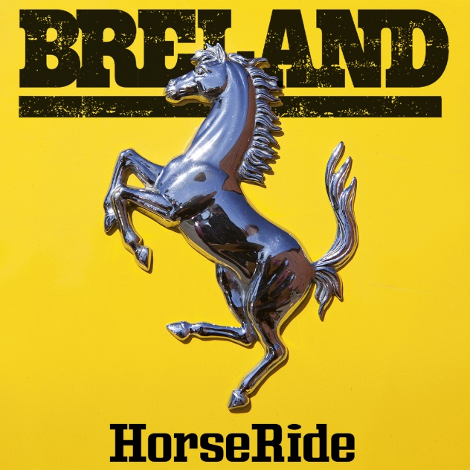

DOWNLOAD ART

NASHVILLE, TENN. (May 8, 2020) – Emerging Bad Realm/Atlantic Records artist BRELAND charges ahead with the new track “Horseride” and adjoining lyric video today (5/8), dropping the gate on another bold Country-trap anthem.
Released by the Atlanta-based singer/songwriter and self-described “cultural bridge,” the fleet-footed anthem once again mixes Rap and Country flavor in fearless style, fusing swift beats with BRELAND’s attitude.
Arriving just ahead of his debut EP, BRELAND (out May 22), it’s yet another glimpse of a genre-bending challenger Rolling Stone calls “1,000 percent the whole package.”
“’Horseride’ was the first song I made with my friend Eddie Bans [co-writer on ‘My Truck’] after signing my record deal,” shared BRELAND. “We were back in Atlanta and the energy in the room was so high, it was only right we made a song like ‘Horseride.’ I hope people have as much fun listening to it as I did creating it.”

DOWNLOAD OR STREAM BRELAND’S “HORSERIDE” HERE.

A New Jersey native and stunning vocalist behind the Country-trap smash, “My Truck,” BRELAND exploded onto the music scene in late 2019 by hitting #1 on Spotify’s Global Viral 50 and US Viral 50 charts. Showcasing tremendous depth of talent and matching his massive appeal with tightly-honed musicianship, the surprise hit has inspired more than 565,000 TikTok visuals to date and also landed on the largest Country playlist on Spotify – the Hot Country playlist with 5.8 Million followers.
Meanwhile, BRELAND and “My Truck” have also attracted the attention of like-minded Country superstar Sam Hunt, who contributed new verses and his multi-PLATINUM vocals to an attention-grabbing remix of the track in April. Continuing to gather rave reviews from the press, Billboard writes “’My Truck’ shouldn’t stand in the shadow of any song, even a Hot 100 record-breaker,” while Sterogum adds “The banjo-laced, 808-powered beat is nearly as contagious as BRELAND’s hook.”
With excitement and notoriety continuing to build, BRELAND’s self-titled EP debut is slated for release May 22.
ABOUT BRELAND
New Jersey-born BRELAND began writing songs as a teenager, inspired by a diverse collection of sounds and eclectic artists like the Beatles, Rascal Flatts, Prince, and his number-one influence, Stevie Wonder. While attending Georgetown University, BRELAND knocked on every possible music-industry door and eventually broke through as a songwriter, landing a number of high-profile cuts with rappers like Elhae and YK Osiris. But as he continued to work on his own music, BRELAND soon posted “My Truck” on social media as a challenge to determine whether he could elicit 500 comments – and after smashing that goal, self-released the track to multi-platform success. Along with paving the way for BRELAND’s signing to Bad Realm/Atlantic Records, “My Truck” sparked headline-worthy streaming success, including hitting #1 on Spotify’s Global Viral 50 and US Viral 50 charts. Praised by Rolling Stone as “1,000 percent the whole package,” BRELAND has been featured in leading press outlets like Genius, Paper, USA TODAY and Billboard’s “Emerging Artists Spotlight,” and in April released a remix of “My Truck” featuring Country superstar Sam Hunt. BRELAND’s self-titled EP debut will arrive on May 22.

CONNECT WITH BRELAND

INSTAGRAM | FACEBOOK | TWITTER | YOUTUBE | SOUNDCLOUD

MEDIA CONTACTS:
Fairley McCaskill / Fairley.McCaskill@atlanticrecords.com
Jensen Sussman / jensen@sweettalkpr.com

