FOR IMMEDIATE RELEASE
MAY 25, 2021

BRELAND GOES “CROSS COUNTRY” ON FIRST-EVER HEADLINE TOUR

TICKETS FOR THE BUCKET-LIST RUN ON-SALE TODAY

NEW MUSIC DROPPING SOON, FOLLOWING CRITICALLY ACCLAIMED
“CROSS COUNTRY” AND PLATINUM SMASH “MY TRUCK”

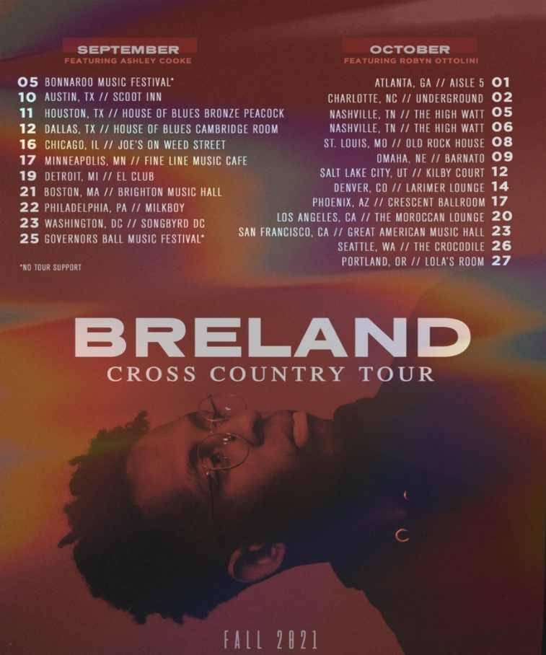
DOWNLOAD TOUR ADMAT

Bad Realm Records / Atlantic Records breakout talent BRELAND will hit the road this fall for his first-ever headline run, the CROSS COUNTRY TOUR. Kicking off September 5 with his high-profile appearance at Bonnaroo Music Festival, BRELAND will perform coast-to-coast in major markets including Chicago, New York, Nashville and Los Angeles.

"I'm headlining my first ever tour!!!," BRELAND shared on Instagram. "I have been waiting for this moment my whole life. I cannot wait to get out on stage and see all of you with my homies Ashley Cooke and Robyn Ottolini, who are incredible artists and performers."

Spotify pre-sale for the CROSS COUNTRY TOUR begins today, with venue/artist pre-sale running from Wednesday, May 26 at 10am local time through Thursday, May 27 at 10pm local time. General on-sale starts Friday, May 28 at 10am local time.

The bucket-list run follows BRELAND’s latest single “Cross Country,” racking up critical acclaim from Billboard, American Songwriter, and Rolling Stone as a “Song You Need to Know,” plus performed for his national television debut on The Kelly Clarkson Show. Taking it to the next level with GRAMMY-nominated singer/songwriter Mickey Guyton, BRELAND released a duet version of “Cross Country” available here.

On the rise since his PLATINUM debut “My Truck” dropped in 2019, BRELAND’s all-star collaborators include Rascal Flatts’ Gary LeVox, Lauren Alaina, Chase Rice, and Keith Urban – who tapped BRELAND to join him on “Out The Cage” featured on his latest album THE SPEED OF NOW PART 1. BRELAND also teamed up with Sam Hunt for the “My Truck” remix, which was recognized by The New York Times and NPR as one of the Best Songs of 2020, and featured on his self-titled debut EP.

The multi-talented singer-songwriter has new music on the horizon, set for release in the coming months.

CROSS COUNTRY TOUR DATES:
Sept. 5 – Bonnaroo Music Festival – Manchester, TN
Sept. 10 – Scoot Inn – Austin, TX*
Sept. 11 – House of Blues Bronze Peacock – Houston, TX*
Sept. 12 – House of Blues Cambridge Room – Dallas, TX*
Sept. 16 – Joe’s on Weed Street – Chicago, IL*
Sept. 17 – Fine Line Music Café – Minneapolis, MN*
Sept. 19 – El Club – Detroit, MI*
Sept. 21 – Brighton Music Hall – Boston, MA*
Sept. 23 – Songbyrd DC – Washington, DC*
Sept. 25 – Governor’s Ball Music Festival – New York, NY
Oct. 1 – Aisle 5 – Atlanta, GA^
Oct. 2 – Underground – Charlotte, NC^
Oct. 5 – The High Watt – Nashville, TN^
Oct. 6 – The High Watt – Nashville, TN^
Oct. 8 – Old Rock House – St. Louis, MO^
Oct. 9 – Barnato – Omaha, NE^
Oct. 12 – Kilby Court – Salt Lake City, UT^
Oct. 14 – Larimer Lounge – Denver, CO^
Oct. 17 – Crescent Ballroom – Phoenix, AZ^
Oct. 20 – The Moroccan Lounge – Los Angeles, CA^
Oct. 23 – Great American Music Hall – San Francisco, CA^
Oct. 26 – The Crocodile – Seattle, WA^
Oct. 27 – Lola’s Room – Portland, OR^

* = featured support: Ashley Cooke
^ = featured support: Robyn Ottolini

ABOUT BRELAND:
With the arrival of his instantly iconic, PLATINUM-certified debut single “My Truck,” singer/songwriter/producer BRELAND emerged as a bold new force on today’s music landscape. Originally from New Jersey, BRELAND moved to Atlanta after graduating from Georgetown University, kicking off his songwriting career by scoring cuts with artists like YK Osiris and Ann Marie. Soon after releasing “My Truck” in late 2019, he saw the wildly catchy hybrid of Hip-Hop and Country hit #1 on Spotify’s Global Viral 50, with a remix featuring Country-hitmaker Sam Hunt landing on best-of-the-year lists from leading outlets like NPR and The New York Times. The song’s breakout success also paved the way for his signing to Bad Realm Records/Atlantic Records, and led to collaborations with heavy-hitters from the Country, Pop, and Hip-Hop worlds (including Gary LeVox of Rascal Flatts, Nelly, Blanco Brown, Lauren Alaina, Chase Rice, and Keith Urban). BRELAND’s early-2021 single “Cross Country” further reveals his passion for transcending boundaries, and continues his mission of breaking down genre barriers and redefining the possibilities of Country music. Now at work on the follow-up to his 2020 self-titled debut EP, the Nashville-based artist made his national TV debut with “Cross Country” on The Kelly Clarkson Show, where she surprised him with a PLATINUM plaque for “My Truck”. He has also been praised by Rolling Stone as “1,000 percent the whole package,” featured on Billboard’s “Emerging Artists Spotlight,” and earned acclaim from major press outlets like Genius, Paper, and USA TODAY. Check out his weekly radio show, Land of the BRE Radio, airing exclusively on Apple Music.

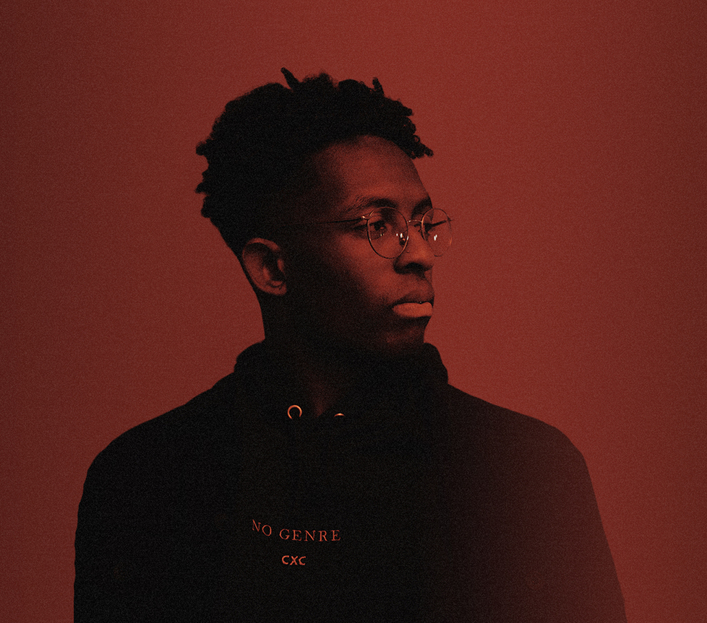
DOWNLOAD HERE | PHOTO CRED: MIKAI KARL

CONNECT WITH BRELAND
INSTAGRAM | FACEBOOK | TWITTER | YOUTUBE | SOUNDCLOUD

PRESS CONTACTS
Fairley McCaskill / Fairley.McCaskill@atlanticrecords.com
Jensen Sussman / jensen@sweettalkpr.com

