FOR IMMEDIATE RELEASE
JUNE 4, 2021

SAM AUSTINS UNVEILS “KILOS” STARTING HIS HOMELESS STAR SAGA
STREAM: LNK.TO/KILOS

OFFICIAL VIDEO RELEASE AND SIGNING ANNOUNCEMENT EXCLUSIVELY VIA BILLBOARD
WATCH: LNK.TO/KILOSVIDEO

DEBUT PROJECT HOMELESS STAR COMING THIS FALL

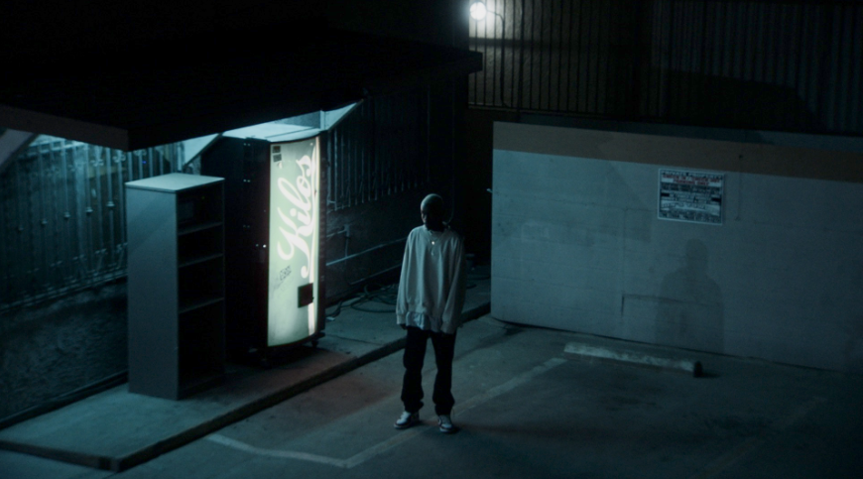
COVER ART | HIGH-RES PRESS PHOTO | PC: SWURVE

Detroit-born and Los Angeles-based artist, model, and maverick creative Sam Austins reveals a new single and music video entitled “KILOS,” out today. He exclusively debuted the music video via Billboard—who noted, “With his musical style, Austins is a boundary-breaker, challenging long-held ideas of what it means to be an alternative artist.”

LISTEN TO SAM AUSTINS’ “KILOS” HERE

“KILOS” hinges on an evocative guitar line offset by a lo-fi beat as Sam Austins’ melodies bubble up over this backdrop. He paints a vivid picture of anxiety in the face of a city in flames with confessions like, “I haven’t slept in a month. These fireworks are like the fourth of July.” The surreal accompanying visual brings his words to life as he leaves a shady motel to roam the empty streets at night before joining a giant Donnie Darko-style bunny in a diner. If Frank Ocean and Johnny Greenwood collab’ed, it might sound something like Sam Austins…

“KILOS” is in some ways my introduction to adulthood, and now it's the world's introduction to me,” notes Austins. “When I wrote it, I was thinking of when I stayed with my aunt on Detroit's west side. In the Midwest, you have ‘100 Days of Summer,’ which is the hottest time of year. People get intense, and murders skyrocket. Everything is basically dangerous. Those aren’t fireworks; they’re gunshots. I was running around the city with my friends. At any moment, something could happen, so I felt like I had to make a song about the trauma that comes with going from the suburbs to somewhere you’ve never been and having to figure out things the hard way."

He has quietly infiltrated music, fashion, and film and television. With buzzing acclaimed tracks under his belt, including a co-write on Big Sean’s gold-selling “Wolves” [feat. Post Malone], he notably just joined Sir Chloe and Kaytranada for a Vogue interview and spread in book and online. Vogue observed how he “went down rabbit holes of creativity.”

However, everything sets the stage for the release of his debut project, HOMELESS STAR, due out this fall. Stay tuned for more as Sam Austins redefines “alternative” in 2021.

ABOUT SAM AUSTINS
Sam Austins doesn’t just make music; he’s building out a world. This place is equally inspired by the likes of the defiantly vulnerable Frank Ocean, the melodies of nineties alternative, and mythologies of sci-fi classics such as Star Wars. Following high school, he slept on floors, bounced from friend to friend, and crashed in the back of his beat-up Impala. He moved in with an aunt in the inner city of Detroit and turned the focus to music. He dropped the GOAT EP on Soundcloud and opened for the likes of Vince Staples, Juicy J, Danny Brown, and Playboi Carti. During a random encounter in the studio, fashion magnate Phillip Lim heard Sam Austins’ ANGST EP and invited him to be an honorary guest at his 2017 NYFW show. linked up with multiplatinum producers Take A Daytrip and dropped “Fiji Water,” amassing 774K Spotify streams. He joined forces with Black Milk on “Black NASA.” Along the way, he landed placements in VH1’s Love & Hip-Hop and HBO’s Euphoria. In late 2019, he became the recipient of TIDAL’s Unplugged Grant and recorded “LAST MONEY,” “WINGS,” and “STAR.” By 2020, he caught the attention of APG/Atlantic Records. Not to mention, he co-wrote the gold-selling “Wolves” [feat. Post Malone] from Big Sean’s #1 blockbuster Detroit 2. After amassing millions of streams and attracting looks from the likes of Vogue, HYPEBEAST, and Pigeons & Planes, the Los Angeles-based multi-hyphenate opens up this world on his 2021 project HOMELESS STAR led by the single “KILOS.”

PRESS CONTACT:
Fairley McCaskill | Fairley.McCaskill@atlanticrecords.com

