FOR IMMEDIATE RELEASE
JUNE 8TH, 2020

RAEDIO, ATLANTIC RECORDS AND HBO® RELEASE LATEST SINGLE OFF FORTHCOMING
INSECURE®: MUSIC FROM THE HBO ORIGINAL SERIES, SEASON 4 SOUNDTRACK

PINK SWEAT$’ “CADILLAC DRIVE” FT. PRICE DEBUTED ON THE NINTH EPISODE OF INSECURE SEASON 4
SUNDAY, JUNE 7TH ON HBO®

POWERFUL TRACK DROPS ALONGSIDE OFFICIAL COMPANION VISUAL
AVAILABLE TO STREAM VIA YOUTUBE

INSECURE®: MUSIC FROM THE HBO ORIGINAL SERIES, SEASON 4 SOUNDTRACK AVAILABLE JUNE 12TH

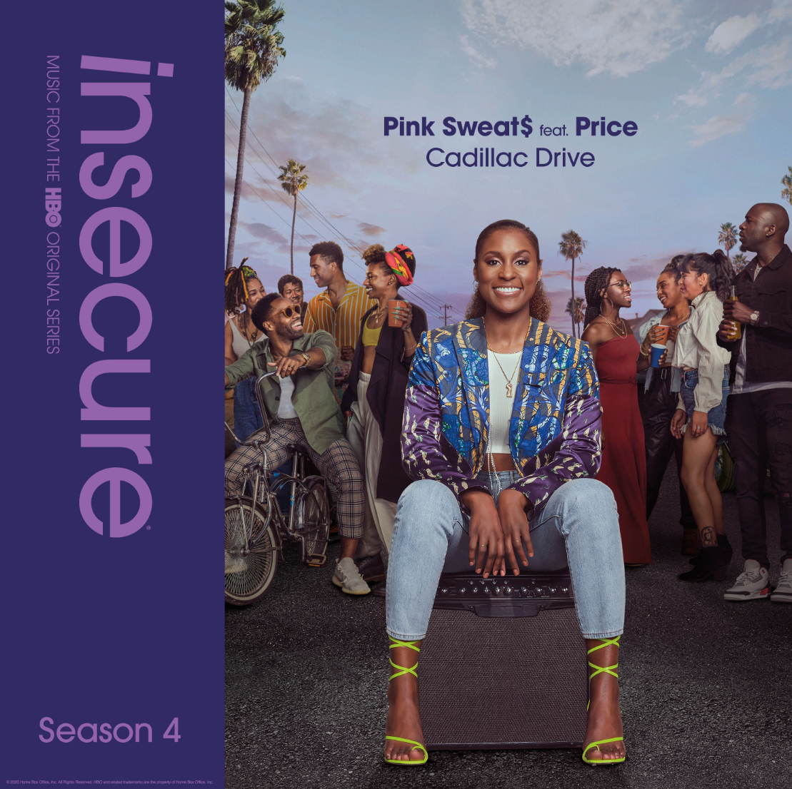
DOWNLOAD HIGH-RES COVER ART HERE

Raedio, Atlantic Records and HBO® release the latest track off the forthcoming INSECURE: Music From the HBO Original Series, Season 4 soundtrack. Pink Sweat$’ “Cadillac Drive” ft. Price delivered the musical backdrop for last night’s episode of the award-winning HBO® series, INSECURE. Listen to “Cadillac Drive” ft. Price HERE. Today, the track receives an incredible companion visual – watch the official video via YouTube. The series will be available on HBO NOW, HBO GO, HBO On Demand and partners’ streaming platforms. INSECURE: Music From the HBO Original Series, Season 4 soundtrack is set for a June 12th release.

“’Cadillac Drive’ is a lot more edgy than my usual sound,” notes Pink Sweat$. “A number of the episodes portray the beauty and sexiness of one’s blackness, so I tapped into that energy for this record.”

Last week’s episode featured Baby Rose’s “Show You” Remix Feat. Q. Last month, TeaMarrr’s “Temperature” brought her quintessential ‘really really raw’ element to the soundtrack. The track dropped alongside a colorful companion visual, bringing the visceral, euphoric single to life. Previous releases included Jidenna’s “Feng Shui,” Ravyn Lenae’s “Rewind,” Poe Leos’ “Look At Me” and Yung Baby Tate’s “Do Me Like That” (ft. Buddy). Further, the soundtrack includes Jucee Froot’s irresistible “Eat Itself,” Cautious Clay’s “Reaching” (ft. Alex Isley), St. Panther’s “Infrastructure,” and Yung Baby Tate’s “Never Lonely” (ft. Jozzy).

INSECURE: Music From the HBO Original Series, Season 4 will feature brand new tracks from a diverse array of major artists and rising stars. The soundtrack is guaranteed to elevate the bar for music culture.

ABOUT RAEDIO
Launched in 2019, Raedio serves artists and creators at the highest level as an “audio everywhere company,” operating as the home to a dynamic roster of talent. Most importantly, Raedio extends a platform across media to align acts with film and television projects, commercials, podcasts, and beyond. Raedio also provided music supervision services for HBO’s critically acclaimed A Black Lady Sketch Show℠.

For more information, please visit: insecuresoundtrack.com, twitter.com/theraedio and
www.instagram.com/theraedio.

ABOUT PINK SWEAT$
Hailed by ROLLING STONE as “An artist you need to know,” Philadelphia-native singer-songwriter-producer Pink Sweat$ has drawn international applause for his utterly unique brand of genre-smashing contemporary soul, marked by lyrical complexity, melodic power, and true vocal majesty. He began making music at the age of 19, cutting demo vocals at Philly’s legendary Sigma Sounds Studios. There he began his career as a songwriter and producer, teaming with a wide range of artists spanning Tierra Whack to Florida Georgia Line. In 2018, Pink Sweat$ fully stepped into the spotlight with his extraordinary debut EP, VOLUME 1, which began accruing major attention in an array of top media outlets around the world. “(Pink Sweat$) is taking a new approach to creating genre-bending music,” declared Ones To Watch. “Though Pink’s music is rooted in R&B and soul, he carefully strips back the typical genre-specific production to leave room for his stunning melodies and memorable lyrics.” DJ Booth applauded VOLUME 1 as “tender, affecting, and plush,” while Billboard personally praised Pink Sweat$ for his “indomitable pen-skills and soothing vocals.” In 2019, the rising artist celebrated the release of VOLUME 1 with the Pink Beginnings Tour, which was later followed by the introduction of its highly-anticipated follow up, VOLUME 2. Shortly after the release of VOLUME 2, Pink Sweat$ went on to support the EP by headlining his Pink Beginnings Tour – Part 2 during the summer.

2019 saw a number of successes for the talented artist, including being named Apple Music’s “Up Next” artist, ranked among Billboard‘s “11 Hip-Hop & R&B Artists to Watch in 2019” and making his high profile network TV debut on ABC’s Jimmy Kimmel Live!. As if that weren’t enough, the break-through star was nominated for “Best New Artist” at the 2019 Soul Train Awards, in addition to having performed at the show in Las Vegas, NV. Pink Sweat$ was also recently named BET's Amplified Artist of the Month for January 2020.

ABOUT INSECURE
Returning for its ten-episode, fourth season on Sunday, April 12th (10:00-10:30 p.m. ET/PT), INSECURE follows our favorite characters as they evaluate their relationships, both new and old, in an effort to figure out who and what comes with them in this next phase of their lives. The series will also be available on HBO NOW, HBO GO, HBO On Demand and partners’ streaming platforms.

Season Four follows the main characters in the aftermath of the decisions they made in the last season. Issa pursues a passion project she actually cares about, Molly navigates a real relationship for the first time, Lawrence figures out what leveling-up means for him, and we see the effect of Tiffany’s new baby on the dynamic of the friend group. Along the way, we’ll see these characters evaluating relationships, both new and old, in an effort to figure out who and what comes with them in this next phase of their lives.

INSECURE stars Issa Rae. Other series regulars include Yvonne Orji, Jay Ellis, Natasha Rothwell, Amanda Seales, Kendrick Sampson and Alexander Hodge. Created by Issa Rae & Larry Wilmore, INSECURE is executive produced by Issa Rae, Prentice Penny, Melina Matsoukas, Michael Rotenberg, Dave Becky, Jonathan Berry, Amy Aniobi and Jim Kleverweis; co-executive producers, Laura Kittrell and Phil Augusta Jackson.

ABOUT HBO®
HBO® is one of the most respected and innovative entertainment brands in the world, serving iconic, award-winning programming to 140 million subscribers globally. A subsidiary of WarnerMedia, HBO is the world’s most successful pay TV service with an extensive array of programming that includes some of the most notable titles to be on television, including drama series Succession®, Watchmen®, Westworld®, Big Little Lies®, Game of Thrones®, The Sopranos®, Band of Brothers® and The Wire®, as well as comedy series Barry®, Insecure® and Sex and the City®. In the United States, HBO® and sister network Cinemax® are available across multiple platforms including HBO On Demand®, Cinemax On Demand®, HBO GO® and MAX GO®, as well as HBONOW®. Internationally, HBO branded services, including television networks and the standalone streaming product HBO GO®, are available in more than 70 countries across Asia, Europe, Latin America and the Caribbean. HBO and Cinemax programming is also sold into more than 150 countries worldwide.

INSECURE is available to stream now on www.hbo.com.

For more information, please visit www.hbo.com/insecure.

PRESS CONTACTS
Fairley McCaskill | Fairley.McCaskill@atlanticrecords.com (Insecure Soundtrack)
Brittany Bell | Brittany.Bell@atlanticrecords.com (Insecure Soundtrack)
Vanessa Anderson | Vanessa@amprgroup.com (Issa Rae)
Emily Weichert | Emily.Weichert@hbo.com (HBO)

