FOR IMMEDIATE RELEASE
JUNE 12TH, 2020

RAEDIO, ATLANTIC RECORDS AND HBO® RELEASE
INSECURE®: MUSIC FROM THE HBO ORIGINAL SERIES, SEASON 4 SOUNDTRACK

WATCH THE INSECURE SEASON 4 FINALE THIS SUNDAY, JUNE 14TH ON HBO®

CHECK OUT NPR TINY DESK CONCERTS FROM INSECURE SOUNDTRACK ARTISTS
BABY ROSE, KIRBY, AND PJ

INSECURE®: MUSIC FROM THE HBO ORIGINAL SERIES, SEASON 4 SOUNDTRACK AVAILABLE NOW HERE

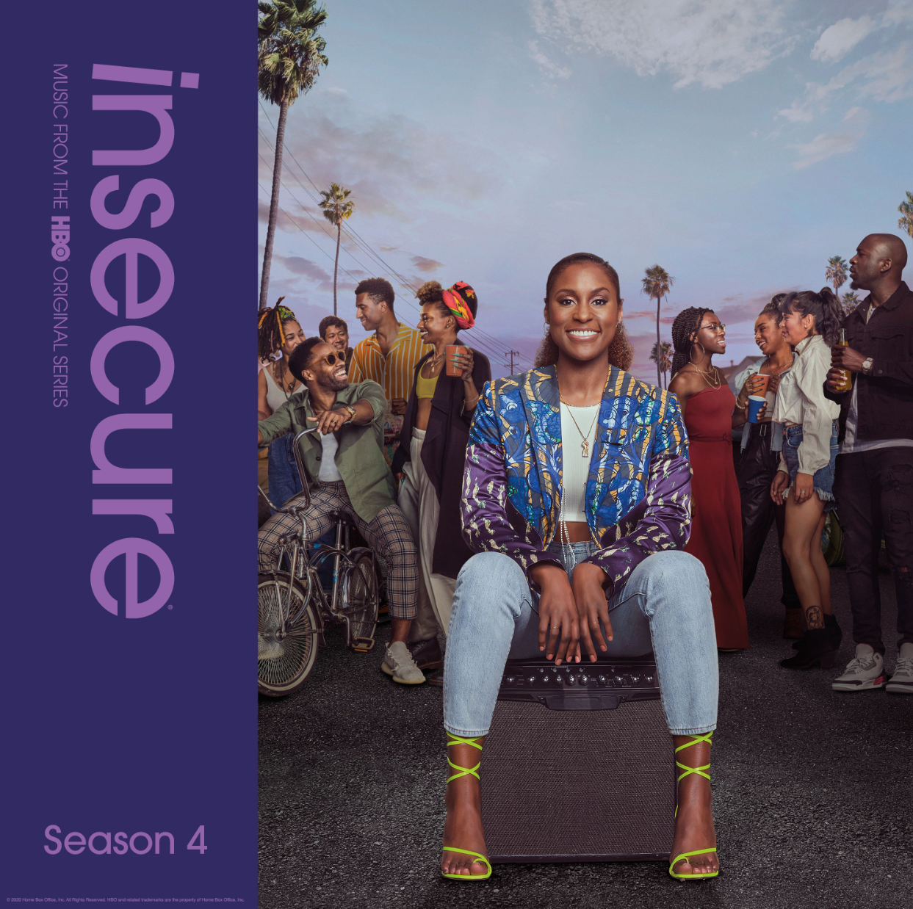
DOWNLOAD HIGH-RES COVER ART HERE

Raedio, Atlantic Records and HBO® are proud to release the full INSECURE: Music From the HBO Original Series, Season 4 soundtrack. INSECURE: Music From the HBO Original Series, Season 4 soundtrack is available today at all DSPs and streaming services HERE. Watch the INSECURE Season 4 finale this Sunday, June 14th episode at 10:00 p.m. (ET/PT) on HBO®. The series will also be available on HBO NOW, HBO GO, HBO On Demand and partners’ streaming platforms.

This week, INSECURE soundtrack artists Baby Rose, Kirby, and PJ took over NPR’s Tiny Desk series. Each of their incredible performances include tracks featured on the INSECURE: Music From the HBO Original Series, Season 4. Baby Rose kicked off the series on Wednesday with her Tiny Desk performance including “Show Me” Remix ft. Q, which debuted on this season’s ninth episode. Kirby followed on Thursday, where her performance included a preview of “Velvet Remix.” Watch PJ’s Tiny Desk performance, which premiered today, showcasing her explosive single “Element.” NPR’s Sidney Madden also hopped on Instagram Live this week to speak to Issa Rae and INSECURE’s music supervisor Kier Lehman to chat about INSECURE: Music From the HBO Original Series, Season 4.

Last week’s episode featured Pink Sweat$’ “Cadillac Drive” ft. Price which arrived alongside a companion visual. This month also saw Baby Rose’s “Show You” Remix Feat. Q featured on the series. Last month, TeaMarrr’s “Temperature” brought her quintessential ‘really really raw’ element to the soundtrack. The track dropped alongside a colorful companion visual, bringing the visceral, euphoric single to life. Previous releases included Jidenna’s “Feng Shui,” Ravyn Lenae’s “Rewind,” Poe Leos’ “Look At Me” and Yung Baby Tate’s “Do Me Like That” (ft. Buddy). Further, the soundtrack includes Jucee Froot’s irresistible “Eat Itself,” Cautious Clay’s “Reaching” (ft. Alex Isley), St. Panther’s “Infrastructure,” and Yung Baby Tate’s “Never Lonely” (ft. Jozzy).

INSECURE: Music From the HBO Original Series, Season 4 features brand new tracks from a diverse array of major artists and rising stars. The soundtrack is guaranteed to elevate the bar for music culture.

TRACKLIST
- Yung Baby Tate “Never Lonely” ft. Jozzy
- Jucee Froot “Eat Itself”
- Poe Leos “Look At Me”
- Rico Nasty “Dirty”
- Jidenna “Feng Shui”
- Iman Omari “The Love That I’m Giving” ft. Kent Jamz
- St Panther “Infrastructure”
- Cautious Clay “Reaching” ft. Alex Isley
- Ravyn Lenae “Rewind”
- Yung Baby Tate “Do Me Like That” ft. Buddy
- TeaMarrr “Temperature”
- PJ “Element”
- Pink Sweat$ “Cadillac Drive” ft. Price
- Kirby “Velvet Remix” ft. Lucky Daye
- Baby Rose “Show You Remix” ft. Q
- Raphael Saadiq “If Its Good”
- Buddy “Bad Decisions”

ABOUT RAEDIO
Launched in 2019, Raedio serves artists and creators at the highest level as an “audio everywhere company,” operating as the home to a dynamic roster of talent. Most importantly, Raedio extends a platform across media to align acts with film and television projects, commercials, podcasts, and beyond. Raedio also provided music supervision services for HBO’s critically acclaimed A Black Lady Sketch Show℠.

For more information, please visit: insecuresoundtrack.com, twitter.com/theraedio and
www.instagram.com/theraedio.

ABOUT INSECURE
Returning for its ten-episode, fourth season on Sunday, April 12th (10:00-10:30 p.m. ET/PT), INSECURE follows our favorite characters as they evaluate their relationships, both new and old, in an effort to figure out who and what comes with them in this next phase of their lives. The series will also be available on HBO NOW, HBO GO, HBO On Demand and partners’ streaming platforms.

Season Four follows the main characters in the aftermath of the decisions they made in the last season. Issa pursues a passion project she actually cares about, Molly navigates a real relationship for the first time, Lawrence figures out what leveling-up means for him, and we see the effect of Tiffany’s new baby on the dynamic of the friend group. Along the way, we’ll see these characters evaluating relationships, both new and old, in an effort to figure out who and what comes with them in this next phase of their lives.

INSECURE stars Issa Rae. Other series regulars include Yvonne Orji, Jay Ellis, Natasha Rothwell, Amanda Seales, Kendrick Sampson and Alexander Hodge. Created by Issa Rae & Larry Wilmore, INSECURE is executive produced by Issa Rae, Prentice Penny, Melina Matsoukas, Michael Rotenberg, Dave Becky, Jonathan Berry, Amy Aniobi and Jim Kleverweis; co-executive producers, Laura Kittrell and Phil Augusta Jackson.

ABOUT HBO®
HBO® is one of the most respected and innovative entertainment brands in the world, serving iconic, award-winning programming to 140 million subscribers globally. A subsidiary of WarnerMedia, HBO is the world’s most successful pay TV service with an extensive array of programming that includes some of the most notable titles to be on television, including drama series Succession®, Watchmen®, Westworld®, Big Little Lies®, Game of Thrones®, The Sopranos®, Band of Brothers® and The Wire®, as well as comedy series Barry®, Insecure® and Sex and the City®. In the United States, HBO® and sister network Cinemax® are available across multiple platforms including HBO On Demand®, Cinemax On Demand®, HBO GO® and MAX GO®, as well as HBONOW®. Internationally, HBO branded services, including television networks and the standalone streaming product HBO GO®, are available in more than 70 countries across Asia, Europe, Latin America and the Caribbean. HBO and Cinemax programming is also sold into more than 150 countries worldwide.

INSECURE is available to stream now on www.hbo.com.

For more information, please visit www.hbo.com/insecure.

PRESS CONTACTS
Fairley McCaskill | Fairley.McCaskill@atlanticrecords.com (Insecure Soundtrack)
Brittany Bell | Brittany.Bell@atlanticrecords.com (Insecure Soundtrack)
Vanessa Anderson | Vanessa@amprgroup.com (Issa Rae)
Emily Weichert | Emily.Weichert@hbo.com (HBO)

