FOR IMMEDIATE RELEASE
JUNE 15TH, 2020

RAEDIO, ATLANTIC RECORDS AND HBO® ANNOUNCE THE
INSECURE SOUNDTRACK MUSIC PANEL

MODERATED BY GIA PEPPERS, THE PANEL WILL DISCUSS ALL THINGS
INSECURE®: MUSIC FROM THE HBO ORIGINAL SERIES, SEASON 4 SOUNDTRACK ON JUNE 18TH

SOUNDTRACK IS CELEBRATED WITH AN INCREDIBLE VISUAL FOR PJ’S “ELEMENT”

CHECK OUT NPR TINY DESK CONCERTS FROM INSECURE SOUNDTRACK ARTISTS
BABY ROSE, KIRBY, AND PJ

LISTEN TO THE SECOND EPISODE OF ISSA’S RAEDIO SHOW ON APPLE MUSIC
FEATURING PINK SWEAT$

INSECURE®: MUSIC FROM THE HBO ORIGINAL SERIES, SEASON 4 SOUNDTRACK AVAILABLE NOW HERE

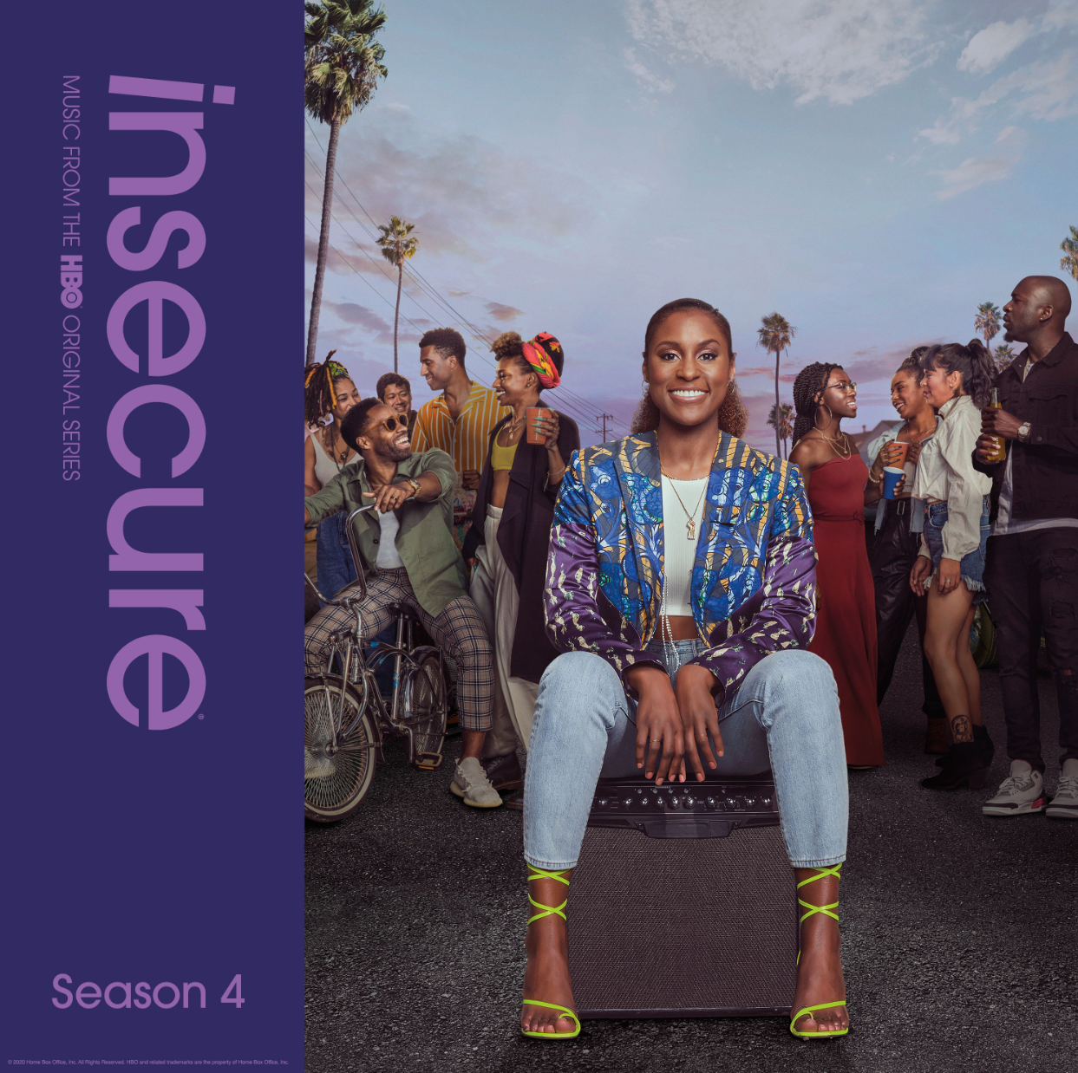
DOWNLOAD HIGH-RES COVER ART HERE

Raedio, Atlantic Records and HBO® are proud to announce the INSECURE Soundtrack Music Panel in celebration of the INSECURE: Music From the HBO Original Series, Season 4 soundtrack and in conjunction with Black Music Month. Moderated by Gia Peppers, the panel will have an open discussion around music from the soundtrack. Panelists include Alexander Hodge, Reggie Conquest, Jean Elie, Kier Lehman, TeaMarrr, PJ, Yung Baby Tate and Kirby. In highlight of Black Music Month, the talent will dive into discussions on the importance of black music for the culture as well as topics around dating and relationships. Catch the INSECURE Soundtrack Music Panel via HBO’s Facebook on June 18th at 2pm PT/5pm ET.

Last week, Raedio, Atlantic Records and HBO® released the full INSECURE: Music From the HBO Original Series, Season 4 soundtrack. The soundtrack is joined today by the companion visual to soul songstress PJ’s “Element.” The visual is available to stream now via YouTube. INSECURE: Music From the HBO Original Series, Season 4 soundtrack is available today at all DSPs and streaming services HERE. INSECURE Season 4 is available on HBO NOW, HBO GO, HBO On Demand and partners’ streaming platforms.

“I love Insecure! I've been wanting to be on the show forever so I'm super hype,” says PJ. “The show reminds me so much of myself, especially Issa because I can relate to trying to get my life tougher. We shot this video, in the quarantine, last week when there was a lot going on. Originally, we planned to do a super crazy video but we had limited resources and we did what we could. But I'm just excited for the song to finally be out.”

Last week, INSECURE soundtrack artists Baby Rose, Kirby, and PJ took over NPR’s Tiny Desk series. Each of their incredible performances include tracks featured on the INSECURE: Music From the HBO Original Series, Season 4. Baby Rose kicked off the series last Wednesday with her Tiny Desk performance including “Show Me” Remix ft. Q, which debuted on this season’s ninth episode. Kirby followed on Thursday, where her performance included a preview of “Velvet Remix.” Watch PJ’s Tiny Desk performance, which premiered Friday, showcasing her explosive single “Element.” NPR’s Sidney Madden also hopped on Instagram Live last week with Issa Rae and INSECURE’s music supervisor Kier Lehman to chat about INSECURE: Music From the HBO Original Series, Season 4.

Issa Rae also recently partnered with Apple Music to bring her latest musical offering, Issa’s Raedio Show. The radio special highlights the music featured on her popular HBO series Insecure and chronicles her musical journey. On the first episode, Issa is joined by special guests Missy Elliott and Joe. The second episode, available today, features Pink Sweat$. Listen to the special only on Apple Music HERE.

This season of INSECURE included Pink Sweat$’ “Cadillac Drive” ft. Price which arrived alongside a companion visual. This month also saw Baby Rose’s “Show You” Remix Feat. Q featured on the series. Last month, TeaMarrr’s “Temperature” brought her quintessential ‘really really raw’ element to the soundtrack. The track dropped alongside a colorful companion visual, bringing the visceral, euphoric single to life. Previous releases included Jidenna’s “Feng Shui,” Ravyn Lenae’s “Rewind,” Poe Leos’ “Look At Me” and Yung Baby Tate’s “Do Me Like That” (ft. Buddy). Further, the soundtrack includes Jucee Froot’s irresistible “Eat Itself,” Cautious Clay’s “Reaching” (ft. Alex Isley), St. Panther’s “Infrastructure,” and Yung Baby Tate’s “Never Lonely” (ft. Jozzy).

INSECURE: Music From the HBO Original Series, Season 4 features brand new tracks from a diverse array of major artists and rising stars. The soundtrack is guaranteed to elevate the bar for music culture.

ABOUT RAEDIO
Launched in 2019, Raedio serves artists and creators at the highest level as an “audio everywhere company,” operating as the home to a dynamic roster of talent. Most importantly, Raedio extends a platform across media to align acts with film and television projects, commercials, podcasts, and beyond. Raedio also provided music supervision services for HBO’s critically acclaimed A Black Lady Sketch Show℠.

For more information, please visit: insecuresoundtrack.com, twitter.com/theraedio and
www.instagram.com/theraedio.

ABOUT PJ
You may know PJ as a critically acclaimed singer and songwriter, but she describes herself appropriately as “a unicorn.” A dynamic background and diverse come-up affirmed her “unicorn” status. Originally hailing from Greensboro, North Carolina, she launched her career after relocating to Los Angeles. Lending her pen to some of the biggest names in the game, PJ established herself as an in-demand songwriter with dozens of credits, including “Left Right Left” for Charlie Puth, “I Don’t Know” for Meek Mill, “True Colors” for Wiz Khalifa, “Excuse Me” for Kevin Gates, and “Rivals” [feat. Future] for Usher.

Simultaneously, she built a tastemaker-approved solo discography, spanning the Walking Around Pools EP [2015] and Rare [2016]. In 2019, she toured with Pink Sweat$ and served up the fan favorite single “One Missed Call.” In addition to 2 million total streams and praise from Essence, Earmilk proclaimed it, “possibly one of the most upbeat and danceable songs about an ex.” Along the way, she charismatically stepped into her own as an artist. Similar to a superheroine actualizing her cosmic potential for the first time, she embraced in-your-face energy, vibrant pops of personality, out-sized charisma, and an unpredictable take on R&B with the 2020 Waiting For Paris EP [Atlantic Records].

ABOUT INSECURE
Returning for its ten-episode, fourth season on Sunday, April 12th (10:00-10:30 p.m. ET/PT), INSECURE follows our favorite characters as they evaluate their relationships, both new and old, in an effort to figure out who and what comes with them in this next phase of their lives. The series will also be available on HBO NOW, HBO GO, HBO On Demand and partners’ streaming platforms.

Season Four follows the main characters in the aftermath of the decisions they made in the last season. Issa pursues a passion project she actually cares about, Molly navigates a real relationship for the first time, Lawrence figures out what leveling-up means for him, and we see the effect of Tiffany’s new baby on the dynamic of the friend group. Along the way, we’ll see these characters evaluating relationships, both new and old, in an effort to figure out who and what comes with them in this next phase of their lives.

INSECURE stars Issa Rae. Other series regulars include Yvonne Orji, Jay Ellis, Natasha Rothwell, Amanda Seales, Kendrick Sampson and Alexander Hodge. Created by Issa Rae & Larry Wilmore, INSECURE is executive produced by Issa Rae, Prentice Penny, Melina Matsoukas, Michael Rotenberg, Dave Becky, Jonathan Berry, Amy Aniobi and Jim Kleverweis; co-executive producers, Laura Kittrell and Phil Augusta Jackson.

ABOUT HBO®
HBO® is one of the most respected and innovative entertainment brands in the world, serving iconic, award-winning programming to 140 million subscribers globally. A subsidiary of WarnerMedia, HBO is the world’s most successful pay TV service with an extensive array of programming that includes some of the most notable titles to be on television, including drama series Succession®, Watchmen®, Westworld®, Big Little Lies®, Game of Thrones®, The Sopranos®, Band of Brothers® and The Wire®, as well as comedy series Barry®, Insecure® and Sex and the City®. In the United States, HBO® and sister network Cinemax® are available across multiple platforms including HBO On Demand®, Cinemax On Demand®, HBO GO® and MAX GO®, as well as HBONOW®. Internationally, HBO branded services, including television networks and the standalone streaming product HBO GO®, are available in more than 70 countries across Asia, Europe, Latin America and the Caribbean. HBO and Cinemax programming is also sold into more than 150 countries worldwide.

INSECURE is available to stream now on www.hbo.com.

For more information, please visit www.hbo.com/insecure.

PRESS CONTACTS
Fairley McCaskill | Fairley.McCaskill@atlanticrecords.com (Insecure Soundtrack)
Brittany Bell | Brittany.Bell@atlanticrecords.com (Insecure Soundtrack)
Vanessa Anderson | Vanessa@amprgroup.com (Issa Rae)
Emily Weichert | Emily.Weichert@hbo.com (HBO)

