FOR IMMEDIATE RELEASE
JUNE 25, 2021

OHGEESY ANNOUNCES NEW PROJECT GEEZY WORLD OUT
AUGUST 13TH VIA ATLANTIC RECORDS

SHARES NEW SONG AND VIDEO "SECRET SERVICE"
WATCH: OHGEESY.LNK.TO/SECRETSERVICEVIDEO
LISTEN: OHGEESY.LNK.TO/SECRETSERVICE

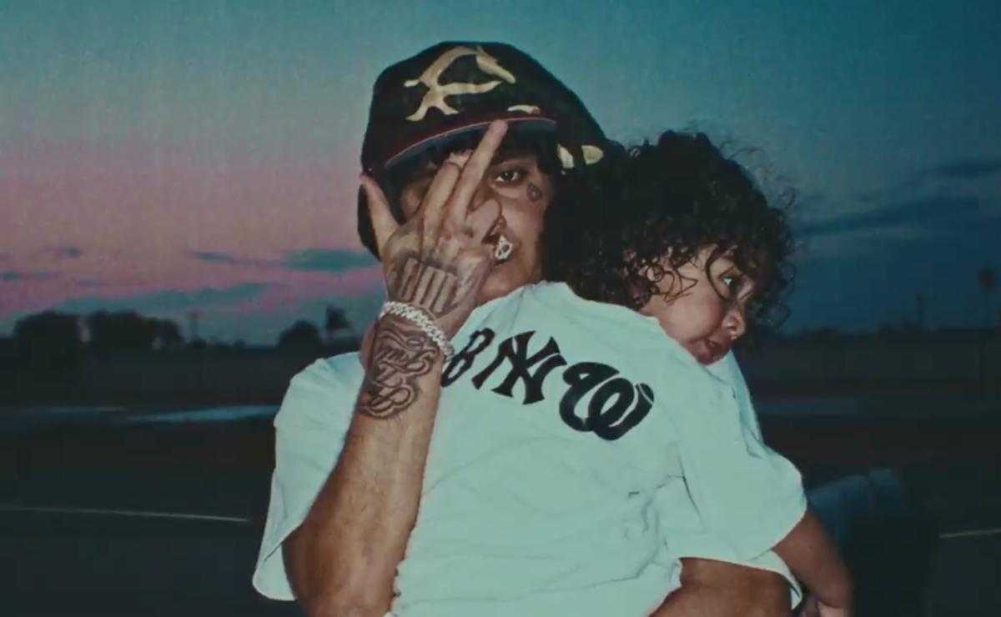

Today, OhGeesy announces his new project Geezy World and shares a new single and accompanying video. Out August 13th via Atlantic Records, the project includes the previously-released single "Get Fly" as well as the new song and video "Secret Service" out today. Directed by Austin Simkins who directed the aforementioned "Get Fly," the visual montages together footage of OhGeesy flying around in a helicopter alongside spliced film footage.

The project arrives after OhGeesy's work as the de facto leader of the hip-hop collective Shoreline Mafia. The group already have three RIAA Platinum Certified singles ("Nun Major, "Bands," "Musty"), two RIAA Gold Certified singles ("Whuss The Deal" and "Bottle Service"), headlined their own festival in Vancouver, sold over 108K tickets in 18 months, and their debut 2020 album MAFIA BIDNESS has over 592M streams and counting. Listen to and watch "Secret Service" above, read more about OhGeesy below, and stay tuned for more coming soon.

UPCOMING TOUR DATES:
7/17 Rosarito, MX Papa’s & Beer
7/23-25 Miami Gardens, FL Rolling Loud
8/6 Salt Lake City, UT Hive Festival
10/8-10 New York, NY Rolling Loud
12/10-12 San Bernardino Rolling Loud
12/18 Once Upon A Time in LA LAFC Stadium

ABOUT OHGEESY:
Life works a lot like a game of chess. One move anticipates the next. OhGeesy maneuvers through hip-hop with a similar level of intention, knowing exactly where he wants to go and how he’ll get there. After bringing Shoreline Mafia from an internet phenomenon to a critically exalted multiplatinum-selling arena headliner, the Los Angeles-born Mexican American rapper asserts himself as an impactful and inimitable solo presence on the mic. His deft wordplay, head-nodding hooks, and undeniable swagger fuel his 2021 full-length debut, Geezy World [Atlantic Records], and much more to come.

“I definitely look at this like a new beginning,” he exclaims. “Everything was meant to unfold and play out like this, so I could take my career to the next level and really go all the way with it. That’s what I’m going to do now.”

During his childhood, he immediately gravitated to hip-hop. His uncle possessed an impressive CD collection, boasting classics by everyone from UGK and Juicy J to L.A. legends like Dr. Dre and Snoop Dogg. OhGeesy often pulled out random titles and listened to them.

“Ever since I was a baby, I always had hip-hop around me,” he explains. “My whole household was playing rap. When I was in third grade, I used to copy lyrics from Three 6 Mafia songs in little notebooks. I finally rapped when I was 18.”

In 2017, he co-founded Shoreline Mafia. Within three years, the group picked up three platinum singles (“Bands,” “Nun Major,” and “Musty”) and two gold singles (“Whuss The Deal” and “Bottle Service”), gathered billions of streams, sold out one show after another, and earned acclaim from Pitchfork, The FADER, Forbes, The Washington Post, and Noisey, to name a few.

By the dawn of the Global Pandemic, OhGeesy’s life had changed forever. He became a father. He focused on “getting healthy,” and he recorded more than ever before. Linking up with trusted engineer Tez, he logged countless hours in the studio to bring Geezy World to life.

“I got in tune with my voice and myself,” he admits. “I was more comfortable. I really want everyone to know where my head is at. It’s in the healthiest space that it’s ever been—both mentally and physically. I’ve been with my son for two years, and that turned me into a better man too. It made me grow up and more mature. I still want to go harder, because I know I’ve got to provide for him. All around, I’m trying to live better than I used to, and that’s made me a better artist too.”

That comes through loud and clear on the first single “Get Fly” [feat. DaBaby]. Latin-style guitar cuts through a thick fingersnap-laden beat as OhGeesy and DaBaby flex with each bar before the hypnotic hook.

“That was the first time I had gotten into a bigger studio since the beginning of the Pandemic,” he says. “I walked in, played the beat, and finished it in 15 minutes. It’s my life. You wake up, start the day, and get fly to do anything. You even need to get fly just to listen to my music,” he grins.

“I don’t ever remember Hispanic rappers coming out with this style when I was a kid,” he states. “It makes me stand out. Everyone in L.A. fucks with me, and they’re proud of me. I think it shows kids this is possible. As my music grows, I want audiences to grow with me. I feel like this shit sounds way better and more elevated than anything I’ve done. It’s really me.”

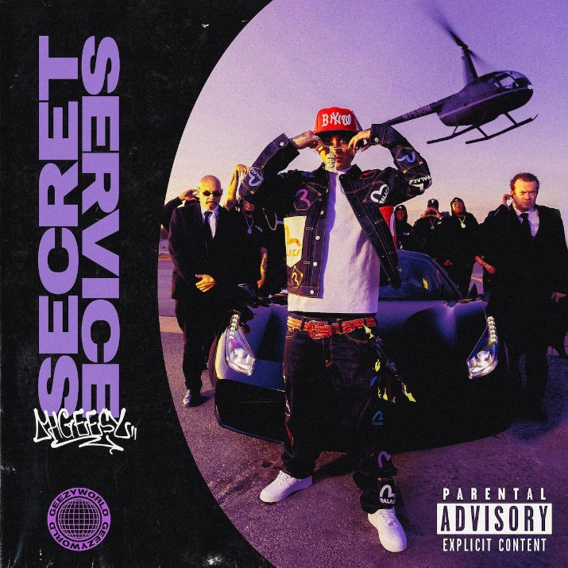 | 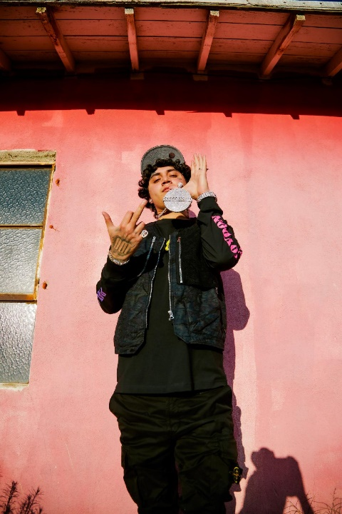
DOWNLOAD HI-RES ASSETS HERE

CONNECT WITH OHGEESY
OFFICIAL |INSTAGRAM | TWITTER | SPOTIFY

PRESS CONTACT
BRITTANY BELL | BRITTANY.BELL@ATLANTICRECORDS.COM

