FOR IMMEDIATE RELEASE
JUNE 26TH, 2020

BANKROL HAYDEN RELEASES DEBUT MIXTAPE PAIN IS TEMPORARY

WITH FEATURES FROM LIL BABY, POLO G, THE KID LAROI AND LUH KEL

INCLUDES THE VIRAL HIT “COSTA RICA” WITH OVER 100M COMBINED STREAMS
WATCH OFFICIAL VIDEO HERE

STREAM/DOWNLOAD PAIN IS TEMPORARY:
BANKROL.LNK.TO/PAINISTEMPORARY

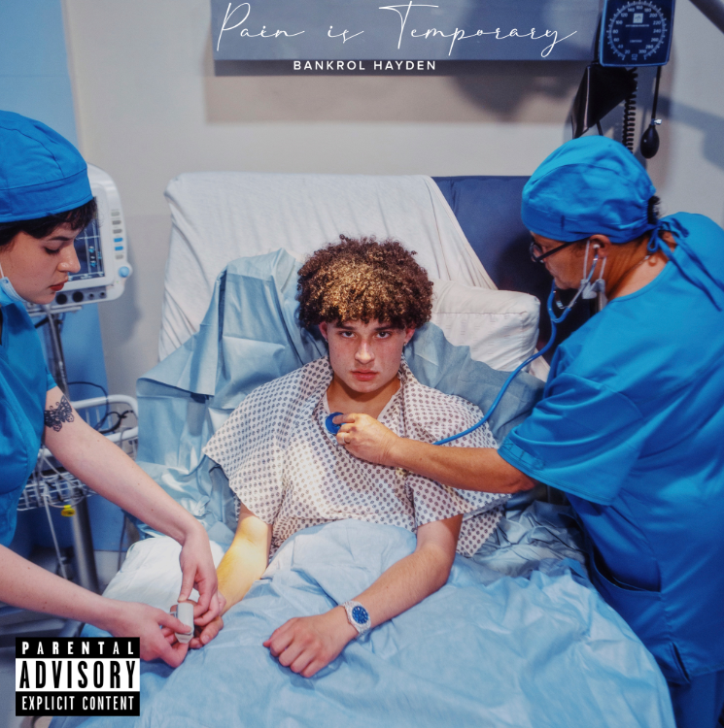
DOWNLOAD HIGH-RES ARTWORK HERE

Atlantic recording artist Bankrol Hayden launches his highly anticipated debut mixtape today, Pain is Temporary. The mixtape includes lauded features from Polo G, Lil Baby, The Kid LAROI and Luh Kel. Pain Is Temporary includes his viral hit “Costa Rica,” which recently amassed over 100 million combined streams alongside it’s official music video, which has over 13 million views. The “Costa Rica ft. The Kid LAROI” remix and his latest offering “Rich Bitch” (over 25 million combined streams) are also featured on the Modesto, CA-native’s debut mixtape. Pain Is Temporary is available today at all DSPs and streaming services HERE.

“Pain is Temporary was a vision I conceptualized laying in the hospital bed recovering. Over the two years I spent making this project, I really watched myself grow as an artist. It’s something my day one fans have been waiting for since I released my first song in 2018. I’ve been through a lot of life experiences – good and bad – since then, and I hope my fans connect with my art and my message.”

Bankrol Hayden has seen incredible streaming success as he is currently on Spotify’s Teen Party (4m followers) and on Spotify’s Most Necessary playlist (2.4m followers). “Costa Rica” is featured on popular Spotify playlists such as Pop Rising (2m followers) and Cali Fire (710k followers). It was recently on featured on Rap Caviar, Spotify’s premiere rap playlist. It’s also featured on popular Apple Music playlists New Fire and The New Bay. YouTube recently featured the young rapper as their Artist on the Rise.

Bankrol was recruited to support Lil Mosey on his Certified Hitmaker European Tour 2020. Watch Bankrol Hayden’s European tour leg vlog HERE; watch the crowd go wild to his viral hit “Costa Rica” at his Norway tour date HERE.

The California native heralded “Costa Rica” with an exclusive preview on his hugely influential Instagram page, joined by fellow social media sensation/artist Einer Bankz. The track marks the latest in a series of increasingly well-liked singles for Bankrol Hayden, following such viral smashes as “B.A.N.K.R.O.L.,” “29,” and “Brothers (Feat. Luh Kel),” the latter now boasting over 100 million worldwide streams thus far.

At just 18 years old, and recently graduating from high school in the midst of the pandemic, Bankrol Hayden is fast proving a phenomenon, earning fans around the globe with his positive brand of soulful, pop-forward hip-hop. Along with his musical efforts, Bankrol Hayden is also a major digital influencer and entrepreneur with a combined social media reach exceeding 1.5 million, including a tremendously popular Instagram earning over 150,000 likes per post.

TRACKLISTING
- Divorce (Intro)
- Drop A Tear (feat. Lil Baby)
- Brothers (feat. Luh Kel)
- Fuck With Us
- Costa Rica
- Whatchu On Today (feat. Polo G)
- Ballin
- Rich Bitch
- School Girl
- Die Right Now
- Costa Rica (feat. The Kid LAROI) [Remix]

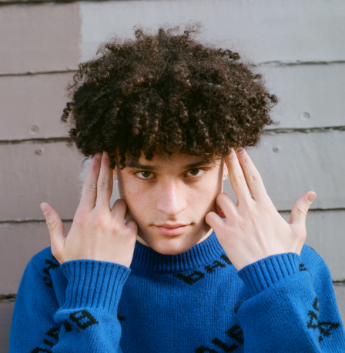
DOWNLOAD HIGH RES PRESS PHOTO HERE
PHOTO CREDIT AIDAN CULLEN

CONNECT WITH BANKROL HAYDEN
INSTAGRAM | TWITTER | YOUTUBE

For additional press assets, please visit his press site HERE.

PRESS CONTACT
FAIRLEY.MCCASKILL@ATLANTICRECORDS.COM

