FOR IMMEDIATE RELEASE
JULY 22, 2020

JASON DERULO WANTS TO “TAKE YOU DANCING”

MULTI-PLATINUM GLOBAL SUPERSTAR UNVEILS SULTRY NEW SINGLE
STREAM/DOWNLOAD “TAKE YOU DANCING” HERE

WATCH THE “TAKE YOU DANCING” TIK TOK DANCE VIDEO HERE

LIVE PERFORMANCE ON ABC’s GOOD MORNING AMERICA “SUMMER CONCERT SERIES”
SET FOR THIS FRIDAY, JULY 24TH

“TAKE YOU DANCING” AVAILABLE EVERYWHERE TODAY EXCLUSIVELY VIA ATLANTIC RECORDS

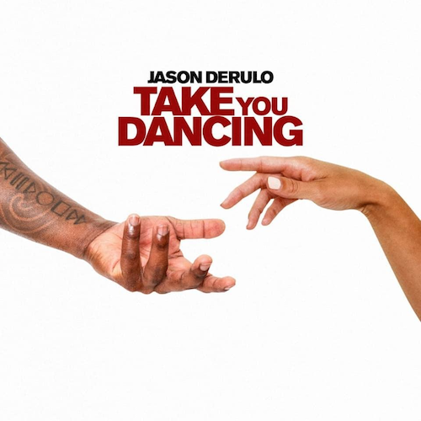
DOWNLOAD “TAKE YOU DANCING” PRESS ASSETS HERE

Multi-platinum global superstar Jason Derulo has announced today’s release of his eagerly awaited new single, “Take You Dancing”, available now via Atlantic Records at all DSPs and streaming services HERE. The sultry, Latin-inspired track is accompanied by the official Tik Tok dance video, streaming now via YouTube HERE. The official visual is set to drop in the coming weeks.

"In these times, we all need a song that’s going to uplift us,” notes Derulo of his latest single. “Hopefully “Take You Dancing” can be a light in these trying days.”

Currently featured on the cover of Apple Music’s influential New Music Daily playlist, “Take You Dancing” was first heralded by Derulo with a series of social media posts directing his millions of followers towards the single’s pre-save. Derulo will further celebrate the track’s arrival with a highly anticipated live appearance on ABC’s Good Morning America “Summer Concert Series,” set for this Friday, July 24th (check local listings).

With close to 30 million followers, Derulo is currently among TikTok‘s top 20 superstars and the most popular active platinum-selling musician across the entire platform. “Take You Dancing” marks the latest in a seemingly infinite series of hit releases from Derulo, including such current favorites as Alok, Martin Jensen & Jason Derulo’s “Don’t Cry For Me“ and Jason Derulo x Puri x Jhorrmountain’s club classic, “Coño,” the latter featured in more than 14 million TikTok videos. In addition, Jawsh 685 & Jason Derulo’s “Savage Love“ has proven a worldwide summer sensation, now boasting over 100 million global streams and counting. The track is currently ascending towards the top 20 at CHR/Pop radio outlets nationwide having already reached #1 in Ireland, Austria, Australia, New Zealand, Norway, Scotland, Sweden, Switzerland, and the United Kingdom – Derulo’s fifth #1 single in the UK. What’s more, “Savage Love” was recently joined by an official music video, now with over 22 million views via YouTube alone.

A true multi-platform powerhouse, Jason Derulo undoubtedly ranks among the top pop and urban artists of this or any era, with 11 RIAA platinum certified singles, 12 billion combined global streams, close to 6.5 billion YouTube views, and worldwide singles sales well in excess of 190 million. The wildly talented singer, songwriter, dancer, and entertainer first drew acclaim through songwriting collaborations with such like-minded icons as Lil Wayne, Pitbull, Diddy, and Sean Kingston. Derulo kicked off his remarkable solo career with 2009’s chart-topping, 5x platinum certified “Whatcha Say” and never looked back, rolling out five acclaimed albums and an epic string of hugely successful hit single including “In My Head,” “Ridin’ Solo,” “Talk Dirty (Feat. 2 Chainz),” and “Want You To Want Me,” all of which received 4x platinum certification from the RIAA. Additional platinum and multi-platinum hits include the 3x platinum “Wiggle (Feat. Snoop Dogg),” the 2x platinum “Swalla (Feat. Nicki Minaj & Ty Dolla $ign)” and “Trumpets,” and the platinum certified “Don’t Wanna Go Home,” “It Girl,” “The Other Side,” and “Marry Me.” As if all that weren’t enough, Derulo has been an in-demand featured artist, creating international hits with such diverse stars as Pitbull, Florida Georgia Line, Little Mix, Flo Rida, Gucci Mane, and Sofía Reyes.

Among his countless career accomplishments, Derulo is among social media’s biggest stars of any genre, currently boasting over 113 million fans and followers across all platforms. In addition to his prolific musical output, Derulo has made countless TV appearances, including live performances and guest roles on such popular competition series as Dancing With The Stars and So You Think You Can Dance. What’s more, Derulo has also embarked on what is proving a very successful acting career, with highlights including TV’s Empire and Lethal Weapon as well as last year’s big-screen adaptation of Cats. Derulo will next be seen starring as soul legend Ron Isley in the upcoming biographical film, Spinning Gold.

CONNECT WITH JASON DERULO
OFFICIAL | INSTAGRAM | TWITTER | FACEBOOK | YOUTUBE | TIKTOK

PRESS CONTACT
FAIRLEY MCCASKILL | FAIRLEY.MCCASKILL@ATLANTICRECORDS.COM

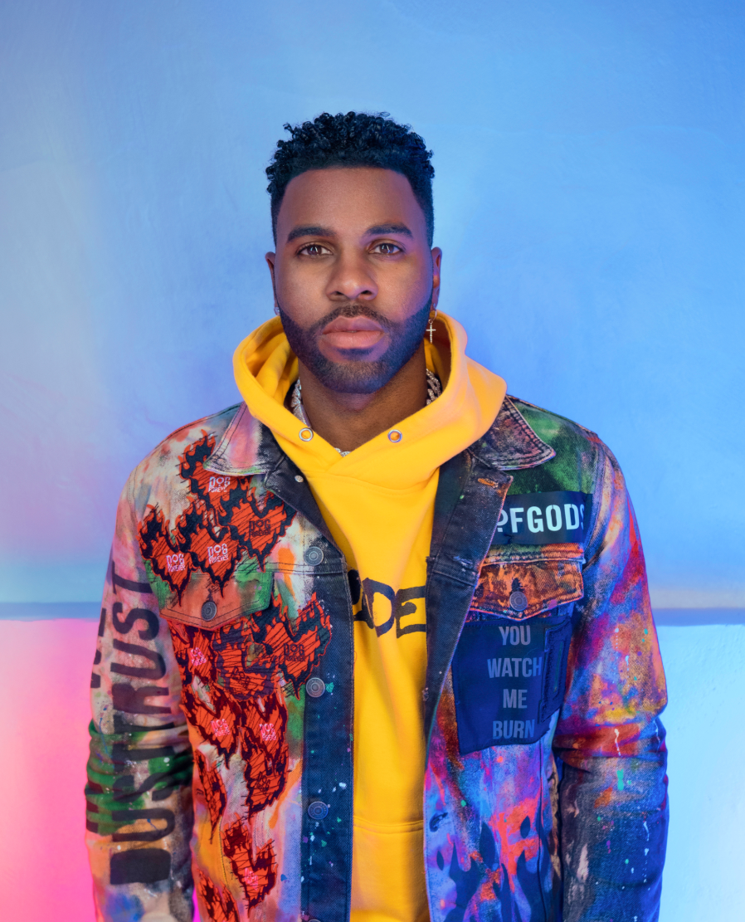
PHOTO CREDIT: DAVID STRBIK| DOWNLOAD HERE

