FOR IMMEDIATE RELEASE
AUGUST 7, 2020
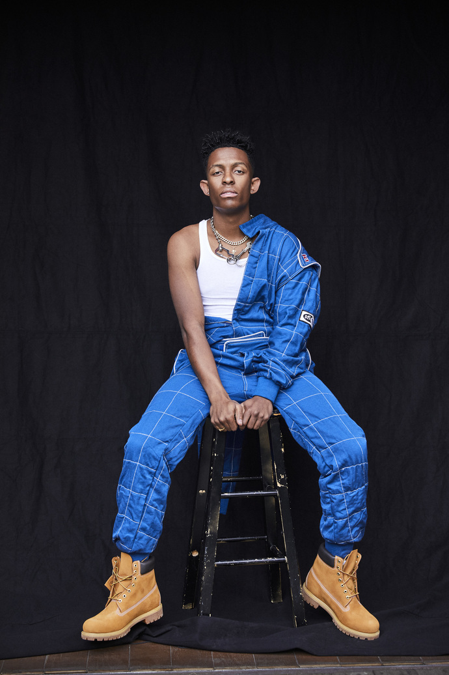

BRELAND DRIVES "MY TRUCK" TO GOLD CERTIFICATION

DEBUT SINGLE RECOGNIZED BY RIAA FOR 500,000 SALES MILESTONE

—

EMERGING TALENT NAMED TO NOISEY NEXT LIST AS ACCOLADES KEEP ROLLING IN

—
“Rather than capitalize on a now-popular sound, the ‘My Truck’ singer is in it for the long haul, an artist who seems to disrupt stereotypes just by existing”
– NOISEY

LOS ANGELES, CA (August 7, 2020) – Bad Realm/Atlantic Records’ newcomer BRELAND has roared into new territory, driving his debut Country single “My Truck” to GOLD certification.
Making its presence felt, “My Truck” was released in early 2020 and quickly made an impact, scoring rave reviews, superstar fans, viral-hit status and a music video amassing 27 MILLION views. Mixing elements of Country, Hip-Hop and Pop with a heavy-duty hook, it now earns official RIAA recognition as a major milestone for the emerging Atlanta-based talent.
First sharing the news on Instagram, BRELAND captioned “WOW. My debut single. I know I usually hit y’all with the long captions but all I can say this time is thank you so much ❤️ 😭 The first of many.”
“My Truck” is part of the multi-talented singer-songwriter’s self-titled EP debut (released in May), which delivered five more genre-defying tracks plus the infectious “My Truck” remix featuring Sam Hunt – all of which he co-wrote.
Stacking up buzzy collaborations with the likes of Lauren Alaina, Chase Rice and Keith Urban, BRELAND followed the EP release with the two-track Rage & Sorrow collection in honor of Juneteenth and racial-inequality protests around the nation.
Drawing praise from outlets like Forbes, The New York Times, Rolling Stone, Spin, Stereogum, USA Today and Billboard, among others, BRELAND continues to solidify his nickname as “The Pen Point Guard” and was recently featured as the latest artist on the Noisey Next list of rising stars.
“Rather than capitalize on a now-popular sound, the ‘My Truck’ singer is in it for the long haul, an artist who seems to disrupt stereotypes just by existing,” Noisey proclaims.
ABOUT BRELAND
New Jersey-born BRELAND began writing songs as a teenager, inspired by a diverse collection of sounds and eclectic artists like the Beatles, Rascal Flatts, Prince, and his number-one influence, Stevie Wonder. While attending Georgetown University, BRELAND knocked on every possible music-industry door and eventually broke through as a songwriter, landing a number of high-profile cuts with rappers like Elhae and YK Osiris. But as he continued to work on his own music, BRELAND soon posted “My Truck” on social media as a challenge to determine whether he could elicit 500 comments – and after smashing that goal, self-released the track to multi-platform success. Along with paving the way for BRELAND’s signing to Bad Realm/Atlantic Records, “My Truck” sparked headline-worthy streaming success, including hitting #1 on Spotify’s Global Viral 50 and US Viral 50 charts. Praised by Rolling Stone as “1,000 percent the whole package,” BRELAND has been featured in leading press outlets like Genius, Paper, USA TODAY and Billboard’s “Emerging Artists Spotlight,” and in April released a remix of “My Truck” featuring Country superstar Sam Hunt. BRELAND’s self-titled EP debut arrived May 22, featuring both versions of “My Truck” and five other standout co-writes.

CONNECT WITH BRELAND

INSTAGRAM | FACEBOOK | TWITTER | YOUTUBE | SOUNDCLOUD

PRESS PHOTO CREDIT: JIMMY FONTAINE

SINGLE ART COURTESY OF BAD REALM/ATLANTIC RECORDS

MEDIA CONTACTS:
Fairley McCaskill / Fairley.McCaskill@atlanticrecords.com
Jensen Sussman / jensen@sweettalkpr.com

