FOR IMMEDIATE RELEASE
AUGUST 9, 2021

SAM AUSTINS & SIR CHLOE HAVE “JOY FOR YOUTH”
LISTEN: LNK.TO/JOYFORYOUTH
WATCH: LNK.TO/JFYVIDEO

“JOY FOR YOUTH” FT. SIR CHLOE DEBUTED ON APPLE MUSIC 1 ZANE LOWE WORLD FIRST

KICKED OFF HIS HOMELESS STAR SAGA WITH “KILOS”
STREAM: LNK.TO/KILOS
WATCH: LNK.TO/KILOSVIDEO

DEBUT PROJECT HOMELESS STAR COMING THIS FALL

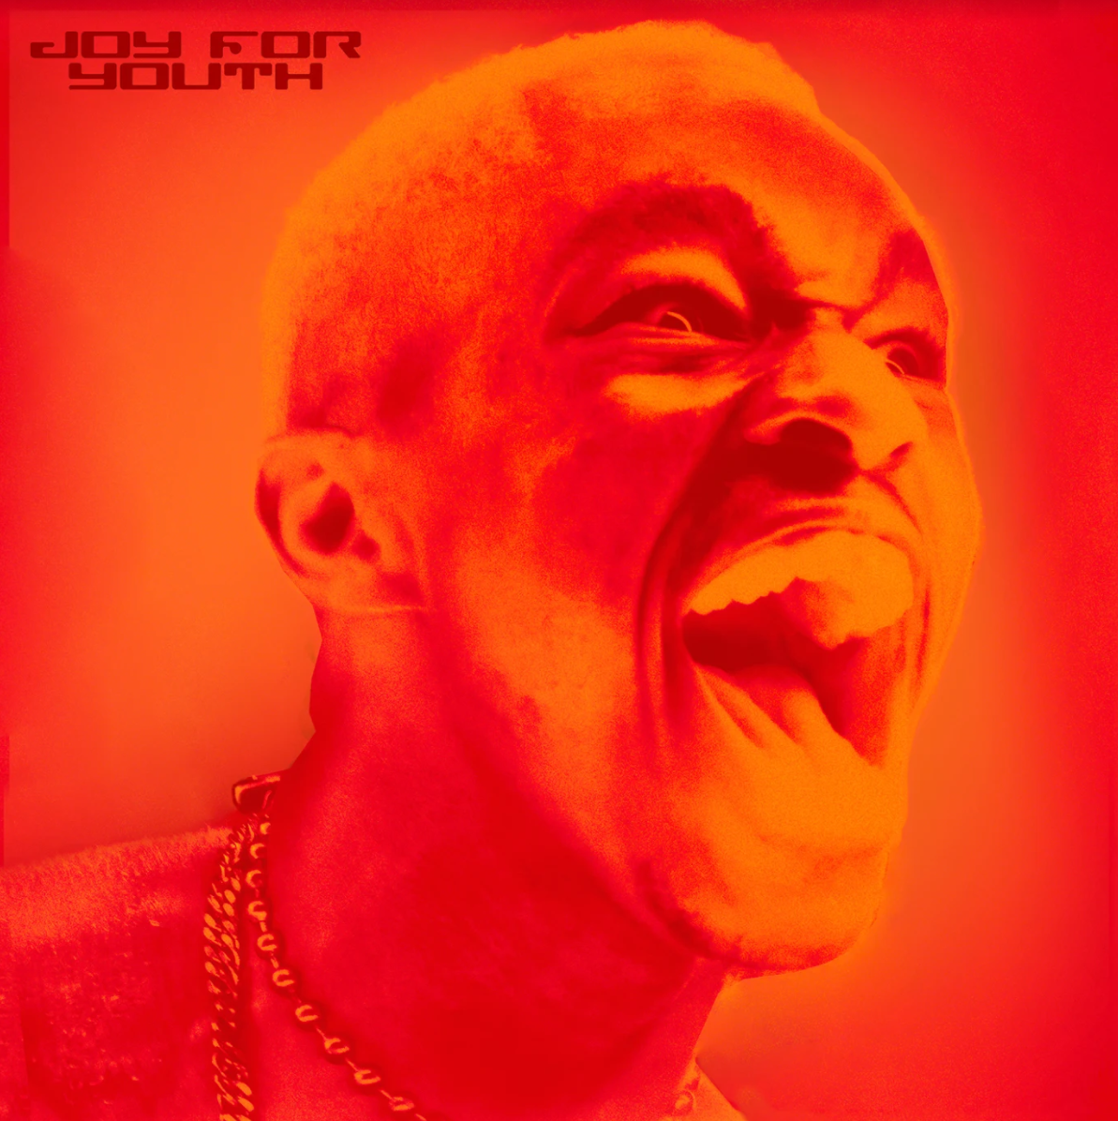
COVER ART | HIGH-RES PRESS PHOTO

Sometimes art is nothing more than creating your own world when the one you live in makes you feel estranged. It’s hard not to see that feeling in the world Sam Austins is creating. It somehow fuses the energy of nineties alternative with the R&B melodies of Frank Ocean, the aspirational aesthetics of high fashion with the authentic storytelling of Detroit culture. After meeting at a Vogue shoot and appearing together in the June issue alongside Kaytranada, Austins linked with NYC-based indie-alt artist Sir Chloe for his second single “JOY FOR YOUTH.” It draws on all his influences to create a sonic time capsule that nostalgically captures the rebellion, bravery and bliss of youth. Directed by Jax Anderson, the official visual harnesses the essence of adolescent melodrama and innocent ignorance of a hazy Midwest summer. Due in October via Atlantic Records, Austins’ debut project HOMELESS STAR is a genre-defying coming-of-age album telling the story of a young man finding his place in a world he’s never fit.

“JOY FOR YOUTH” is a sonic time capsule, surrounding the aura of childhood bliss and teenage rebellion. I had so much fun getting Dana on this record with me, bringing her to Detroit for the video, to peek a little bit into my world from her lens. It was important to me that the key components of the record were storytelling, exploration, and bravery, which were all quintessential pieces of my youth. - Sam Austins

It was a privilege to work on “JOY FOR YOUTH” with Sam, he’s a fantastic songwriter and I was honored when he asked me to contribute a verse to his song. I love the gratitude expressed in the piece, a thesis which I interpreted as appreciating where you are and what you have really spoke to me. - Sir Chloe

The Detroit-born and Los Angeles-based artist, model, and maverick creative kicked off HOMELESS STAR with "KILOS,” hinging on an evocative guitar line offset by a lo-fi beat as melodies bubble up over the backdrop. The accompanying visual brought his words to life as he leaves a shady motel to roam the empty streets at night before joining a giant Donnie Darko-style bunny in a diner. As Billboard noted in the visual premiere, “With his musical style, Austins is a boundary-breaker, challenging long-held ideas of what it means to be an alternative artist.” Austins then tapped Norway’s Jimi Somewhere to breathe new life into “KILOS (Jimi’s Version).” Although Jimi Somewhere recreating a song about the fireworks and gunshots of Detroit may seem left-of-center, it’s a true testament to the transcendent quality of incredible songwriting. The original "KILOS" uses metaphors to highlight complicated forces that have shaped Austins’ young adult life, while Jimi Somewhere’s lush, lo-fi reinterpretation transforms that personal story into something altogether universal.

ABOUT SAM AUSTINS
Sam Austins doesn’t just make music; he’s building out a world. This place is equally inspired by the likes of the defiantly vulnerable Frank Ocean, the melodies of nineties alternative, and mythologies of sci-fi classics such as Star Wars. Following high school, he slept on floors, bounced from friend to friend, and crashed in the back of his beat-up Impala. He moved in with an aunt in the inner city of Detroit and turned the focus to music. He dropped the GOAT EP on Soundcloud and opened for the likes of Vince Staples, Juicy J, Danny Brown, and Playboi Carti. During a random encounter in the studio, fashion magnate Phillip Lim heard Sam Austins’ ANGST EP and invited him to be an honorary guest at his 2017 NYFW show. linked up with multiplatinum producers Take A Daytrip and dropped “Fiji Water,” amassing 774K Spotify streams. He joined forces with Black Milk on “Black NASA.” Along the way, he landed placements in VH1’s Love & Hip-Hop and HBO’s Euphoria. In late 2019, he became the recipient of TIDAL’s Unplugged Grant and recorded “LAST MONEY,” “WINGS,” and “STAR.” By 2020, he caught the attention of APG/Atlantic Records. Not to mention, he co-wrote the gold-selling “Wolves” [feat. Post Malone] from Big Sean’s #1 blockbuster Detroit 2. He notably just joined Sir Chloe and Kaytranada for a Vogue interview and spread in book and online. After amassing millions of streams and attracting looks from the likes of HYPEBEAST and Pigeons & Planes, the Los Angeles-based multi-hyphenate opens up this world on his 2021 project HOMELESS STAR led by “KILOS” and “JOY FOR YOUTH.”

ABOUT SIR CHLOE
Sir Chloe is the band Dana Foote formed during her senior year at Bennington College in Vermont, where she put on a concert in lieu of a thesis. Originally comprised of guitarist and producer Teddy O’Mara, Willy Giambalvo on drums and bassist Pixel West, the group now includes Dana’s brother Palmer Foote and Austin Holmes. Together, they began to flesh out Dana’s songs, developing a sound as much inspired by The Pixies as Stravinsky. Foote’s musical background is eclectic: she taught herself guitar using Mel Bay books before taking up the piano, the mandolin, the accordion and the harmonium. At Bennington, she and O’Mara formally studied music theory and composition. She crosses her more traditional rock touchpoints with the intimate songwriting of contemporaries like St. Vincent, Lianne La Havas and Andy Shauf. Her academic training shows itself, too: she cites Igor Stravinsky, Sofia Gubaidulina, Claude Debussy and Béla Bartók among her influences.

PRESS CONTACTS:
SAM AUSTINS
Fairley McCaskill | Fairley.McCaskill@atlanticrecords.com
& Chandler Owen | Chandler.Owen@atlanticrecords.com

SIR CHLOE
Jessica Nall | Jessica.Nall@atlanticrecords.com
& Megan Rasmussen | Megan.Rasmussen@atlanticrecords.com

