FOR IMMEDIATE RELEASE
SEPTEMBER 13, 2021

IN CASE YOU MISSED IT: BRELAND TAKES OVER YOUR SCREEN AS YOUTUBE'S ARTIST ON THE RISE TO SHARE HIS STORY

BRELAND TAKES PART IN STAR-STUDDED CHEVY COMMERCIAL THAT AIRED DURING NFL’S SEASON OPENER LAST THURSDAY (9/9)

HIGH PROFILE TV LOOKS FROM CMT CROSSROADS (9/1) TO CMA SUMMER JAM (9/2)

HEADLINING CROSS COUNTRY TOUR KICKED OFF ON FRIDAY IN AUSTIN, TX (9/10)

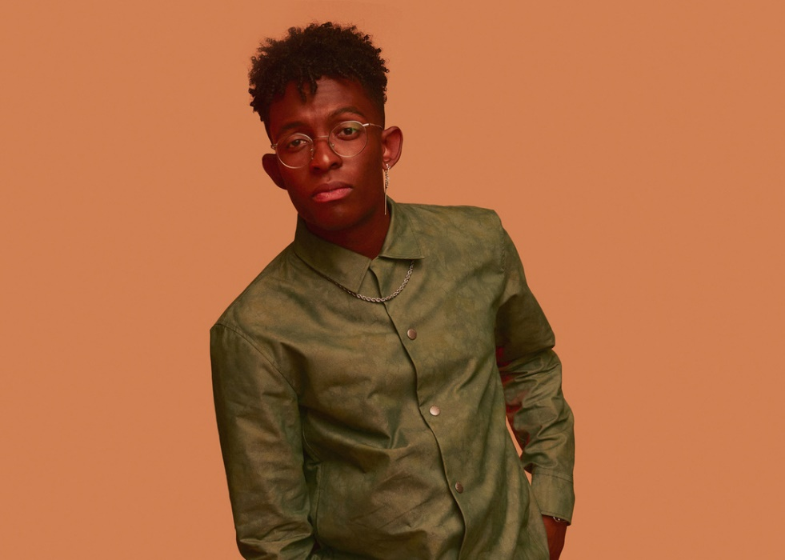

Bad Realm Records / Atlantic Records breakout talent BRELAND is on fire, and he is showing no signs of cooling down. After a whirlwind summer, BRELAND has racked up quite the bill of appearances to show. Within the last few weeks, he performed on some of Country music’s biggest stages with a round of stops including ABC’s CMA Summer Jam, CMT Crossroads, ABC’s Jimmy Kimmel Live!, and ABC’s Good Morning America.

This summer BRELAND was named YouTube’s Artist on The Rise. The programs is centered around breaking artists, and amplifying music’s most compelling up-and-comers. Last week's launch of BRELAND’s “Hero” piece was produced in collaboration with YouTube Music as part of this special program. The short film follows BRELAND’s journey from his introverted childhood to finding his voice as a songwriter and performer. Featuring an exclusive interview with BRELAND and acoustic performance of his popular “Cross Country,” this piece highlights how his no-genre approach to music brings audiences together.
“What I stand for is unity and community and breaking down barriers and telling your story," says BRELAND in the introspective video.

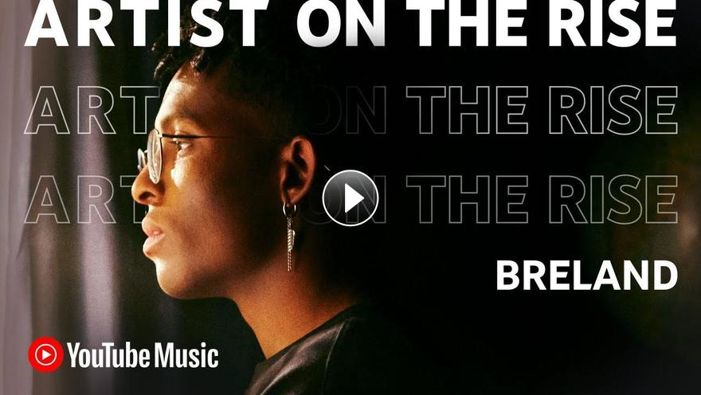

In addition to these high-profile looks, BRELAND was selected to take part in a brand-new Chevy campaign that launched Thursday night (9/9), revealed in a high-energy 60-second commercial during NFL’s season opener featuring BRELAND alongside Michele Tafoya, Chase Elliot, Chris Pratt and Chad Hall. The campaign is centered around the launch of Chevrolet’s First-Ever Silverado ZR2 and BRELAND highlights the elevated design of the Silverado ZR2 on the set of a video shoot. Watch the commercial below now.

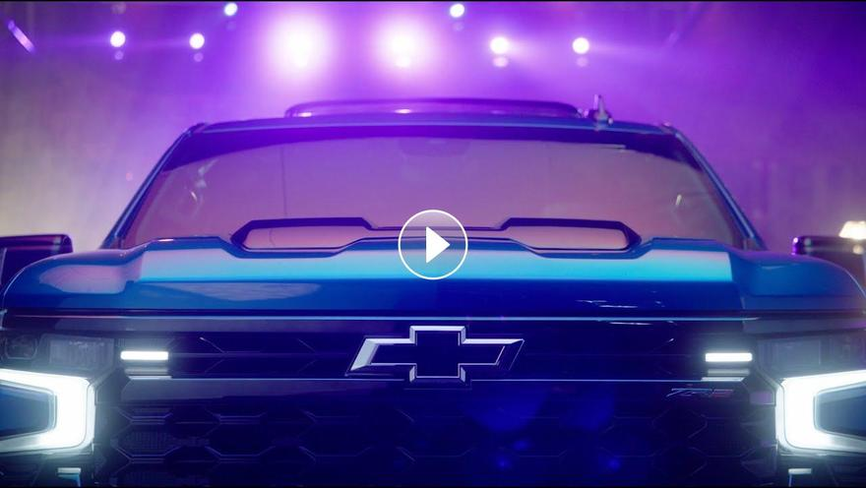

In case you missed it, BRELAND kicked off the month with CMT Crossroads: Nelly & Friends (airing on 9/1) as he performed their new smash hit “High Horse” with Nelly and Blanco Brown. Performing three tracks total with the iconic rapper, BRELAND closed the show with the classic “Country Grammar” with Nelly, Kane Brown and Blanco Brown. (Watch the performances here: “High Horse"/ “Country Grammar” / "Hot in Herre") The following day (9/2), BRELAND performed Dierks Bentley’s new single "Beers On Me" featuring he and HARDY for the first time on ABC’s CMA Summer Jam at Bentley’s honky-tonk on Broadway, Whiskey Row, in downtown Nashville, TN. (Watch HERE). Leading into the big week, he had teamed up with Nelly and Brown to perform “High Horse” on GMA’s Summer Concert Series in early August, and did the same on Jimmy Kimmel Live!.

To add to all the excitement, BRELAND's summer anthem and current single "Throw It Back" featuring Keith Urban has amassed more than 35 MILLION streams to date. BRELAND launched his headlining CROSS COUNTRY TOUR on Friday night (9/10) in Austin, TX. Marking his first-ever headline tour, the trek will then continue with coast-to-coast dates through October, with more details and tickets available here.

BRELAND’s CROSS COUNTRY TOUR:
Sept. 10 – The Parish – Austin, TX*
Sept. 11 – House of Blues Bronze Peacock – Houston, TX*
Sept. 12 – House of Blues Cambridge Room – Dallas, TX*
Sept. 16 – Joe’s on Weed Street – Chicago, IL*
Sept. 17 – Fine Line Music Café – Minneapolis, MN*
Sept. 19 – El Club – Detroit, MI*
Sept. 21 – Brighton Music Hall – Boston, MA*
Sept. 23 – Songbyrd DC – Washington, DC*
Sept. 25 – Governor’s Ball Music Festival – New York, NY
Oct. 1 – Aisle 5 – Atlanta, GA^
Oct. 2 – Underground – Charlotte, NC^
Oct. 5 – The High Watt – Nashville, TN^
Oct. 6 – The High Watt – Nashville, TN^
Oct. 14 – Larimer Lounge – Denver, CO^
Oct. 17 – Crescent Ballroom – Phoenix, AZ^
Oct. 20 – The Moroccan Lounge – Los Angeles, CA^
Oct. 23 – Great American Music Hall – San Francisco, CA^
Oct. 26 – The Crocodile – Seattle, WA^
Oct. 27 – Lola’s Room – Portland, OR^
* = featured support: Ashley Cooke
^ = featured support: Robyn Ottolini

ABOUT BRELAND
With the arrival of his PLATINUM-certified debut single “My Truck,” singer/songwriter/producer BRELAND emerged as a bold new force on today’s music landscape. Originally from New Jersey, BRELAND moved to Atlanta after graduating from Georgetown University, kicking off his songwriting career by scoring cuts with artists like YK Osiris and Ann Marie. Soon after releasing “My Truck” in late 2019, he saw the Hip-Hop and Country hybrid hit #1 on Spotify’s Global Viral 50, with a remix featuring Country hitmaker Sam Hunt landing on best-of-the-year lists from NPR and The New York Times. The song’s success paved the way for his signing to Bad Realm Records/Atlantic Records, leading to collaborations with heavy-hitters from the Country, Pop, and Hip-Hop worlds (including Gary LeVox of Rascal Flatts, Nelly, Blanco Brown, Lauren Alaina, and Chase Rice). BRELAND’s 2021 single “Cross Country” further reveals his passion for transcending boundaries, continuing his mission of breaking down genre barriers in Country music. The Nashville-based artist made his national TV debut with “Cross Country” on The Kelly Clarkson Show, where she surprised him with a PLATINUM plaque for “My Truck.” Now at work on the follow-up to his 2020 self-titled debut EP, he enlisted superstar Keith Urban for the dynamic collaboration “Throw It Back.” Adding to his list of buzzy collaborations, he is currently featured on Dierks Bentley’s single with HARDY, “Beers On Me.” BRELAND has been praised by Rolling Stone as “1,000 percent the whole package,” featured on Billboard’s “Emerging Artists Spotlight,” and earned acclaim from Genius, Paper, USA TODAY, and more.

CONNECT WITH BRELAND
INSTAGRAM | FACEBOOK | TWITTER | YOUTUBE | SOUNDCLOUD

MEDIA CONTACTS:
Fairley McCaskill / Fairley.McCaskill@atlanticrecords.com
Jensen Sussman / jensen@sweettalkpr.com

