**JASON DERULO WANTS TO TAKE YOU DANCING!**

**JOIN JASON DERULO FOR A VIRTUAL DANCE PARTY ON FRIDAY, OCTOBER 16TH**

**SIGN UP FOR YOUR CHANCE TO JOIN THE PARTY!**

[**JASONDERULO.LNK.TO/VIRTUALDANCEPARTY**](https://nam04.safelinks.protection.outlook.com/?url=http%3A%2F%2Fjasonderulo.lnk.to%2FVirtualDanceParty&data=02%7C01%7CChandler.Owen%40atlanticrecords.com%7Cc6f8e2da1e2f49ead5aa08d86bf5b429%7C8367939002ec4ba1ad3d69da3fdd637e%7C0%7C0%7C637378050315426211&sdata=TFz2Idffw78tkUAXRb8LO5fNXlsa0wV3%2F4ZkUgcNexs%3D&reserved=0)

**“**[**TAKE YOU DANCING**](https://nam04.safelinks.protection.outlook.com/?url=https%3A%2F%2Fjasonderulo.lnk.to%2FTakeYouDancing&data=02%7C01%7CChandler.Owen%40atlanticrecords.com%7Cf7e22761878d4406b06b08d82e58ab1d%7C8367939002ec4ba1ad3d69da3fdd637e%7C0%7C0%7C637310305834430465&sdata=LQszN4TjRa%2F3Ydbyo9ujSvn4bMFrLQaiQPanUvxXhMU%3D&reserved=0)**” AVAILABLE EVERYWHERE EXCLUSIVELY VIA ATLANTIC RECORDS**

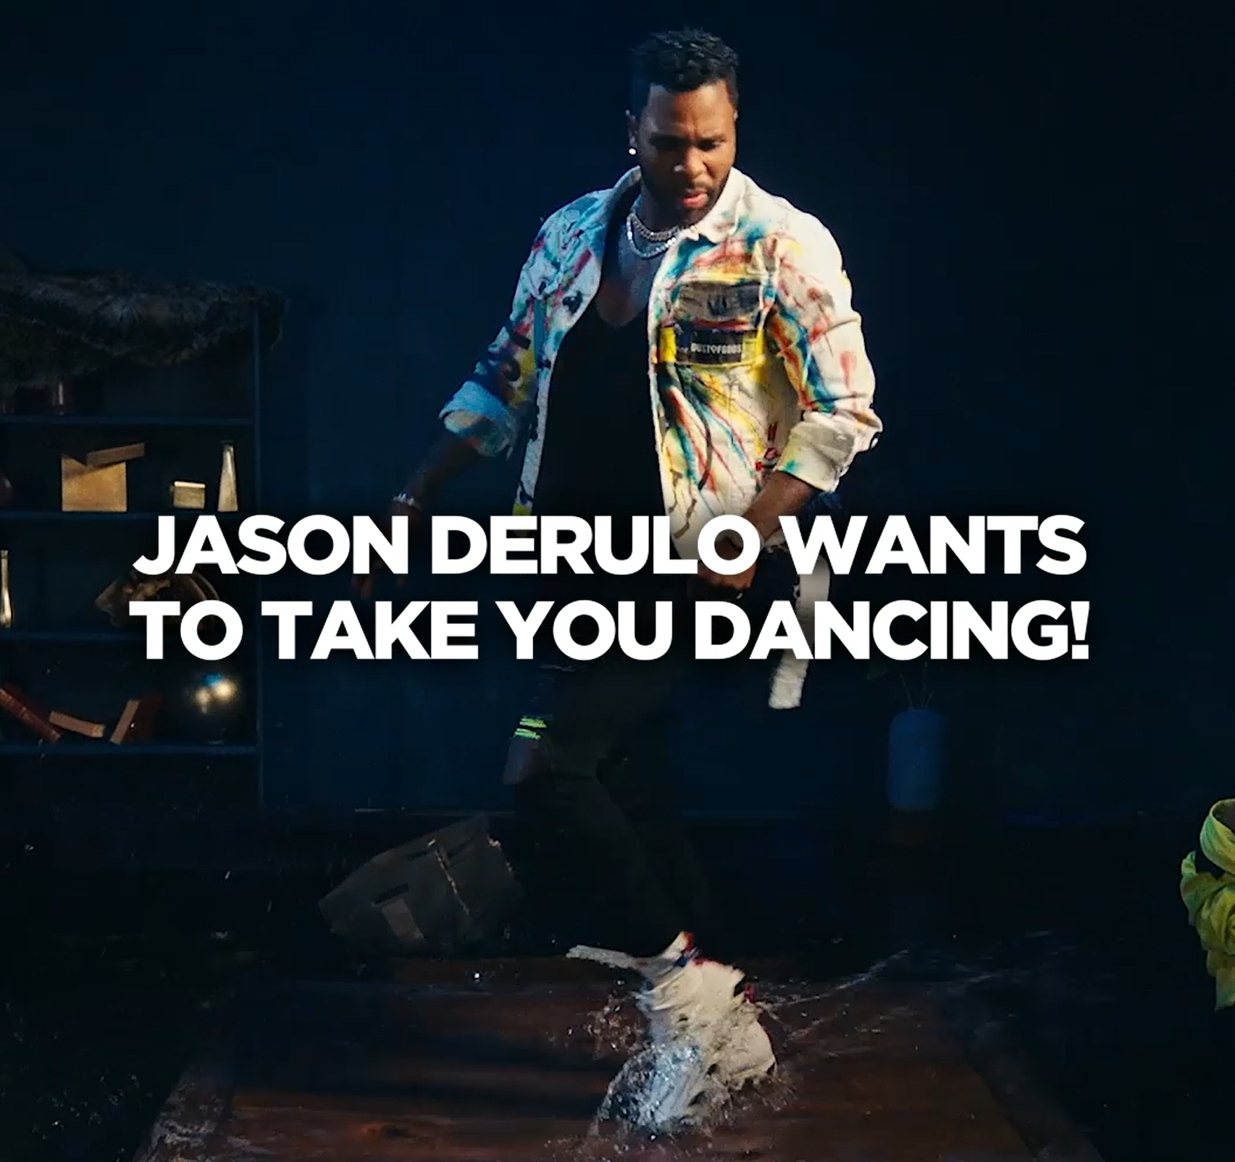

***DOWNLOAD “TAKE YOU DANCING” PRESS ASSETS***[***HERE***](https://nam04.safelinks.protection.outlook.com/?url=https%3A%2F%2Fwarnermusicgroup.box.com%2Fs%2F9ijqpcgwsl5k7jz6450868bgsza7uz72&data=02%7C01%7CChandler.Owen%40atlanticrecords.com%7C135beb866ad740d4c10608d86c770f0c%7C8367939002ec4ba1ad3d69da3fdd637e%7C0%7C0%7C637378605908160692&sdata=mZVGVYkg%2F%2FTjXN5t33J1jEo18Lv7m3VThTBdm7pL4OE%3D&reserved=0)

Jason Derulo wants to take you dancing! The multi-platinum global superstar announced today his virtual dance party on Friday, October 16th. Learn the “Take You Dancing” TikTok dance from the master himself along with a surprise guest appearance. Join fans from around the globe at the virtual party, personally ask Jason questions during the Q&A, and get a chance to show off your moves during the dance party where fans will be highlighted on the screen!

Sign up for a chance to join the party [HERE](http://jasonderulo.lnk.to/VirtualDanceParty). The virtual dance parties will take place on October 16th, one at 10am PST and another at 6pm PST. Fans can sign up for the dance party with their e-mail address. They will get two emails sent to them, one directly after they sign up and one the day of the event, fifteen minutes before start time.

**MORE ABOUT “TAKE YOU DANCING”:**

* “Take You Dancing” has seen incredible success since its release, with over 145M Global Streams to date!
* It is currently #13 on European Airplay & #15 Global Shazam
* “Take You Dancing” is impacting Top 40 Radio in the US this month.

**CONNECT WITH JASON DERULO**

[OFFICIAL](https://nam04.safelinks.protection.outlook.com/?url=https%3A%2F%2Fwww.jasonderulo.com%2F&data=02%7C01%7CChandler.Owen%40atlanticrecords.com%7Cf7e22761878d4406b06b08d82e58ab1d%7C8367939002ec4ba1ad3d69da3fdd637e%7C0%7C0%7C637310305834460449&sdata=plBGSTytjN9XPR3O%2FbsVI0L5lqJ4xDz6wJgaY9AN9Jk%3D&reserved=0) | [INSTAGRAM](https://nam04.safelinks.protection.outlook.com/?url=https%3A%2F%2Fwww.instagram.com%2Fjasonderulo%2F&data=02%7C01%7CChandler.Owen%40atlanticrecords.com%7Cf7e22761878d4406b06b08d82e58ab1d%7C8367939002ec4ba1ad3d69da3fdd637e%7C0%7C0%7C637310305834470443&sdata=Qgr0ra2g95H18Kmmr1AIupbB0%2BiIpXuALmGDkLL9db8%3D&reserved=0) | [TWITTER](https://nam04.safelinks.protection.outlook.com/?url=https%3A%2F%2Ftwitter.com%2Fjasonderulo&data=02%7C01%7CChandler.Owen%40atlanticrecords.com%7Cf7e22761878d4406b06b08d82e58ab1d%7C8367939002ec4ba1ad3d69da3fdd637e%7C0%7C0%7C637310305834470443&sdata=9c9O3cwdr%2BNZCaGiwdUOx%2BN55NUfitZqTcdW8rgA3mQ%3D&reserved=0) | [FACEBOOK](https://nam04.safelinks.protection.outlook.com/?url=https%3A%2F%2Fwww.facebook.com%2Fjasonderulo&data=02%7C01%7CChandler.Owen%40atlanticrecords.com%7Cf7e22761878d4406b06b08d82e58ab1d%7C8367939002ec4ba1ad3d69da3fdd637e%7C0%7C0%7C637310305834480440&sdata=FLHeAaJwFZVywWV7fi6YgYTkFpC2DsYJt8zIXBFOywA%3D&reserved=0) | [YOUTUBE](https://nam04.safelinks.protection.outlook.com/?url=https%3A%2F%2Fwww.youtube.com%2Fchannel%2FUCe3yZzUwpmy2eKKmF9svX0Q&data=02%7C01%7CChandler.Owen%40atlanticrecords.com%7Cf7e22761878d4406b06b08d82e58ab1d%7C8367939002ec4ba1ad3d69da3fdd637e%7C0%7C0%7C637310305834480440&sdata=0lfrnHKlDbgNI1cZsA%2BXHmCaRZB9Nbn4Tg%2BrmYk7DE8%3D&reserved=0) | [TIKTOK](https://nam04.safelinks.protection.outlook.com/?url=https%3A%2F%2Fwww.tiktok.com%2F%40jasonderulo&data=02%7C01%7CChandler.Owen%40atlanticrecords.com%7Cf7e22761878d4406b06b08d82e58ab1d%7C8367939002ec4ba1ad3d69da3fdd637e%7C0%7C0%7C637310305834490426&sdata=PDVwqJwjSFzUYWw%2FY0x7YukpN%2FINkbIQB%2FerpZFporg%3D&reserved=0)

**PRESS CONTACT**

FAIRLEY MCCASKILL | [FAIRLEY.MCCASKILL@ATLANTICRECORDS.COM](mailto:FAIRLEY.MCCASKILL@ATLANTICRECORDS.COM)

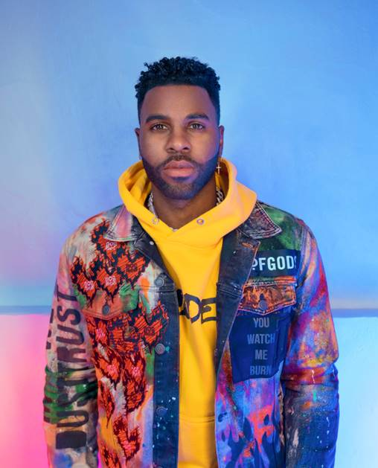

**PHOTO CREDIT**: DAVID STRBIK| [DOWNLOAD HERE](https://nam04.safelinks.protection.outlook.com/?url=https%3A%2F%2Fwarnermusicgroup.box.com%2Fs%2Fnpen6y5z0wcr7hfjxyf4umsm7i9gnd7e&data=02%7C01%7CChandler.Owen%40atlanticrecords.com%7Cf7e22761878d4406b06b08d82e58ab1d%7C8367939002ec4ba1ad3d69da3fdd637e%7C0%7C0%7C637310305834490426&sdata=50McQxIAlEe91QxHy%2FlV2XMuw%2FOe%2Fp85Dq1xTNPHgkU%3D&reserved=0)