FOR IMMEDIATE RELEASE
NOVEMBER 6, 2020

ATLANTIC WELCOMES MIKE WiLL MADE-IT TO GROUNDBREAKING ROSTER

GRAMMY® AWARD-WINNING SUPERSTAR PRODUCER CELEBRATES WITH
NEW SINGLE FT. YOUNGBOY NEVER BROKE AGAIN & NICKI MINAJ

UPCOMING ALBUM, MICHAEL, DUE EARLY 2021

RECENTLY NOMINATED FOR BET HIP HOP AWARDS PRODUCER OF THE YEAR

LISTEN TO “WHAT THAT SPEED BOUT?! (FEAT. YOUNGBOY NEVER BROKE AGAIN & NICKI MINAJ)”:
MIKEWILLMADEIT.LNK.TO/WHATTHATSPEEDBOUT

WATCH OFFICIAL MUSIC VIDEO:
MIKEWILLMADEIT.LNK.TO/WHATTHATSPEEDBOUTVID

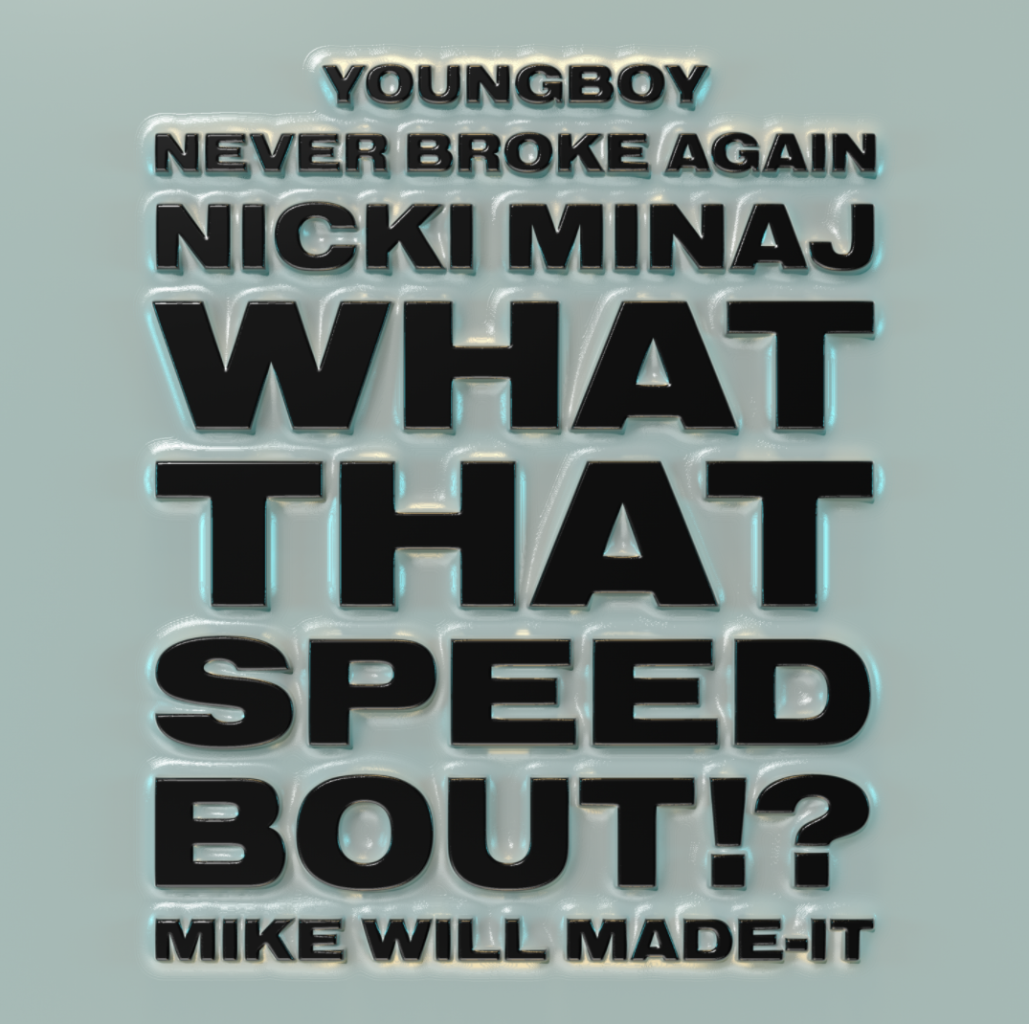
DOWNLOAD HIGH-RES PRESS ASSETS
DOWNLOAD HIGH-RES COVER ART

Atlantic Records is very proud to announce the signing of superstar producer Mike WiLL Made-It to its historic roster. The multi-platinum, GRAMMY® Award-winning singer-songwriter-rapper-producer will celebrate with the release of the new single, “What That Speed Bout?! (Feat. YoungBoy Never Broke Again & Nicki Minaj),” available now at all DSPs and streaming services HERE; the star-studded track is joined by an official companion video, streaming now via YouTube HERE.

“What That Speed Bout?! (Feat. YoungBoy Never Broke Again and Nicki Minaj)” precedes Mike WiLL Made-It’s eagerly awaited new album, MICHAEL, due to arrive via Atlantic and the producer’s own Eardrummers Entertainment early next year.

“I’m going to give the people what they want but also what they never knew they needed. Having vision is having the ability to see the unseen,” says Mike WiLL Made-It, who was recently nominated for BET Hip Hop Awards Producer of the Year.

“Few producers are as unmistakable, successful and versatile as Mike WiLL Made-It,” says Mike Kyser, President of Black Music, Atlantic Records. “He’s dominated the charts by breaking into the worlds of rap, R&B and pop– never letting the box of genre confine him. We’re excited to welcome Mike WiLL into the Atlantic family. This project is an incredible compilation showcasing his authentic sound and evolution as a top-tier producer.”

Mike WiLL Made-It is of course one of the most gifted, prolific, and popular producers of the past decade, known for his chart-topping blend of Atlanta trap and American Top 40. Born and raised in Marietta, GA, Mike Will first captured attention for his groundbreaking work alongside some of ATL hip-hop’s best and brightest, including Gucci Mane, Future, and 2 Chainz. By 2014 he had produced and co-written more than a dozen RIAA Gold and Platinum certified hits across a wide array of genres, spanning hip-hop (Kanye West, Lil Wayne, Future), R&B (Rihanna, Ciara, Kelly Rowland), and pop (Miley Cyrus).

In 2015, Mike WiLL introduced the world to Rae Sremmurd – the first act out of his Eardrummers Entertainment brand, resulting in nine multi-platinum singles including 2016’s chart-topping, 6x RIAA platinum, Mike WiLL-produced smash, “Black Beatles.” That same year saw Mike WiLL behind the boards for Beyoncé’s critically acclaimed, GRAMMY® Award-nominated “Formation,” which famously premiered during her historic Super Bowl 50 halftime show.

Mike WiLL scored his second career Billboard “Hot 100” #1 hit in 2017 with Kendrick Lamar’s “Humble,” later named “Best Rap Song” at the 60th Annual GRAMMY® Awards. 2018 saw him made his first foray into film, serving as soundtrack producer on CREED II: THE ALBUM. Mike WiLL is not only a chart-topping producer in his own right, Mike also oversees a stable of producers and artists as CEO of Eardrummers Entertainment where he actively works alongside some of the brightest names of tomorrow.

Throughout his rise Mike WiLL has demonstrated a commitment to giving back to his community through his Making Wishes Matter Foundation’s annual “Wish Week,” a weeklong series of events to benefit Atlanta’s youth. In the midst of the COVID-19 pandemic, his non-profit organization partnered with Ludacris and a local sewing company to distribute 3,000 face masks to MARTA employees. For more information, please visit www.makingwishesmatter.org.

CONNECT WITH MIKE WILL MADE-IT
TWITTER | FACEBOOK | INSTAGRAM

PRESS CONTACT
Brittany Bell | Brittany.Bell@atlanticrecords.com

