FOR IMMEDIATE RELEASE
NOVEMBER 9, 2021

IN CASE YOU MISSED IT:
BRELAND RECEIVES A STANDING OVATION AT GRAND OLE OPRY DEBUT FRIDAY NIGHT (11/5)

TUNE IN: BRELAND TO MAKE HIS CMA AWARDS DEBUT PERFORMING “BEERS ON ME” WITH DIERKS BENTLEY AND HARDY THIS WEDNESDAY ON ABC (11/10)

TO PLAY THE RYMAN AUDITORIUM FOR THE FIRST TIME AS PART OF DIANA CARTER’S 25TH ANNIVERSARY SHOW ON NOVEMBER 18

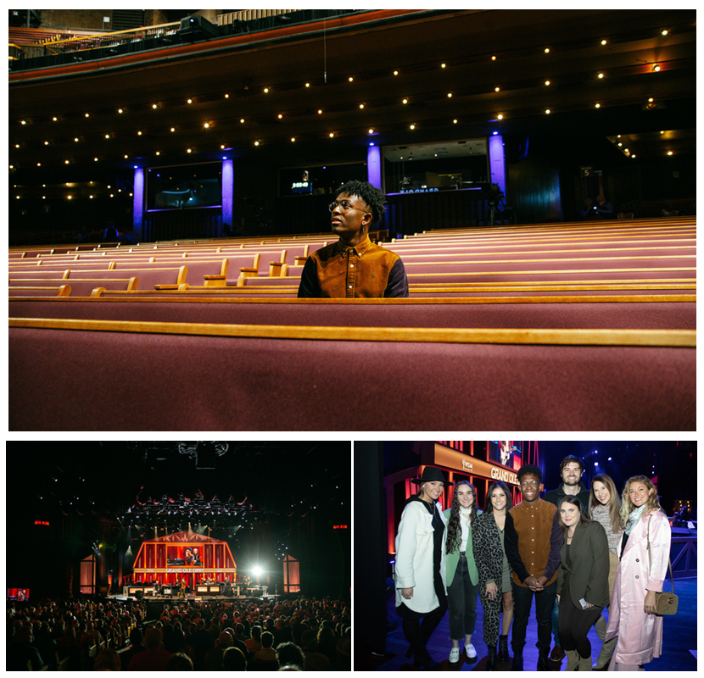
TOP PHOTO: DOWNLOAD HERE // PHOTO CREDIT: MIKE LERNER
BOTTOM LEFT PHOTO: DOWNLOAD HERE // PHOTO CREDIT: MIKE LERNER
BOTTOM RIGHT PHOTO: DOWNLOAD HERE // PHOTO CREDIT: © GRAND OLE OPRY, PHOTOS BY CHRIS HOLLO
(PICTURED L-R) HALIE HAMPTON MOSELY, WHY&HOW; LILLIAN JONES, WHY&HOW; NADA TAHA, GOODCOPBADCOP; BRELAND; MATT STUBBS, WHY&HOW;
MOLLY FREE, BRELAND'S STYLIST; JENSEN SUSSMAN, SWEET TALK PUBLICITY; SARAH BETH WATSON, SWEET TALK PUBLICITY

Bad Realm Records / Atlantic Records PLATINUM star BRELAND received a warm Grand Ole Opry welcome with a standing ovation for his debut Friday night (11/5). After his introduction by WSM’s Charlie Mattos, he burst onto the stage to share his story through fan-favorite “Cross Country” and breakout, PLATINUM smash “My Truck.”

BRELAND shared on socials following this special night, “I had my Opry debut yesterday and got a standing ovation!!! Wow. Sharing my version of Country music in the home of Country music and having it received this way… I’m just so grateful.”

Adding to his list of firsts, BRELAND will perform on The 55th Annual CMA Awards with Dierks Bentley and HARDY for their chart-rising collaboration “Beers On Me.” Tune in this Wednesday (11/10) at 7pm CT on ABC to watch.

Next up, BRELAND will appear at Deana Carter’s 25th anniversary celebration for her 5X Platinum debut DID I SHAVE MY LEGS FOR THIS to be held at the Ryman Auditorium on November 18. Performing on this iconic stage for the first time, the invite was sparked by his cover of Carter’s classic “Strawberry Wine” as part of a recent Spotify’s Singles campaign.

The breakthrough talent continues to notch career milestones with several high-profile looks earlier this year including ABC’s CMA Summer Jam, CMT Crossroads, ABC’s Jimmy Kimmel Live!,ABC’s Good Morning America, YouTube’s Artist on The Rise, and most recently, a Chevy campaign that launched during NFL’s season opener featuring BRELAND alongside Michele Tafoya, Chase Elliot, Chris Pratt and Chad Hall.

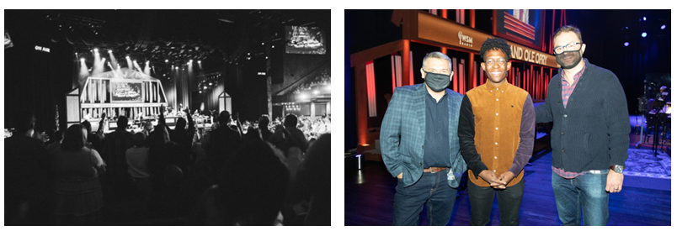
PHOTO 1: DOWNLOAD PHOTO HERE // PHOTO CREDIT: MIKE LERNER
PHOTO 2: DOWNLOAD PHOTO HERE
PHOTO CREDIT: © GRAND OLE OPRY, PHOTOS BY CHRIS HOLLO
(PICTURED L-R) DAN ROGERS, GRAND OLE OPRY; BRELAND; JORDAN PETTIT, GRAND OLE OPRY

ABOUT BRELAND
With the arrival of his PLATINUM-certified debut single “My Truck,” singer/songwriter/producer BRELAND emerged as a bold new force on today’s music landscape. Originally from New Jersey, BRELAND moved to Atlanta after graduating from Georgetown University, kicking off his songwriting career by scoring cuts with artists like YK Osiris and Ann Marie. Soon after releasing “My Truck” in late 2019, he saw the Hip-Hop and Country hybrid hit #1 on Spotify’s Global Viral 50, with a remix featuring Country hitmaker Sam Hunt landing on best-of-the-year lists from NPR and The New York Times. The song’s success paved the way for his signing to Bad Realm Records/Atlantic Records, leading to collaborations with heavy-hitters from the Country, Pop, and Hip-Hop worlds (including Gary LeVox of Rascal Flatts, Nelly, Blanco Brown, Lauren Alaina, and Chase Rice). BRELAND’s 2021 single “Cross Country” further reveals his passion for transcending boundaries, continuing his mission of breaking down genre barriers in Country music. The Nashville-based artist made his national TV debut with “Cross Country” on The Kelly Clarkson Show, where she surprised him with a PLATINUM plaque for “My Truck.” Now at work on the follow-up to his 2020 self-titled debut EP, he enlisted superstar Keith Urban for the dynamic collaboration “Throw It Back.” Adding to his list of buzzy collaborations, he is currently featured on Dierks Bentley’s single with HARDY, “Beers On Me.” BRELAND has been praised by Rolling Stone as “1,000 percent the whole package,” featured on Billboard’s “Emerging Artists Spotlight,” and earned acclaim from Genius, Paper, USA TODAY, and more.

PRESS CONTACTS:
Fairley McCaskill, Atlantic Records / Fairley.McCaskill@atlanticrecords.com
Jensen Sussman, Sweet Talk Publicity / jensen@sweettalkpr.com

