FOR IMMEDIATE RELEASE
NOVEMBER 16, 2021

BRELAND DUE ON TOUR WITH RUSSELL DICKERSON TO KICK OFF 2022’S
ALL YOURS, ALL NIGHT TOUR

BREAKOUT STAR TO MAKE RYMAN AUDITORIUM DEBUT THIS THURSDAY (11/18) FOR DEANA CARTER’S 25TH ANNIVERSARY SHOW

RYMAN AUDITORIUM DEBUT ROUNDS OUT BRELAND’S TWO-WEEK HAT-TRICK OF NASHVILLE DEBUTS

TO PERFORM ON ABC'S 12TH ANNUAL "CMA COUNTRY CHRISTMAS" ON NOVEMBER 29

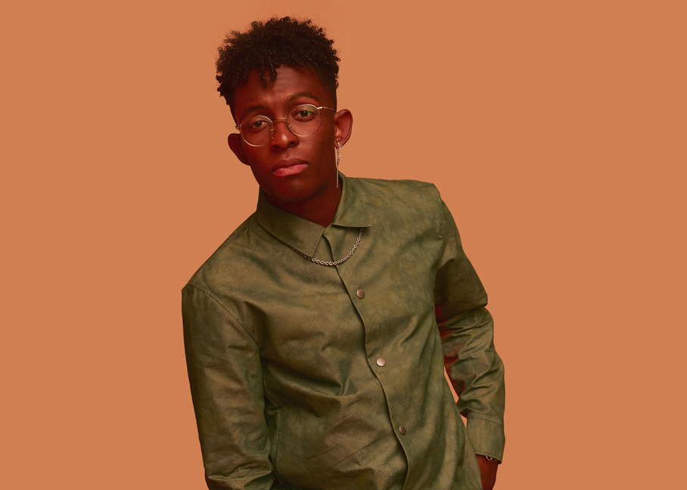

Bad Realm Records / Atlantic Records PLATINUM breakout artist BRELAND is tapped to join chart-topping Country artist Russell Dickerson for his ALL YOURS, ALL NIGHT TOUR set to launch in 2022 at New York City’s Irving Plaza and wrapping in Nashville at the celebrated Ryman Auditorium. See list of tour stops below.

ALL YOURS, ALL NIGHT TOUR DATES:
01/25/2022 – New York NY – Irving Plaza
01/27/2022 – Boston, MA – House of Blues
01/28/2022 – Sayreville, NJ – Starland Ballroom
01/29/2022 – Pittsburgh, PA – Stage AE
02/03/2022 – Madison, WA – The Sylvee
02/04/2022 – St. Louis, MO – Ballpark Village
02/05/2022 – Newport, KY – Ovation
02/17/2022 – Minneapolis, MN – The Fillmore
02/18/2022 – Milwaukee, WI – The Rave
02/19/2022 – Grand Rapids, MI – GLC Live at 20 Monroe
03/25/2022 – Nashville, TN – Ryman Auditorium

In addition to the exciting tour announce, BRELAND is set to make his Ryman Auditorium debut this Thursday (11/18) as part of Deana Carter’s 25th Anniversary show for DID I SHAVE MY LEGS FOR THIS? This appearance marks a hat-trick of career firsts for BRELAND as he made his Grand Ole Opry debut, performed on the CMA Awards, and played the Ryman Auditorium all within the span of two weeks.

Also this just in, BRELAND will be performing on ABC's 12th annual "CMA Country Christmas" to air at 8PM ET/7PM CT on Monday, November 29. Hosted by Gabby Barrett and Carly Pearce, BRELAND will appear alongside Jimmie Allen with Louis York & The Shindellas, Brett Eldredge, Lady A, Pistol Annies, Carrie Underwood, and Lainey Wilson for an intimate evening of holiday classics. The breakthrough talent continues to notch milestones with several high-profile looks earlier this year including ABC’s CMA Summer Jam, CMT Crossroads, ABC’s Jimmy Kimmel Live!, ABC’s Good Morning America, YouTube’s Artist on The Rise, and most recently, a Chevy campaign that launched during NFL’s season opener featuring BRELAND alongside Michele Tafoya, Chase Elliot, Chris Pratt and Chad Hall.

ABOUT BRELAND
With his PLATINUM debut “My Truck,” singer/songwriter/producer BRELAND has emerged as a bold new force on today’s music landscape. The Hip-Hop and Country hybrid hit #1 on Spotify’s Global Viral 50 in 2019, and a remix featuring Sam Hunt landed on best-of-the-year lists from NPR and The New York Times. Having signed to Bad Realm Records/Atlantic Records, he has collaborated with heavy-hitters such as Gary LeVox of Rascal Flatts, Nelly, Blanco Brown, Lauren Alaina, and Chase Rice. The New Jersey native notched several career milestones this year with high profile looks on The Kelly Clarkson Show, ABC’s CMA Summer Jam, CMT Crossroads, ABC’s Jimmy Kimmel Live!, ABC’s Good Morning America, YouTube’s Artist on The Rise, and most recently, a Chevy campaign that launched during NFL’s season opener featuring BRELAND alongside Michele Tafoya, Chase Elliot, Chris Pratt and Chad Hall. He recently enlisted Keith Urban for the dynamic collaboration “Throw It Back” and is currently featured on Dierks Bentley’s single with HARDY, “Beers On Me.” Praised by Rolling Stone as “1,000 percent the whole package,” he made his Grand Ole Opry debut to a standing ovation.

PRESS CONTACTS:
Fairley McCaskill, Atlantic Records / Fairley.McCaskill@atlanticrecords.com
Jensen Sussman, Sweet Talk Publicity / jensen@sweettalkpr.com

