FOR IMMEDIATE RELEASE
NOVEMBER 19, 2021

SAM AUSTINS TAPS CASPR FOR “MIND ON DRUGS” REMIX
STREAM: SAM-AUSTINS.LNK.TO/MINDONDRUGS
WATCH: SAM-AUSTINS.LNK.TO/MODVISUALIZER

ON THE HEELS OF HIS DEBUT PROJECT HOMELESS STAR
& “DRIFTING AWAY” VISUALIZER

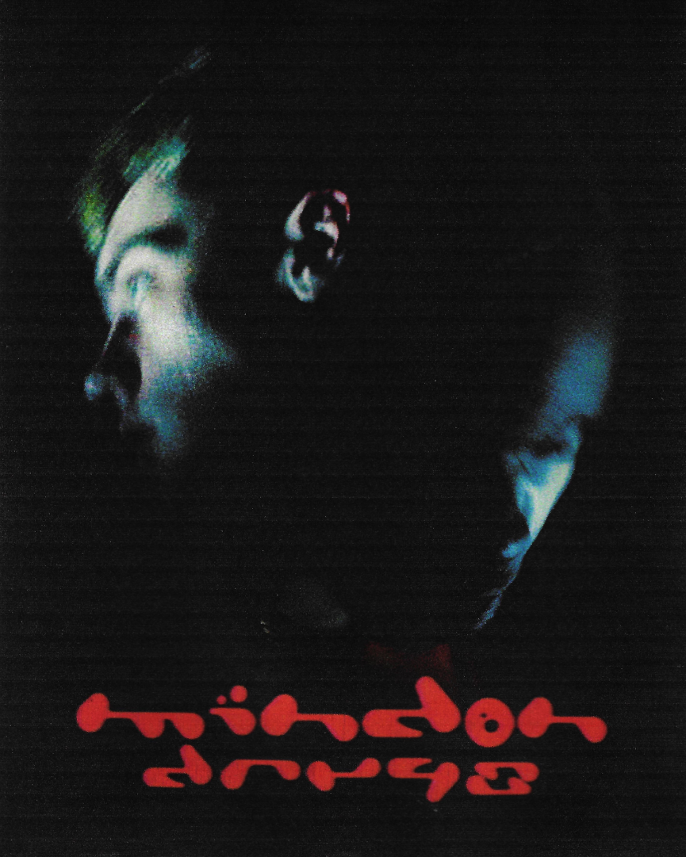
HIGH-RES PRESS PHOTO, CRED: SAM TROTTER

Sam Austins stays prolific post-release of HOMELESS STAR, a coming of age project and an ode to Detroit youth. He quickly followed with the official visual to “DRIFTING AWAY,” a stand-out track that touches on acceptance of the unknown. Now the Detroit-born and Los Angeles-based artist, model, and maverick creative taps rising punk star caspr for an alternative take on “MIND ON DRUGS.” Austins continues to prove he “is a boundary-breaker, challenging long-held ideas of what it means to be an alternative artist (Billboard).”

Last month we took a step into his world – a world inspired by the fusion of energies: 90s alternative with R&B melodies reminiscent of Frank Ocean. It highlights the aspirational aesthetics of high fashion with the authentic storytelling of Detroit culture. HOMELESS STAR is the world he forged when our world claimed he didn’t belong. The rising star even inspired 3D artist and designer Nusi Quero (Kylie Jenner, Grimes, SZA) to design the first male breastplate for the galactic HOMELESS STAR artwork. Austins celebrated the release with a legendary Los Angeles event in the hills. Check out photos from the event HERE (Photo Credit: Sam Trotter).

HOMELESS STAR TRACKLIST:
- KILOS
- MIND ON DRUGS
- DRIFTING AWAY
- SIMPLE AS
- YOUNGBLOOD
- SUMMER HEAT
- JOY FOR YOUTH (with Sir Chloe)
- MISTER BLUE
- BE HONEST
- HOMELESS

ABOUT SAM AUSTINS:
A genre-defying coming of age project and an ode to Detroit youth, HOMELESS STAR is here. The Detroit-born and Los Angeles-based artist, model and maverick creative kicked off HOMELESS STAR with "KILOS,” using metaphors to highlight complicated forces that have shaped Austins’ young adult life in the heat of Detroit summers. Austins then tapped Sir Chloe for “JOY FOR YOUTH,” a sonic time capsule that nostalgically captures the rebellion, bravery and bliss of adolescence. “DRIFTING AWAY” touches on the ebbs and flows of life, finding yourself distant from who you used to be and finding acceptance in surrendering to the unknown.

Following high school, Austins found himself couch surfing, sleeping on friends’ floors and camping out in his old Impala. Once his aunt opened her home to him in the inner city of Detroit, he could finally turn his focus to music. After dropping the GOAT EP, he opened for Vince Staples, Juicy J, Danny Brown and Playboi Carti. Austins linked up with the likes of Take A Daytrip, Black Milk and Big Sean while also landing placements on VH1’s Love & Hip-Hop and HBO’s Euphoria. He became the recipient of TIDAL’s Unplugged Grant and caught the attention of Atlantic Records. Austins now continues to amass millions of streams, attract looks from the likes of Vogue, HYPEBEAST, Pigeons & Planes, and challenge what it means to be an alternative artist.

PRESS CONTACTS:
SAM AUSTINS
Fairley McCaskill | Fairley.McCaskill@atlanticrecords.com
& Chandler Owen | Chandler.Owen@atlanticrecords.com

